

Available online at http://journal.walisongo.ac.id/index.php/jnsmr

Analysis of Optical Properties TiO₂, ZnO, TiO₂: ZnO Thin Films Deposited On Glass Substrate Using Sol-Gel Spray Coating Method And Application For Degradation Of Dye Liquids.

Wilda Amananti 1, Agus Susanto 2, and Ahmad Sunardi

1Politeknik Harapan Bersama, Prodi DIII Farmasi,

Corresponding author:
Recived:
Revised :
Accepted:

Abstracts

TiO₂, ZnO and TiO₂: ZnO Thin film have been deposited on glass substrate by sol-gel method of Spray Coating Technique. TiO₂: ZnO and ZnO can form well above the glass substrate. The precursor solution of TiO₂ and TiO₂: ZnO is deposited using sol-gel method of Spray Coating Technique. Zinc acetate dehydrate (Zn (COOCH₃) ₂ .2H₂O was dissolved into an isopropanol ((CH₃) 2CHOH) solvent and then added monoethanolamine (MEA: HOCH₂CH₂NH₂) .The solution was stirred at 70ºC until a clear and homogeneous solution was obtained.Titanium Tetraisopropoxide (TTIP) 0 , 73 ml was dissolved into 4.27 ml of isopropanol and 20 ml of ethanol, after which the solution was titrated with 5 ml of ethanol, 3.4 ml acetic acid and 0.26 ml H₂O, then stirred on hot plate stirrer at room temperature ( Further, the ZnO, TiO₂ and TiO₂: ZnO precursor gels were sprayed on a glass substrate that was heated at a temperature of 450 ° C. The results of the TiO₂ thin film bandgap energy measurement were 3.58 eV, ZnO thin films of 3.08 eV, and a thin layer of TiO₂: ZnO of 3.06 eV Doped photodegradation dye Direct blue 10 ppm using UV-reactor The highest percentage of degradation is found in TiO₂: ZnO thin film.

Key words: Photocatalyst, ZnO, TiO₂,, energy band gap.

1. Introduction

Industrial waste is a problem that continues to get attention by society, companies, and even the government because it has a negative impact on the environment if not managed properly. Industrial waste can be liquid, solid or gas that has special processing techniques on each type.

Industrial waste has a direct and indirect impact on the surrounding environment. Industrial waste discharged directly into the river, usually liquid waste, will accumulate in the sea causing raw water sources in polluted major cities [1].

Wastewater treatment technology either biologically, chemically, physically or in combination between the three processes can be used to treat liquid waste.

Several methods of removal of existing colors in liquid waste have been done, such as semiconductor photocatalyst.This method attracts many researchers because it has great potential to solve environmental problems especially the problem of liquid waste [2].
TiO₂ is known as a good material for environmental pollutant degradation because of its high photocatalytic activity, non-toxic and stable in aqueous solution as well as relatively low cost [3]. TiO₂ in the form of powder is considered inefficient because TiO₂ powder is difficult to separate from the degradation of the degradable substances, which can lead to new waste. The weakness can be overcome by coating the TiO2 particles on the transparent media. Thin layers are easier to store and apply in various places, because the layers are scratch resistant and insoluble in water or gas.
The recombination rate of TiO 2 can be derived through the combination of TiO 2 with another oxide as a composite. One of the most widely used oxides as composites is ZnO because of the optical absorption in the ultraviolet region with an energy band gap almost equal to TiO2 [3].
In this study, a combination of ZnO and TiO₂ was done in the hope of increasing the ability of ZnO and TiO₂ in degrading the dye liquids. A thin layer of ZnO: TiO₂ is deposited on a glass substrate using a spray-coating method with a volume ratio between ZnO and TiO₂ being 50%: 50%. The resulting thin films were tested for degradation applications of dye liquids. and also examine the difference of optical properties in ZnO: TiO₂ thin film.

2. Experiments Procedure

The process of preparing a ZnO precursor solution: TiO₂ was initiated by preparing ZnO precursor solution and TiO₂ precursor solution using sol-gel method, then mixing ZnO precursor solution with TiO₂ with variation of predetermined volume ratio.

The ZnO precursor solution was prepared by dissolving Zinc acetate dehydrate (Zn (COOCH₃) 2.2H₂O) into isopropanol ((CH₃) 2CHOH) and stirring with magnetic stirrer at 70ºC and then adding monoethanolamine (MEA: HOCH₂CH₂NH₂) by titration. The solution was stirred for 30 minutes until a clear and homogeneous solution was obtained. Preparation of TiO₂ precursor solution ie; Titanium Tetraisoproxide (TTiP: Ti (OC₃H7) 4) concentrated was dissolved into isopropanol ((CH₃) 2CHOH) and stirred with a magnetic stirrer to obtain an aqueous TTiP solution of 0.5 M. Then a dilute TTiP of 0.5 M was introduced into ethanol by titration and stirred with a magnetic stirrer for 0.5 hours. On the other hand, H₂O and Acetic acid glacial were dissolved in ethanol until homogeneous and titrated into the previous solution and stirred with a magnetic stirrer at room temperature for 1 hour to obtain a clear TiO₂ precursor solution.
The process of deposition of precursor solution TiO₂, ZnO, ZnO: TiO₂ above glass substrate using spray coating technique. Prior to the deposition process, the glass substrate is first cleaned by RCA (Radio Corporation of America) method of glass washed with acetone, then with methanol each for 5 minutes with an ultrasonic washer system to remove organic impurities such as fats and oils. The glass washed with DI water (deionized water) for 5 minutes with an ultrasonic wash and dried with a compressor. Dry glass substrate is placed on a hotplate at 400 ° C for 5 minutes. The heated glass substrate is spray-coated at a distance of 15 cm to obtain a thin layer of ZnO: TiO₂ on a glass substrate. Then annealing process is done at 450oC for 2 hours using furnace.
test of optical properties of thin film ZnO: TiO2 is done by using UV-Vis Spectroscopy tool to obtain the value of transmittance in the wavelength range of UV light to near infrared (NIR) light between 200-1100 nm.
The process of testing the photocatalytic capability of the ZnO: TiO₂ thin film was carried out on Direct Blue dye 71. Direct Blue dye 71 with 25 ml volume, inserted in a container containing a thin film of ZnO: TiO₂ with a volume ratio of 100%: 0%, 50% : 50% and 0%: 100%.

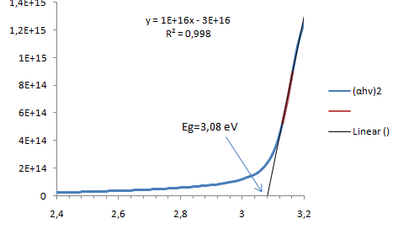
The photodegradation test was then irradiated using light from a 30 Watt UV lamp for 5 hours in a UV-reactor. Then the sample was characterized using UV-Vis 1240 SA (Ultraviolet-Visible) to determine the absorbance of the dye from the dye photodegradation.

3. Result and Discussion

Characteristics of Optical Properties Thin Layer ZnO, ZnO: TiO₂ and TiO₂
The optical properties of thin films ZnO, ZnO: TiO₂ and TiO₂ were carried out using a 1240 SA UV-Vis spectrophotometer in wavelength ranges from 200 nm to 800nm. The data obtained from this test is the value of transmittance which is further processed to obtain the bandgap energy value of each thin film.

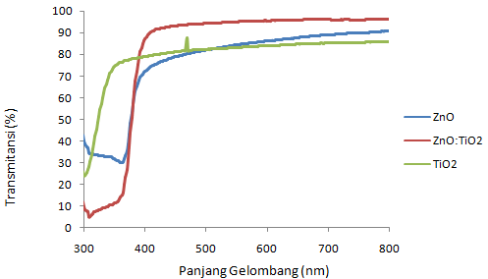
Figure 1 spectrum of transmittance of thin film ZnO, ZnO: TiO₂ and TiO₂

The optical properties test results show that the absorption edge of the thin film ZnO and ZnO: TiO₂ shifts to a longer wavelength (Redshift) of the TiO₂ layer. According to the optical absorption theory, the relationship between the absorption coefficient (α) and the photon energy (hv) for the transition direct is (αhv)² = hv - Eg, where Eg is the energy band gap of the thin layer. Figure 2 shows the energy band bands ZnO, ZnO: TiO₂ and TiO₂.

(a)


(b)

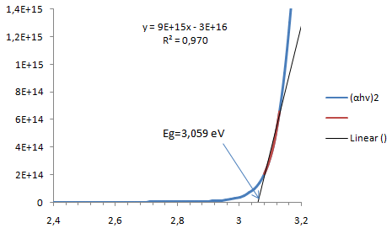
(c)

Figure 2 band gap of ZnO (a) TiO₂, (b) ZnO:TiO₂(c) thin film

Shows the reduction of energy band gap when TiO₂ is combined ZnO (ZnO: TiO₂). The band of energy bands is a forbidden area for electrons located between the valence band and the conduction band. The magnitude of the band value of the energy gap affects the optical properties of the semiconductor material because it is related to the photon energy to excite the electrons.
lattice strain will cause changes in the energy band gap. semiconductor band bandgap changes may occur due to residual stress in the film, tensile stress (grid strain) will result in narrowing of energy band gaps and compressive strains will lead to widening of energy band gaps [4].

Thin Film Photocatalyst Capability TiO₂, ZnO, TiO₂: ZnO.
Direct blue 71 doped photodegradation test of 10 ppm was performed to determine the capability of photocatalyst activity of TiO₂, ZnO, TiO₂: ZnO layers deposited on glass substrate. Direct blue photodegradation 71 was performed using from a 30 Watt UV lamp for 1 hour in a UV-reactor. Figure 3 shows the degradation graph in each sample. The results obtained from the research show that thin films TiO₂, ZnO, TiO₂: ZnO have the ability of photocatalyst to degrade (reduce) dye pollutants.
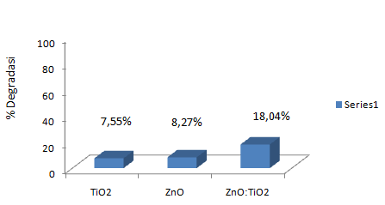

Gambar 3 Degradasi lapisan tipis TiO_{2,} ZnO , TiO₂:ZnO untuk Direct Blue 71 selama 1 jam.

The highest degradation increase was obtained for thin film TiO₂: ZnO deposited on glass substrate. These results indicate that ZnO has a great influence on TiO₂ photocatalyst activity, It occurs due to narrowing of energy band gap. The decrease in the bandgap of energy can reduce the minimum energy required for electron excitation [5] so that more energy ranges can be used to produce electrons and holes.

4. Conclusion

The thin layers TiO₂, ZnO and TiO₂: ZnO have been successfully deposited on the glass substrate by spray coating method. Testing of optical properties and photocatalytic activities concludes that the incorporation of TiO₂ with ZnO results in the reduction of energy band gaps resulting in increased photocatalytic capability of the thin film. TiO₂: ZnO thin layer has better photocatalytic capability than TiO₂ and ZnO thin films.

Acknowledgment

The authors wish to thank Politeknik Harapan bersama and Kemenristek Dikti for supporting this work

References

- Prihatin, R.B., 2013, Problema Air Bersih di Perkotaan, Pusat Pengkajian Pengolahan Data dan Informasi: Jakarta.
- Tian, J., Chen L., Yin Y., Wang X, Dai J., Zhu Z., Liu X, dan Wu P, 2009. Photocatalyst of TiO2/ZnO Nano Composite Film: Preparation, Characterization, and Photodegradation Activity of Methyl Orange. Surface & Coatings Technology 204 205–214.
- Tian, J., Wang J., Dai J., Wang X., dan Yin Y, 2009. N-Doped TiO2/ZnO Composite Powder and Its Photocatalytic Performance for Degradation of Methyl Orange. Surface & Coatings Technology 204 723–730.
- Zhao, D.G., Xu, S.J., Xie, M.H. dan Tong, S.Y., 2003, Stress and its effect on optical properties of GaN epilayers grown on Si(111), 6H-SiC(0001), and c-plane sapphire. Applied Physics Letters Volume 83, Number 4.
- Firdaus, C.M., Rizam M.S.B.S., Rusop M., dan Hidayah S.R, 2012. Characterization of ZnO and ZnO:TiO2 Thin Films Prepared by Sol-Gel Spray-Spin Coating Technique. Procedia Engineering 41 1367 – 1373.

