# OKI Bank M&A Transaction Data

Table1. Sample List of Sharia Banks

|  |  |  |  |  |
| --- | --- | --- | --- | --- |
| No | Bidder Banks / Acquirers (Bidder Banks) | Target Banks (Acquired Banks) | Agreement Date | Country |
| 1 | Al Salam Banks Bsc | BMI Banks Bsc | 3/2/2014 | Sanabis, Bahrain |
| 2 | Barwa Bank Qsc (Dukhan Bank) | International Bank Of Qatar Qsc | 12/4/2018 | Doha, Qatar |
| 3 | Dubai Islamic Bank Plc | Noor Bank Pjsc | 01/22/2020 | Dubai, UAE |
| 4 | Kuwait Finance House Ksc | Member of United Bank Bsc | 02/25/2020 | Safat, Kuwait |
| 5 | Indonesian Sharia Bank | BRI Syariah; Bank Syariah Mandiri; And BNI Syariah Bank | 1/2/2021 | Jakarta, Indonesia |
| 6 | Masraf Al Rayan (QSC) | Ai Rayan (Uk, London) | 08/23/2021 | Doha, Qatar |
| 7 | Ithmaar Bank Bsc | Faisal Islamic Bank Of Egypt | 10/18/2020 | Al Seef, Bahrain |
| 8 | Oman Arab Bank | Alizz Islamic Bank SAOG | 1/7/2020 | Ruwi, Oman |
| 9 | Arab Banking Corporation BSC | Blom Bank Egypt (Egypt) | 1/08/2021 | Manama, Bahrain |
| 10 | Islamic Bank Pakistan Limited | Kasb Bank Limited | 7/5/2015 | Karachi, Pakistan |
| 11 | Albaraka Bank (Pakistan) Ltd | Burj Bank Ltd | 11/1/2016 | Karachi, Pakistan |
| 12 | Abu Dhabi Commercial Bank | Al Hilal Bank Pjsc | 1/5/2019 | Abu Dhabi, UAE |

Source: BankFocus, Bureau Van Dijk, processed 2023

Table2. Sample List of Conventional Banks

|  |  |  |  |  |
| --- | --- | --- | --- | --- |
| No | Bidder Banks / Acquirers (Bidder Banks) | Target Banks (Acquired Banks) | Agreement Date | Country |
| 1 | National Bank Of Bahrain | Bahrain Islamic Banks BSC | 01/20/2020 | Bahrain |
| 2 | Saudi British Bank JSC, THE | Alawwal Bank (From The Royal Bank Of Scotland Group, Banco Stander) | 06/16/2019 | Riyadh, Saudi Arabia |
| 3 | First Abu Dhabi Bank | Bank Audi Egypt SAE | 5/5/2021 | Abu Dhabi, UAE |
| 4 | Saudi National Bank /National Commercial Bank | Samba Financial Group | 12/4/2021 | Saudi Arabia |
| 5 | Yevraziiski Bank Ao / Eurasian Bank | Bankpositive Kazakhstan AQ | 12/30/2015 | Almaty, Kazakhstan |
| 6 | Kina Bank Ltd | Australia And New Zealand Banking Group (PNG) Ltd's Retail, Commercial And SME Banking Business In Papua New Guinea | 09/23/2019 | PORT MORESBY, Papua New Guinea |
| 7 | Bank Central Asia and BCA Finance | Bank Rabobobank International Indonesia | 09/25/2020 | Jakarta, Indonesia |
| 8 | Fortebank AO | Kassa Nova Bank / FREEDOM BANK | 2/5/2019 | Kazakhstan |
| 9 | DFCU Bank Ltd | Crane Bank Rwanda Ltd | 2/19/2018 | Uganda |
| 10 | American Bank Of Investments SA | National Bank Of Greece | 4/7/2018 | Albania |
| 11 | Bank Agris Tbk | Mitraniaga Bank Tbk, PT | 08/23/2019 | Indonesia |
| 12 | Bank Of Africa - Benin | Banque De l'Habitat Du Benin | 10/2/2018 | Benin |
| 13 | Intesa Sanpaolo Bank Albanisa SHA | Veneto Banka Sha | 06/29/2017 | Albania |
| 14 | Skye Bank Lc | Mainstreet Bank Ltd | 10/31/2014 | Nigeria |
| 15 | Arab Bangking Corporation Bsc | Blom Bank Egypt SAE | 11/8/2021 | Egypt |
| 16 | Bank Saudara Tbk | Bank Woori Indonesia | 12/30/2015 | Bandung |
| 17 | Baiduri Bank Bhd | HSBC Holdings Plc's Retail And Commercial Banking Business In Brunei | 11/11/2017 | Brunei Darussalam |
| 18 | National Retirement Savings Bank | Bank Sumtomo Mitsui Indo | 1/2/2019 | Indonesia |
| 19 | Expobank Ooo | Aktsionernyi Kommercheskii Bank Yapy Kredi Bank Moskva AO | 25/20/2017 | Turkey |
| 20 | Acecess Bank Nigeria | Diamond Bank | 04/30/2019 | Nigeria |
| 21 | Qazaqstan Khalyq Banki AQ | Aktsionernyi Kommercheskii Bank Tenge Bank | 10/7/2019 |  |
| 22 | Societe Generale De Banque Au Liban Sal | KBL Richelieu Banque Privee, Aparis, KBL Monaco Private Bankers SA, | 10/7/2018 | Lebanon |
| 23 | Al Ahli Bank Of Kuwait Ksc | Piraeus Bank Egypt SAE | 10/11/2015 | Kuwait |
| 24 | Bank Danamon Indonesia | Bank Nusantara Parahyangan | 1/5/2019 | Indonesia |
| 25 | Bank Of Beirut Sal | Fortuna Banque SC | 6/11/2020 | Lebanon |
| 26 | MCB Bank Lmts | NIB Bank Ltd | 7/7/2017 | Pakistan |

Source:BankFocus, Bureau Van Dijk, processed 2023

1. Islamic Bank Analysis Data

|  |  |  |  |  |  |  |  |  |  |  |  |
| --- | --- | --- | --- | --- | --- | --- | --- | --- | --- | --- | --- |
| S1.1 | S1.2 | S2.1 | S2.2 | S2.3 | S3 | S4 | S5 | ROA | ROE | ROE-preB | RESIZE |
| 0.997363 | 0.084236 | 17.44825 | 330.1378 | 15.5272 | 26.46961 | 11.04546 | 160.0407 | 0.584063 | 3.251516 | 5.385511 | 0.672248 |
| 0.594405 | 1.047549 | 0.703966 | 16.00754 | 2.258072 | 3.298091 | 1.694869 | 26.87441 | 1.259425 | 8.382062 | 10.13548 | 0.680261 |
| 1.881383 | 0.447722 | 69.14094 | 0.757265 | 0.117796 | 7.555434 | 1.353853 | 18.36986 | 1.549678 | 13.6847 | 18.5263 | 0.204475 |
| 0.13762 | 0.926082 | 28.99128 | 10.90685 | 2.63857 | 8.018718 | 1.74139 | 21.57076 | 1.432817 | 14.83304 | 12.12823 | 2.07727 |
| 0.806507 | 1.247416 | 8.894742 | 26.24424 | 26.90277 | 38.26789 | 3.981193 | 48.98684 | 0.797951 | 14.55986 | 16.30677 | 759.3127 |
| 0.097598 | 0.223077 | 6.084792 | 106.6743 | 54.80376 | 63.69195 | 5.635041 | 5.147668 | 0.797951 | 5.807465 | 15.18314 | 0.019319 |
| 1.395087 | 0.182263 | 8.850637 | 71.47833 | 48.07155 | 58.92923 | 8.534344 | 42.87444 | 0.160722 | 5.114661 | 1.645965 | 35.03568 |
| 0.100357 | 4.513037 | 72.43004 | 216,935 | 0.772605 | 38.6374 | 2.102458 | 43.81321 | 0.210253 | 1.981919 | 11.21435 | 0.287864 |
| 0.552036 | 2.81907 | 1.952667 | 57.64714 | 18.46877 | 45.03561 | 4.664395 | 5.392145 | 0.584289 | 4.773869 | -1.73752 | 1.283279 |
| 1.418961 | 0.741748 | 67.53398 | 19.02872 | 22.12484 | 15.42763 | 4.909841 | 8.585109 | 0.553274 | 8.520041 | 8.339582 | 0.694655 |
| 1.465839 | 1.597554 | 3.709969 | 8.906197 | 3.744775 | 35.26857 | 6.874852 | 10.17835 | -0.31224 | -3.5161 | 3.949979 | 0.392149 |
| 0.316107 | 6.785411 | 1.154418 | 2.624577 | 4.836527 | 30.72629 | 1.923931 | 21.34967 | 0.933261 | 7.598061 | 16.90764 | 0.155972 |

1. Conventional Bank Analysis Data

|  |  |  |  |  |  |  |  |  |  |  |  |
| --- | --- | --- | --- | --- | --- | --- | --- | --- | --- | --- | --- |
| S1.1 | S1.2 | S2.1 | S2.2 | S2.3 | S3 | S4 | S5 | ROA | ROE | ROE-preB | RESIZE |
| 0.215338 | 2.922027 | 19.08413 | 35.16636 | 25.69401 | 26.54693 | 6.780015 | 22.00816 | 1.236372 | 10.36172 | 14.72076 | 0.383021 |
| 0.013266 | 13.34925 | 41.94305 | 7.314887 | 7.263428 | 40.37705 | 1.752164 | 40.67053 | -1.53662 | -7.80113 | 8.170956 | 0.4696 |
| 0.811348 | 5.826276 | 19.17499 | 43.94016 | 29.8216 | 10.38109 | 1.939058 | 34.83542 | 2.370144 | 20.97325 | 11.15545 | 0.669712 |
| 0.386898 | 5.69937 | 8.282019 | 8.172338 | 5.2949 | 20.73044 | 4.501994 | 29.68717 | 2.014239 | 12.40846 | 17.46796 | 0.495369 |
| 0.552736 | 44.1093 | 15.99838 | 122.3501 | 5.300481 | 12.47428 | 59.28568 | 57.26125 | 0.03998 | 0.457368 | 18.20406 | 0.0206 |
| 5.624503 | 18.46719 | 1.693223 | 82.92571 | 40.12945 | 24.6709 | 25.81564 | 90.27579 | 0.353658 | 5.861202 | 10.83052 | 0.000735 |
| 6.68021 | 5.49508 | 157,012 | 1788.047 | 12.23149 | 8.825856 | 8,255 | 153.6694 | 2.729281 | 16.22451 | 17.53315 | 2.513853 |
| 1.762514 | 2.28719 | 79.41463 | 5.678507 | 16.35835 | 2.350229 | 1,031 | 9.723128 | 2.546719 | 21.51689 | 14.7442 | 0.077239 |
| 3.723719 | 4.796096 | 24.06098 | 12.45073 | 9.862991 | 7.473516 | 1.24 | 4.091456 | 2.553129 | 14.28706 | 34.87751 | 0.597267 |
| 0.350411 | 0.82328 | 44.30989 | 55.06141 | 32.86574 | 18.07358 | 10,438 | 2.820941 | 0.96294 | 8.005138 | 17.49291 | 0.963477 |
| 0.07183 | 11.37295 | 28.08228 | 43.50402 | 32.86704 | 82.59449 | 3,649 | 43.07903 | -2.17331 | -11.4015 | -5.67425 | 0.557283 |
| 1.328005 | 8.371225 | 15.60745 | 13.63246 | 35.57161 | 20.40027 | 0.599 | 4.125385 | 1.683882 | 18.12397 | 16.88767 | 0.023429 |
| 0.375228 | 122.8105 | 71.48717 | 5.578483 | 6.615996 | 24.28647 | 2,048 | 34.60638 | 0.518533 | 4.222034 | 11.72622 | 0.176752 |
| 1.473424 | 7.897205 | 14.40927 | 31.66281 | 31.96684 | 44.52202 | 12,036 | 0.443343 | -3.10825 | -34.4495 | 16.23689 | 0.295509 |
| 0.034792 | 16.29936 | 48.32747 | 59.09294 | 21.97464 | 45.7187 | 2,263 | 24.65044 | 0.584289 | 4.773869 | -1.73752 | 1.446173 |
| 1.732631 | 21.18838 | 1.264333 | 31.60149 | 9.36237 | 44.59828 | 7,483 | 0.800403 | 1.452825 | 7.249005 | 4.973608 | 352.0252 |
| 0.95811 | 5.755393 | 0.07497 | 9.92054 | 12.49081 | 35.29746 | 3,145 | 22.55999 | 0.591548 | 8.124476 | 1.813226 | 0.001713 |
| 2.746123 | 21.86643 | 17.98945 | 125.8514 | 7.160039 | 16.8798 | 7,594 | 5.65051 | 1.099612 | 6.225265 | 11.82681 | 0.868358 |
| 0.395744 | 47.22164 | 22.58108 | 66.21238 | 28.4344 | 15.13733 | 2,786 | 31.39426 | 3.596347 | 15.33154 | 25.09165 | 3.767715 |
| 0.470582 | 8.873902 | 9.72159 | 5.97625 | 1.08077 | 30.42873 | 7,835 | 32.39015 | 1.339952 | 15.61514 | 18.96385 | 0.277401 |
| 0.902482 | 94.0724 | 9.387412 | 36.73793 | 40.71736 | 50.36218 | 2,336 | 46.13343 | 3.594368 | 25.18516 | 25.34179 | 0.000276 |
| 8.131141 | 3.315065 | 1.210566 | 48.88444 | 18.71925 | 1.621987 | 33,139 | 38.00642 | -0.61275 | -8.20217 | 12.47556 | 0.007726 |
| 0.335307 | 31.10575 | 141.7197 | 14.1577 | 5.230163 | 33.35669 | 7,777 | 8.148008 | 0.758773 | 5.846105 | 6.838916 | 25.51835 |
| 1.311716 | 13.79472 | 15.00042 | 35.4236 | 3.375435 | 21.90029 | 6.105 | 17.78305 | 0.552168 | 2.447266 | 10.12691 | 43.95248 |
| 0.221486 | 83.48085 | 39.08611 | 46.95295 | 49.63602 | 116.6099 | 9,055 | 23.5423 | 3.053042 | 51.33177 | -13.8149 | 15.08571 |
| 0.36767 | 24.82057 | 0.24382 | 64.97326 | 1.950919 | 3.186024 | 5,847 | 18.35549 | 1.372594 | 13.26245 | 15.39141 | 0.226569 |

1. Bootstrapping Second Order
2. 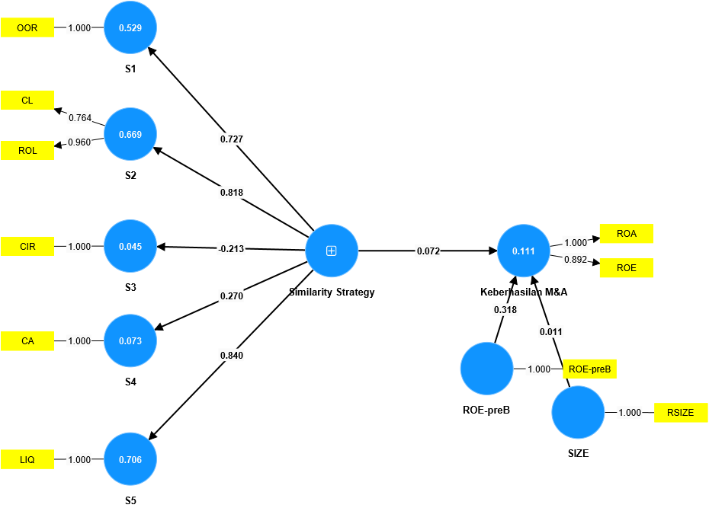AVE, CR, CA

|  |  |  |  |  |
| --- | --- | --- | --- | --- |
|  | Cronbach's alpha | Composite reliability (rho_a) | Composite reliability (rho_c) | Average variance extracted (AVE) |
| M&A success | 0.936 | 13,077 | 0.946 | 0.898 |
| S2 | 0.712 | 1,078 | 0.857 | 0.753 |
| Similarity Strategy | 0.755 | 0.764 | 0.861 | 0.675 |

Source: SmartPLS 4 output, processed 2024

1. R-Square

|  |  |  |
| --- | --- | --- |
|  | R-square | R-square adjusted |
| M&A success | 0.111 | 0.033 |

Source: SmartPLS 4 output, processed 2024

1. Bootstrapping Islamic Bank and Conventional Bank
2. 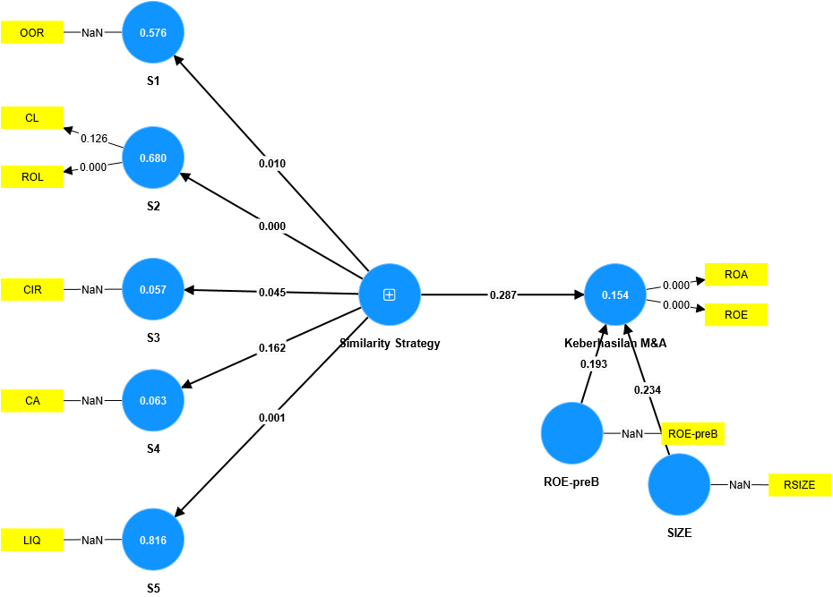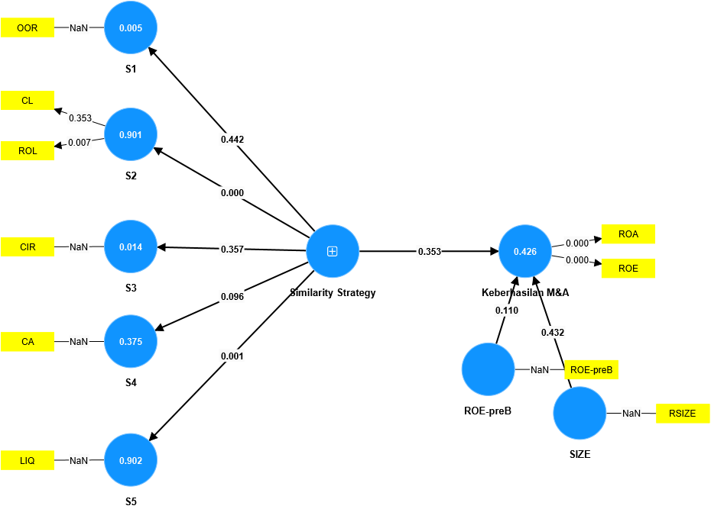Islamic Bank b.Conventional Bank