**Analysis of the Da'wah Strategy of the Pondok Tahfidz Foundation and Yatim Piatu Rabbunallah Surabaya in Forming Donor Loyalty**

**Ulya Fithriani1, Carissa Shofwah Wailah2, Ayu Farinda Novita3, Dimas Afrianto4, Moh Ilham5**

1,2,3,4,5UIN Sunan Ampel Surabaya

1ulyafithriani24122003@gmail.com, 2carissashofwahw@gamil.com , 3ayufarinda019@gmail.com, 4afriantodimas30@gmail.com, 5moh.ilham@uinsa.ac.id

|  |  |  |
| --- | --- | --- |
| **Article Info** |  | **Abstract** |
| Article history:  Received 03 Mei 2021  Accepted10 Juni 2021  Published 31 Juli 2021 |  | *In da'wah, the role of the media is very necessary, one of which is through organizations or foundations. The existence of a foundation, which is supported by donors, is an important element in carrying out the mission of da'wah. Donor loyalty is a key element for the operational sustainability of non-profit organizations, especially for foundations that rely on donations to fund their activities. In general, donors will remain loyal in providing support if they feel there are benefits from the contributions they make, and are confident that the funds donated are used transparently and effectively. This research aims to analyze the Foundation's efforts to build donor loyalty, with a focus on how the foundation maintains and increases donor loyalty, understands the factors that influence it, and identifies strategies for building long-term relationships with donors. Apart from that, this research also aims to explore strategies that foundations can use to attract new donors and increase the number of donations. This research uses a qualitative approach with grounded theory methods, where data is collected through in-depth interviews with informants who consist of donors and Foundation managers. The research results show that analysis of the Foundation's da'wah strategy in forming maximum donor loyalty, such as establishing good communication with donors by giving greetings, saying thanks, inviting donors to various events, etc. The obstacle faced in the Foundation's efforts to maintain donor loyalty is that the Foundation does not yet have a very formal financial reporting system. Efforts made to overcome these obstacles are; (1) continue to make financial reports but not through online or print media, (2) continue to provide updates through related reports such as charity boxes, proposals, etc. (3) Provide videos or evidence to donors to ensure that the funds are distributed properly. To realize the economic independence of Islamic boarding schools, the Foundation also opens businesses and collaborates with successful entrepreneurs such as fried rice stalls and food stalls, soto abas stalls, selling sacrificial animals, etc.* |
| *Keywords:*  *Donor Loyalty*  *Non-profit Organization* |
| *Copyright © 2021 Journal of Islamic Management and Pilgrimage. All rights reserved.* |

**Introduction**

In most cities in Indonesia, we often see beggars hanging around traffic lights. This is unlikely to happen if all Indonesian people give their donations to philanthropic organizations indeed operates to accommodate donations from the public and distribute them to people who need them. Data collected by the Public Interest Research and Advocacy Center (PIRAC) shows that foreign aid received in 2007 amounted to IDR 3.7 trillion, but this figure decreased to IDR 2 .3 trillion in 2008. Furthermore, in 2010, foreign aid decreased more significantly, only around IDR 900 billion. As a result of this decline, these organizations now depend on donations from the public (donors).

In establishing a relationship, trust in the relationship partner is a very important element (Handriana 2016). Apart from trust, commitment in a relationship is also an important variable that determines the quality of the relationship. Trust and commitment are central concepts in social exchange theory as well as relationship marketing literature.

According to (Chozin 2015), da'wah is one way to invite Muslims to the right and straight path. Da'wah can also be said to be a method of preaching good and evil. For this reason, a da'wah activity requires clear planning and objectives so that the aims and targets of da'wah (mad'u) are achieved. In preaching, it is not uncommon for the preacher (da'i) to insert the teachings he brings so that the listeners follow the teachings in question. Therefore, in Islam da'wah is also defined as a communication activity, so its success is influenced by various factors.

Among them are the da'i as the transmitter of the message, the mad'u who receives the message, the da'wah material delivered, the media used, and the da'wah methods as steps of invitation. To achieve the goal of da'wah effectively, it is important that there is harmony between these elements. Therefore, da'i need to organize and manage themselves well, as well as fulfill other supporting requirements. Several important factors include the quality of the preacher, sincerity in conveying the message, and using the right method according to the audience. It is not an exaggeration to say that the success of da'wah and the improvement of society is very dependent on the performance of the preachers.

In religious life, especially in Indonesia, where the majority of the population is Muslim, many believe that every fortune obtained contains the rights of other people who must be expended to cleanse their wealth and souls through zakat, infaq, or shodaqoh. This is based on clear commands in the holy book Al-Qur'an. Donors who are satisfied with the services provided by the institution will provide great benefits to the institution. Satisfaction and enjoyment of the service will increase the possibility of the donor to remain loyal to the institution concerned.

According to Sukmana and Gusman (2008:423) in (Fahmi 2016), a foundation is an organization that obtains resources through donations from its members and donors, without expecting anything in return from the foundation. However, all financial transactions, both incoming and outgoing, must be recorded in financial reports. This is important because financial management by management is related to the interests of other parties, including the Foundation as a non-profit organization.

According to (Maulidiyah and Darno 2020), non-profit entities, one of which is a body in the form of a foundation, are required to present financial reports. Financial reporting that is not accountable and transparent will affect donors' trust in foundation managers, because donors assume that the control of the resources they have been given is not managed and distributed properly. For this reason, transparency and accountability of financial reports is very necessary.

Institutions will be able to survive if they have loyal donors. Donor loyalty is often not only formed from good service, but also from the values promoted by the institution. Loyal donors will continue to support the institution on an ongoing basis, even inviting other people to participate. One of the factors that strengthens donor loyalty is the belief that their contributions are channeled to the right goals, such as developing independence in society.

Here, the role of kyai in Islamic boarding schools becomes very important. According to Hafidh (2017) in (Ilham et al. 2023) Kyai play a role in forming the independence of santri, both through organizational activities within Islamic boarding schools and through practices in the community. Apart from that, kyai also collaborate with agencies and experts to provide training and practical experience for students. As central leaders, kyai have charisma and vision that go beyond traditional boundaries, bringing Islamic boarding schools to contribute more in the economic and social fields.

According to Karim (2011) in (Ilham et al. 2023) Islamic boarding schools also play a role in the formation of entrepreneurship through capital subsidies, entrepreneurship training, internships in business units, and collaboration with experts. In this way, Islamic boarding schools not only produce students who are knowledgeable, but also economically independent. This independence supports efforts to empower the people's economy, which is often the main goal of philanthropic institutions.

Donor loyalty has several important interests for non-profit organizations and charitable activities. Loyal donors tend to give on an ongoing basis, which helps organizations plan and execute long-term programs. There are also loyal donors who often become ambassadors for the organization, helping to build its reputation and attract new donors. Loyal donors are more likely to be involved in organizational activities, either through donations of time or other resources. Donors who are also actively involved can provide valuable input to improve organizational programs and strategies.

The research objectives at the Pondok Tahfidz and Yatim Piatu Rabbunallah Surabaya Foundation include several aspects, namely to assess the effectiveness of the tahfidz and orphan care programs in improving the quality of education and welfare and identifying ways to increase donor loyalty and community support for the Foundation.

**Literature Review**

**A. Loyalty Theory**

Loyalty literally means fidelity, or can be interpreted as a firm commitment. Donor loyalty is an effort made by donors to remain loyal, driven by awareness, perceived quality, satisfaction and deep pride in an organization, which is then followed by repeated donations.

According to Selnes (1993) in (Erica and Al Rasyid 2018), consumer or donor loyalty is formed when donors feel satisfied with the organization or the level of service they receive, which then encourages them to continue support in the future. This satisfaction plays an important role in creating long-term relationships between donors and organizations. Donor loyalty reflects their loyalty to the organization, which is not only based on momentary transactions, but rather on a commitment to continue to support it consistently. This loyalty is usually strengthened by a high level of trust in the organization's transparency and accountability, as well as the emotional connection that exists between donors and the organization's mission. This shows that emotional factors and positive donation experiences are key in maintaining donor loyalty.

Loyalty has been extensively researched by previous researchers including (Sambodo Rio Sasongko 2021), (Safitri, Wibawa, and Ardiantono 2019), (Mayanda, Wijayanto, and Muflikhati 2018), and (Noyan and Simsek 2011)

**B. Social Exchange Theory**

The theory put forward by Homans (1968) in (Handriana 2016) emphasizes that in an exchange relationship, individuals expect a balance between what they receive and what they sacrifice. Therefore, the profits received must be commensurate with the investment made. Thus, the basic principle of social exchange is distributive justice, where any imbalance must correspond to the investment incurred. These social exchanges often give rise to a desire to fulfill obligations, foster feelings of gratitude, and build trust. In the context of the relationship between Foundations and donors, this theory focuses on reciprocity in which Foundations provide emotional benefits, moral satisfaction, or other forms of appreciation to donors.

**C. Belief Theory**

Trust is a fundamental aspect for the development of an institution. The programs and services offered by the institution always focus on creating trust from customers. Thus, the strength and sustainability of a group or agency is very dependent on the level of trust given by other people and within the group itself. According to (Darsono Basu Swastha 2005), trust can be defined as a person's willingness to depend on another party in an exchange, based on the confidence they have in that party. Trust includes an individual's hope that the words and actions of another party are reliable. In the context of donations, trust is crucial. Donors must feel confident that their donations are well managed and used for their intended purposes. This theory helps explain how trust can be built through transparency, effective communication, and a good reputation of the Foundation.

**D. Da'wah Strategy Theory**

The da'wah strategy is a planning and decision process designed to convey Islamic teachings, teach them, and apply them in everyday life (Fitriani and Rahmawati 2020). Basically, strategy is a series of actions and decisions that require someone to determine their vision, mission and goals; analyzing the external and internal environment, choosing the strategy to be implemented, implementing the strategy, and evaluating or adjusting it according to needs (Nurasia 2023). Da'wah is the process of conveying and informing the truth originating from the Al-Qur'an and Al-Hadith to individuals or groups who are the targets of da'wah. Da'wah is essentially an obligation for all Muslims, this is in accordance with the word of Allah in the QS. Saba' verse 28 which means: And we have not sent you, but to all mankind as a bearer of good news and a warner, but most of them do not know about it. This verse explains that every human being, both Muslim and non-Muslim, has the same responsibility in life, namely spreading the truth and reminding fellow humans to do good in accordance with the commands of Allah SWT, in order to avoid evil paths.

By emphasizing strategic planning that focuses on vision, mission and goals to build long-term relationships with donors, in accordance with Islamic teachings. Foundations need to analyze internal conditions such as financial transparency and program effectiveness, as well as external factors such as motivation and challenges faced by donors. Based on this analysis, the da'wah strategy formulated must include emotional and transparent communication, showing how donor contributions have a positive impact. Implementation of this strategy can be done through regular events such as lectures and regular reporting, which strengthen relationships with donors. Evaluation of the effectiveness of this strategy must be carried out periodically to ensure that donor loyalty is maintained, and if necessary, the Foundation must immediately adjust the strategy to remain relevant and effective. Thus, implementing a good da'wah strategy can help the Foundation maintain and increase donor loyalty, supporting the continuity of the social programs it carries out.

**Research Methods**

The research method used in this research is a qualitative research method, using a grounded theory approach, with collection using in-depth interview techniques with informants. The informants involved in this research were donors at the Rabbunallah Foundation, and also managers of the Robunalloh Foundation Surabaya. The use of a qualitative research approach is considered appropriate in this research, considering that the issues raised in this research are to understand and explore, not just test the relationship/influence of one variable on other variables. In this research, there are 2 (two) groups of informants who will be interviewed in depth. The two groups include: (1) donors, namely people who make donations in the form of money to the Foundation and (2) managers of the Rabbunallah Surabaya Foundation.

**Results and Discussion**

**A. The Foundation's Efforts to Maintain Good Relations with Donors**

Overall, donors were satisfied with the relationships established and trusted the Foundation. They hope that with developments in transparency and reporting, the loyalty and trust of donors can continue to increase, while ensuring that funds are allocated well and provide maximum impact for the children being helped.

To submit either a proposal or a charity box, overall, donors feel satisfied with the relationship they have established and trust in the Foundation. They hope that with developments in transparency and reporting, the loyalty and trust of donors can continue to increase, while ensuring that funds are allocated well and provide maximum impact for the children being helped.

Once a month, or once every three months maximum, that's us, if it's a city, we check it, like that. If it's a proposal, it's usually one week from progress, keep following up, like that. As for the city, there are indeed several of them, there are indeed special activities, such as the Khataman, every month, or he, indeed establishes communication, donors come to the institution to hand over the city. Or from us, it comes to the donors' place to check the city and take funds or donations that are already in the city, like that. So the first communication starts from social media, then VHC (Video Home Call), TWA (Telephone WhatsApp), etc., or by visiting homes.

**B. Efforts to Develop The Tahfidz and Orphanage Rabbunallah Pondok Surabaya in Realizing The Economic Independence Of Islamic Boarding Schools.**

1. Establish a canteen

This canteen, which was founded by the Rabbunallah Foundation, is a business unit owned by the Foundation which was first established in 2019. Initially, this canteen business unit was developed because it was to meet the needs of the Foundation and schools, initially this canteen focused on the production of snacks, then expanded to sell primary needs. such as rice, eggs, oil, etc.

2. Fried Rice Stall and Coffee Shop

This business was the second business after establishing a canteen, because it was felt that the income generated from selling raw materials in the canteen still did not cover the costs of the students, the Rabbunallah Foundation opened a fried rice stall and warkop business, unfortunately it could not run for long due to declining income.

3. Soto Stall

The soto stall business unit is the third business unit established after the fried rice stall and warkop. There is no special training in this unit because the students only play a role in helping in the packaging and marketing process of the products produced. Because there is already a management or person responsible for marketing and production at this soto shop. The purpose of establishing this soto stall is to make efforts to realize the development of economic independence of the Rabbunallah Surabaya Foundation in supporting the running of an independent economy without the intervention of investor capital. With this, the Rabbunallah Surabaya Foundation is able to provide adequate facilities and scope for students who are less fortunate, although not yet optimal.

1. **Factors Affecting Donor Loyalty**

Donor loyalty is the key to the sustainability of non-profit organizations. This research aims to analyze the factors that influence donor loyalty towards donors. Based on interviews conducted with several regular donors of the Pondok Tahfidz Foundation and Yatim Piatu Rabbunallah Surabaya, it was found that the level of donor loyalty to the Foundation is quite high. Donors decided to continue contributing because they felt confident in the Foundation's transparency, personal relationships, and efforts in managing funds for the needs of orphans and Islamic boarding school students.

There are several important factors that influence donor loyalty towards the Pondok Tahfidz Foundation and Yatim Piatu Rabbunallah Surabaya. First, good communication is the main element. The Foundation consistently maintains relationships with donors through media such as WhatsApp groups, inviting them to be involved in joint prayer activities, and inviting donors to various events. This creates a sense of closeness and active participation from donors. Second, the personal attention provided by the Foundation, such as sending sacrificial meat at the Qurbani moment, also strengthens the emotional relationship between the Foundation and donors. These actions show deep concern and appreciation, making donors feel appreciated. Third, the transparency aspect also influences donor trust. Even though the Foundation does not yet have a very formal reporting system, they are considered quite transparent in managing funds, with reports on the use of funds provided regularly.

Donors appreciate this, although there is hope that the Foundation will develop more formal financial reporting through online or print media. Lastly, the positive experiences felt by donors while contributing, both through regular interactions and involvement in spiritual activities, help create solid relationships and strengthen their loyalty to the Foundation. Apart from that, intensive interaction and special attention from the Foundation, such as inviting donors to pray together and giving gifts at special moments, strengthens the emotional bond between the Foundation and its donors.

**D. Foundation Financial Transparency Towards Donors**

From the interviews conducted, it was revealed that transparency in reports on the use of funds is considered very important by donors. According to one donor, "For me, transparency is very important. Donors will have more trust in the Foundation if they can manage and report the use of funds well." This shows that donors value a clear recapitulation of funds, including the source of donations and their use.

The Foundation always provides updates through related reports such as charity boxes, proposals, etc. Every three months there will be a report, starting from signing and handover. Then, donors usually ask for videos or evidence to ensure that the funds are distributed properly apart from that, regarding communication, donors feel the need for consistent information regarding the Foundation's activities. The question of how the Foundation maintains communication with donors shows that openness in information greatly influences donors' trust in the Foundation.

**E. Special Program to Appreciate Donors Who Have Been Loyal in Supporting the Foundation in the Long Term**

In this case, the foundation also has several special programs or joint prayers for donors. This program aims to strengthen relationships, build togetherness, and provide special prayers for donors who have supported the Foundation. Either there are donors who only send their names or there are also several donors who participate. This is one of the feedback the Foundation provides to donors. This was built to build relationships, then also appreciate donors who have always provided donations to the institution.

1. **Strategy Carried Out by the Rabbunallah Foundation to Maintain Donor Loyalty**

Several strategies are available for managing institutions, including distributing charity boxes and then distributing proposals. For the charity box itself, the Foundation chose to distribute it through food stalls, coffee shops and people's homes. Meanwhile, the Foundation's proposal chose to distribute it through companies, PTs, CVs, parties, or several institutions that provide social security. To maintain this, apart from submitting offers, the Foundation maintains good relationships personally and internally with donors. Usually also via chat, social media, or other relationships that the Foundation forms with donors.

Then the Foundation always reminds donors to support each other. The Foundation also asks donors to provide the names of donors and their families who they wish to pray for. Apart from that, the Foundation also provides Islamic Content through social media Facebook and Instagram as part of the documentation and also as CR (Customer Reationship) in the form of implementing activities at the Foundation. This step can attract other donors or sympathizers. This documentation also plays a role in attracting interest and maintaining donor loyalty.

Figure 1 Rabbunallah Foundation Social Media

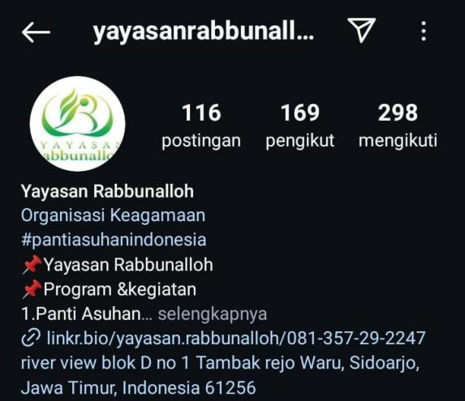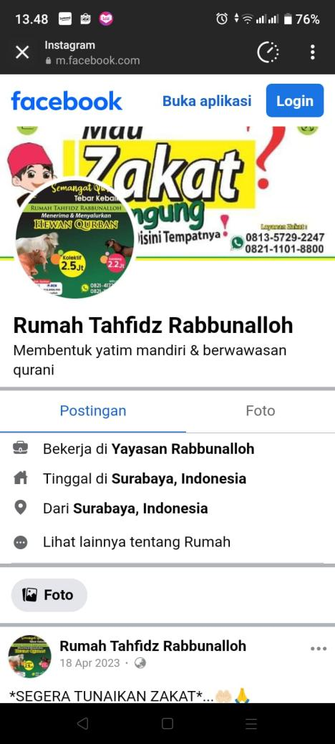

**G. Foundation's Efforts to Evaluate Donors to Determine Their Needs and Expectations**

Then the Foundation always reminds donors to support each other. The Foundation also asks donors to provide the names of donors and their families who they wish to pray for. Apart from that, the Foundation also provides Islamic Content through social media Facebook and Instagram as part of the documentation and also as CR (Customer Reationship) in the form of implementing activities at the Foundation. This step can attract other donors or sympathizers. This documentation also plays a role in attracting interest and maintaining donor loyalty.

Figure 2 Rabbunallah Foundation's Compensation Program for Widows, Elderly and Orphans

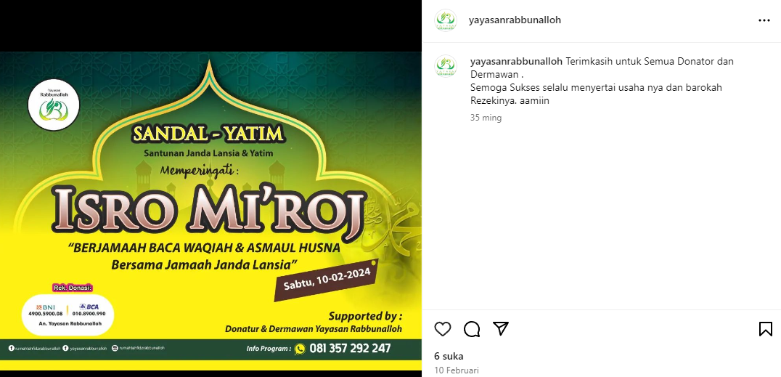

**H. Foundation Strategy Developing a Long Term Plan to Increase the Number of Loyal Donors**

The Foundation has formulated a strategy to achieve two main goals: retaining and attracting new donors. To retain donors, the Foundation's focus is on building good communication and holding mutual support activities, especially at important moments such as the fasting month or big holidays at the company, where the Foundation tries to provide support at company events such as Yamaha or Sotabas, while hoping that they also suports the Foundation's activities. In a long-term effort to increase the number of donors, the Foundation assigns several officers to search for and establish relationships with potential new donors through direct visits, disseminating information in various cities, as well as approaching relevant companies, so that the donation network can be expanded and support for activities is sustainable. Foundation guaranteed.

This activity can be done once a week, once a month, or at certain events. Foundation officers were tasked with finding donors, and in this process, it was realized that this approach was two-way. The goal is not to sell products, but rather to offer useful social and marketing programs. With a religious approach, the Foundation tries to build strong relationships, starting with debriefing for officers so that they understand the essence of the Foundation's offer. The products offered are not cosmetics or food, but social and religious assistance, such as khataman or sholawatan, which prioritize spiritual and community values.

Figure 3 Forms of Loyalty of Rabbunallah Foundation Donors

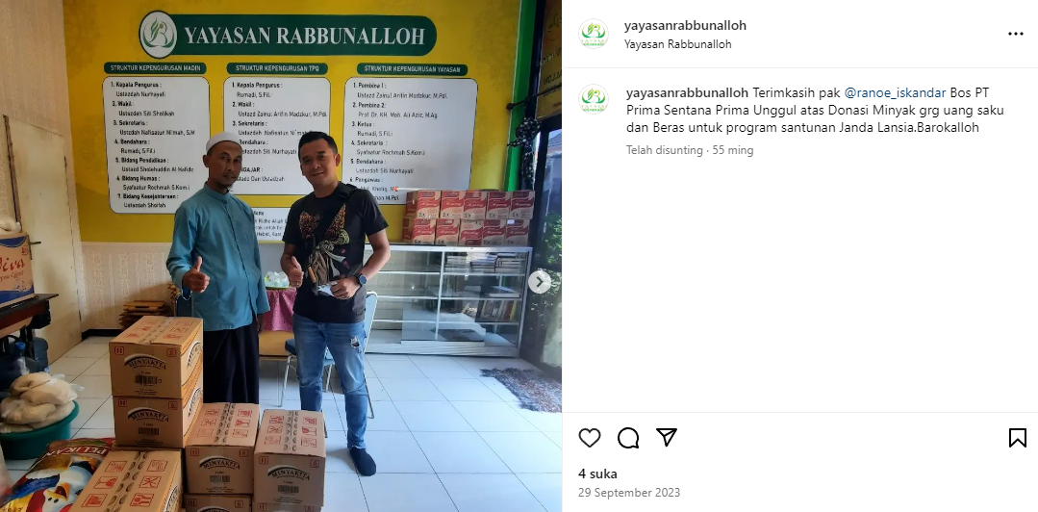

In the context of this scientific work, the Foundation realizes that the success rate in achieving this goal is approximately 50-50. However, the role of the Foundation as a social servant is considered very important. Society not only needs economic prosperity, but also peace of mind and smooth running of religious activities. Therefore, the Foundation seeks to fill religious spaces that are often neglected amidst the busy world of economics and business. Through activities such as group prayers, the Foundation hopes to provide the spiritual support needed, so that people can feel a balance between the material and spiritual aspects of their lives.

**Table of Da'wah Strategies to Form Donor Loyalty**

|  |  |  |
| --- | --- | --- |
| No. | Da'wah Strategy to Form Donor Loyalty | Details |
| 1. | Establishing Good Communication | Give greetings, thanks, invite donors to various events, via WhatsApp and send sacrificial meat |
| 2. | Realizing the Economic Independence of Islamic Boarding Schools | Establishing canteens, food stalls, providing greetings, thanks, inviting donors to various events, via WA and sending sacrificial meat, fried rice and food stalls, soto abbas stalls, and renting empty land |
| 3. | Special Programs | Weekly recitations and shared prayers |
| 4. | Strategy to Maintain Loyalty | Distribute charity boxes in food stalls, coffee shops and homes, and distribute proposals to companies, PTs, CVs and parties. |
| 5. | Collaboration with entrepreneurs | Soto Abas stall, selling sacrificial animals, angkringan entrepreneur (Gunung Anyar area) |

**Conclusion**

The Pondok Tahfidz and Yatim Piatu Rabbunallah Surabaya Foundation has implemented various effective da'wah strategies in forming and maintaining donor loyalty. Through good communication, financial transparency, and personal attention, the foundation has succeeded in creating strong emotional connections with donors. Apart from that, the foundation also carries out business innovations to support economic independence, and consistently involves donors in various spiritual and social activities, which further strengthens ties and trust. All of these efforts contribute significantly to maintaining donor loyalty and increasing long-term support.

In addition to communication and transparency strategies, the Pondok Tahfidz and Yatim Piatu Rabbunallah Surabaya Foundation also applies a deep religious approach, such as joint prayer programs and special donations, to strengthen relationships with donors. These programs are not only intended as a form of appreciation for donors, but also provide space for donors to participate spiritually, strengthen shared values and support each other.

With this approach, the foundation succeeded in attracting and maintaining donor loyalty through a strong emotional and spiritual approach, which is the main foundation for long-term relationships with donors.

**References**

Chozin, Muhammad Ali. 2015. “Strategi Dakwah Salafi Di Indonesia.” *Jurnal Dakwah* 14(1):1–25. doi: 10.14421/jd.2013.14101.

Darsono Basu Swastha, Licen Indahwati; Dharmmesta. 2005. “KONTRIBUSI INVOLVEMENT DAN TRUST IN A BRAND DALAM MEMBANGUN LOYALITAS PELANGGAN.” *Journal of Indonesian Economy and Business* (Vol 20, No 3 (2005): July).

Erica, Denny, and Harun Al Rasyid. 2018. “Pengaruh Kualitas Layanan Dan Pemanfaatan Teknologi Informasi Terhadap Kepuasan Dan Loyalitas Pelanggan Jasa Transportasi Online Di Jakarta.” *Jurnal Ekonomi Dan Manajemen Akademik Bina Sarana Infromatika* 16(2):168–76.

Fahmi, Redista Adytya. 2016. “Penerapan Laporan Keuangan Pada Yayasan Panti Asuhan Yatim Piatu Dan Fakir Miskin Daarul Aytam Situbondo.” *S1 Universitas Muhammadiyah Jember* (45).

Fitriani, Anisa Yuli Rahma, and Laili Etika Rahmawati. 2020. “Analisis Kesalahan Penggunaan Tanda Baca Dan Huruf Miring Dalam Teks Berita Online Detiknews Dan Tribunnews.” *BAHASTRA* 40(1):10. doi: 10.26555/bahastra.v40i1.14695.

Handriana, Tanti. 2016. “Bentuk Loyalitas Donatur Pada Organisasi Filantropi.” *Jurnal Manajemen Teori Dan Terapan| Journal of Theory and Applied Management* 8(3):165–82. doi: 10.20473/jmtt.v8i3.2734.

Ilham, Moh, Imam Mukhlis, Novie Andriani, and Zakariya Muhamad. 2023. “Peran Kepemimpinan Kewirausahaan Kyai Dalam Kemandirian Ekonomi Pesantren.” *Jurnal of Islamic Manajemen* 3(2).

Maulidiyah, Nikmahtul, and Darno Darno. 2020. “Pengaruh Transparansi Dan Akuntabilitas Laporan Keuangan Terhadap Kepercayaan Donatur Di Yayasan Sosial Keagamaan.” *Neraca : Jurnal Akuntansi Terapan* 1(1):1–8. doi: 10.31334/neraca.v1i1.642.

Mayanda, Luvy, Hari Wijayanto, and Istiqlaliyah Muflikhati. 2018. “Factors Affecting Satisfaction and Loyalty of Online Taxi-Motor Partners.” *Indonesian Journal of Business and Entrepreneurship* 4(2):207–16. doi: 10.17358/ijbe.4.2.207.

Noyan, Fatma, and Gulhayat Golbasi Simsek. 2011. “Structural Determinants of Customer Satisfaction in Loyalty Models: Turkish Retail Supermarkets.” *Procedia - Social and Behavioral Sciences* 30:2134–38. doi: 10.1016/j.sbspro.2011.10.414.

Nurasia. 2023. “Strategi Dakwah Yayasan Darussalam Pinrang Dalam Pembinaan Muallaf Di Kampung Muallaf Darussalam Kelurahan Betteng Kecamatan Lembang Kabupaten Pinrang.” *Jurnal A-Darah* 11(1):136.

Safitri, Azizah Yulia, Berto Mulia Wibawa, and Dewie Saktia Ardiantono. 2019. “Pengukuran Kepuasan Dan Loyalitas Konsumen Terhadap Kualitas Layanan Taksi Resmi Bandar Udara Juanda Surabaya.” *Jurnal Sains Dan Seni ITS* 8(1). doi: 10.12962/j23373520.v8i1.41573.

Sambodo Rio Sasongko. 2021. “Faktor-Faktor Kepuasan Pelanggan Dan Loyalitas Pelanggan (Literature Review Manajemen Pemasaran).” *Jurnal Ilmu Manajemen Terapan* 3(1):104–14. doi: 10.31933/jimt.v3i1.707.