Design of Thermoelectric Peltier Effect Demonstrator using Modul TEC-12706 and TEG-SP1848
Fachrizal Rian Pratama^{1*}, Vierta Saraswati²
¹ Physics Department, Universitas Islam Negeri Walisongo Semarang, Indonesia
² Graduate School of Natural Science and Technology, Kanazawa University, Japan

A R T I C L E I N F O  Article history:  Submitted : August 4th, 2022  Revised : November 19th, 2022  Accepted : January 21st, 2023  Keywords:  Demostrator; Module; Tec; Teg; Thermoelectric; Peltier |  | A B S T R A C T  Thermoelectric devices have several advantages, including no moving parts, noise-free operation, long service life, zero-emission, and precise temperature control. Therefore, they have been widely used in solid-state cooling, heating, and power generation. The study of the Thermoelectric Peltier Effect Demonstrator can provide insights into the potential applications and benefits of thermoelectric devices. This research aims to investigate the Thermoelectric Peltier Effect Demonstrator and its applications in solid-state cooling and heating. Specifically, the study aims to examine the Peltier effect generated by applying an electric current to the TEC-12706 and TEG-SP1848 modules connected to a heatsink and placed in a container filled with water. The research methodology involves conducting experiments using the Thermoelectric Peltier Effect Demonstrator. The modules are connected to the heatsink and placed in a water-filled container, and an electric current is applied to generate the Peltier effect. The temperature changes on both sides of the modules and the amount of heat transfer are measured and recorded. The results of the experiments show that the Thermoelectric Peltier Effect Demonstrator can effectively generate the Peltier effect and produce temperature differences between the two sides of the modules. The amount of heat transfer can also be controlled by adjusting the electric current. These findings demonstrate the potential applications of thermoelectric devices in solid-state cooling and heating, as well as their ability to provide more precise temperature control compared to conventional compressors.
Copyright (c) 2023 Physics Education Research Journal

Introduction
Even though thermoelectric (TE) phenomena were identified over 150 years ago, thermoelectric devices (TE modules) have only recently been commercially viable. The action of heating or cooling at the junctions of two different conductors exposed to the current was named in honor of Jean Peltier (1785–1845), a French watchmaker who discovered it in 1834. When a current flows across the contacts of two dissimilar conductors in a circuit, a temperature difference between them is seen. Thermoelectricity is based on this briefly mentioned phenomenon, which is used actively in the so-called thermoelectric cooling modules shown in Figure 1 (Gromov, 1962; Tritt, 2002).
The urgency of research on the design of the Thermoelectric Peltier Effect Demonstrator using the TEC-12706 and TEG-SP1848 modules are driven by the need for more sustainable and efficient cooling and heating solutions. Traditional cooling and heating systems that rely on compressors and refrigerants have several drawbacks, such as high energy consumption, greenhouse gas emissions, and maintenance costs. In comparison to conventional compressor cooling, TECs do not require Freon. These considerations provide TEC with a significant advantage over conventional compressors (P. Zhang et al., 2021).
No moving parts, noise-free, long service life, zero-emission, and precise temperature control are some advantages of thermoelectric devices (Hong et al., 2018). As a result, thermoelectric materials and devices have been used in solid-state cooling, heating, and power generation. In terms of heating and cooling, thermoelectric devices (TEDs) can be used as thermoelectric coolers (TECs), which use direct current (DC) to reduce one side's temperature while increasing the other's (Zhao & Tan, 2014). TECs can be switched between cooling and heating modes by changing the current direction (Sharma et al., 2014).
Figure 1
Schematic thermoelectric cooling modules (Gromov, 1962).
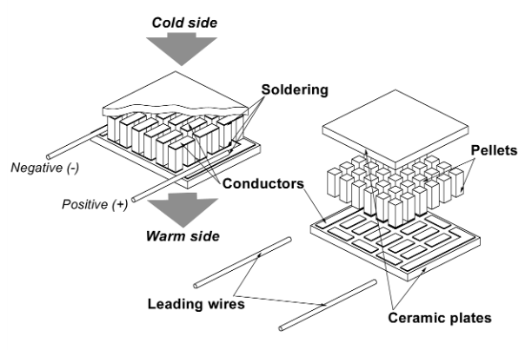
In the thermoelectric phenomenon, we recognize several effects, namely the first Seebeck effect. The Seebeck effect is the ability to create electricity by converting the ΔT between the two sides of a thermoelectric material, whereas the Peltier effect is the heat transfer from the cold side to the hot side of a thermoelectric material driven by imposed electricity (Hong et al., 2018). The Thomson effect states that depending on the direction of the current and the material, the temperature differential between any two locations of a current-carrying conductor causes heat to be absorbed or expelled (Lee, 2013). The dimensionless figure of merit, ZT, is commonly used to assess thermoelectric materials (Pei et al., 2020), and it is stated as Equation 1.
$ZT=\frac{σα^{2}}{κ}T$ (1)
Where α stands for Seebeck coefficient, σ for electrical conductivity, $κ$ for thermal conductivity, and T is the average temperature of the hot side T_{h} and cold side T_{c}, as shown in the following Equation 2 (Goldsmid, 2016).
$T=\frac{T_{h}T_{c}}{2}$ (2)
A popular representation of the Peltier coefficient can be seen in Equation 3.
P = $α T$ (3)
The Peltier coefficient, P, is determined by the nature of the contacting materials as well as the contact temperature (Gromov, 1962).
Thermoelectric materials are categorized into three categories: one-dimensional (1D), two-dimensional (2D), and three-dimensional (3D). Because semiconductors have better thermoelectric characteristics than metallic materials, 3D materials are mostly bulk semiconductor materials (Pei et al., 2020). The majority of traditional thermoelectric bulk materials are inorganic compounds, with Bi2Te3 being the first to be created (Pei et al., 2020; Soleimani et al., 2020).
The TEC-12706 and TEG-SP1848 modules are selected for the design of the Thermoelectric Peltier Effect Demonstrator based on their strengths and weaknesses. The TEC-12706 module is widely used in thermoelectric coolers and has a high cooling capacity, while the TEG-SP1848 module is commonly used in thermoelectric power generation and has high power output (Gürbüz et al., 2022). Furthermore, both modules have different material compositions and thermoelectric properties, which can provide insights into the optimal design and performance of thermoelectric devices (Z. Zhang et al., 2020). However, the modules also have limitations, such as low efficiency and high cost, which need to be addressed in the design of the Thermoelectric Peltier Effect Demonstrator (Zhao & Tan, 2014). Single, low-cost thermoelectric modules are the TEC-12706 and TEG-SP1848. The module can be used as an electric generator, or it can be utilized to convert electrical energy into heat or cool (Tian et al., 2021). Different TEC modules, such as the TEC-12704, TEC-12705, and TEC-12710, can cool to temperatures of 9°C, 10°C, and 11°C, respectively. The voltage and contact of the ceramic plate terminals are responsible for the TEC's cooling and heating (Saket Kumar, Ashutosh Gupta, Gaurav Yadav, 2015). The TEC-12706 and SP1848 parameters utilized in this work are listed in Table 1 (Hebei I.T. (Shanghai) Co., 2010; Zairi, 1994).
Based on this, the TEC-12706 and TEG-SP1848 modules were chosen for this study because they have good ZT values, are made of non-toxic materials, and are cost-effective (Wirth et al., 2020).

Table 1
Thermoelectric module specification.
Model | TEC-12706 | TEG-SP1848
Dimension (mm) | 40 × 40 × 3.6 | 40 × 40 × 3.4
Internal resistance (Ω) | 1.98 | 2.10
Single weight (g) | 23 | 25
Max Operating Temperature (°C) | 138 | 150
V_{max} (Volt) | 16.4 | 6.8
I_{max} (Ampere) | 6.40 | 9.24

Methods
The design of the Thermoelectric Peltier Effect Demonstrator is shown in Figures 2, Figure 3, and Figure 4. The TEC-12706 and TEG-SP1848 modules are each connected to a heatsink (radiator) which functions as a stabilizer on the hot side so that the conduction phenomenon in the ceramic module can be reduced.
Figure 2
Flowchart of the Thermoelectric Peltier Effect Demonstrator
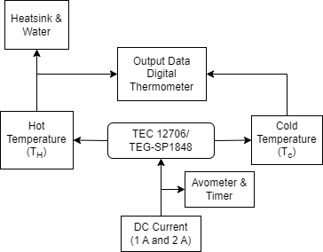

Figure 3
TEC12706 and TEG-SP1848 module
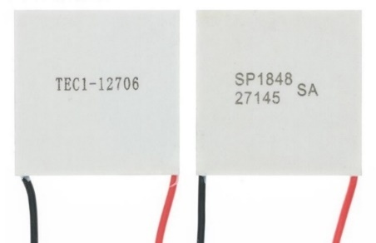
TEC-12706 and TEG-SP1848 modules are connected to heatsinks (radiators) as they help to stabilize the temperature on the hot side and reduce conduction phenomena in the ceramic modules. The use of a display can further strengthen the design by allowing for real-time monitoring and control of the temperature. The display can also provide a user-friendly interface to adjust the current and voltage input to the modules for optimal performance. Overall, this design helps to improve the efficiency and effectiveness of the thermoelectric Peltier effect demonstrator using the TEC-12706 and TEG-SP1848 modules.
Figure 4
Installation of thermoelectric module Peltier effect demonstrator.
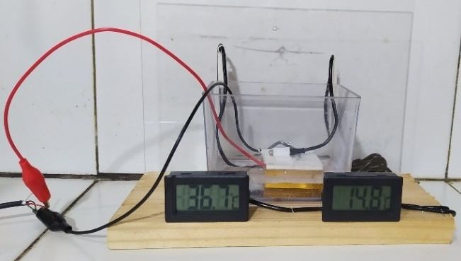
The module is connected by a special hot adhesive to the heatsink, and placed in a container filled with water with a volume level sufficient to fill the heatsink. The demonstrator tool is designed with occupational health and safety in mind in the laboratory (Wirth et al., 2020) so that some variable limits are set as shown in Table 2, which were obtained from the datasheet and initial testing of the device.
Table 2
The variable of Operational Procedures
Model | TEC-12706 | TEG-SP1848
Voltage (volt) | 5 | 5
Current (Ampere) | 1-2 | 1-2
During the thermoelectric experiment, the Peltier effect demonstrator alternated for each of these modules. The container is filled with enough water to fill the volume limited to the heatsink, then for 15 minutes the temperature change every minute is measured using an NTC digital thermometer (10K/3435) as shown in Figure 3. The electric current is varied, value are one ampere and two amperes with a voltage is five volts.

Result and Discussions
The Peltier effect can be generated from this experiment by applying an electric current to the module. At the same electrical voltage, the Thermoelectric Peltier Effect Demonstrator is placed and the temperature changes are observed using an NTC temperature sensor. The decrease and increase in temperature were observed at intervals of every minute up to 15 minutes, with an electric current of one ampere and two amperes as shown in Table 3 and Table 4.
Table 3
Peltier effect experimental data for TEG-SP1848.
Time (min) | 1 Ampere |  |  | 2 Ampere
 | T_{h_ 1} | T_{c_1} | T₁ | T_{h_2} | T_{c_2} | T₂
0  1  2  3  4  5  6  7  8  9  10  11  12  13  14  15 | 28,5  31,6  32,6  33,3  33,9  34,5  35,1  35,7  36,3  36,6  37,2  37,6  38  38,4  38,7  39,1 | 28,1  17,7  13,7  13,7  13,6  13,6  13,5  13,5  13,5  13,4  13,4  13,3  13,2  13,3  13,2  13,2 | 0,4  13,9  18,9  19,6  20,3  20,9  21,6  22,2  22,8  23,2  23,8  24,3  24,8  25,1  25,5  25,9 | 27,1  31,9  32,9  33,8  34,6  35,2  35,9  36,6  37,2  37,9  38,5  38,9  39,5  39,9  40,5  40,9 | 27,1  14,5  11,9  11,9  11,8  11,8  11,8  11,7  11,7  11,6  11,6  11,5  11,5  11,5  11,4  11,5 | 0  17,4  21  21,9  22,8  23,4  24,1  24,9  25,5  26,3  26,9  27,4  28  28,4  29,1  29,4

Table 4
Peltier effect experimental data for TEC-12706.
Time (min) | 1 Ampere |  |  | 2 Ampere
 | T_{h_ 1} | T_{c_1} | T₁ | T_{h_2} | T_{c_2} | T₂
0  1  2  3  4  5  6  7  8  9  10  11  12  13  14  15 | 27,9  30,3  31,6  32,6  33,5  34,3  35  35,8  36,6  37,3  37,9  38,4  39  39,6  40,1  40,6 | 27,9  19,8  14  12,7  12,7  12,6  12,6  12,6  12,5  12,5  12,4  12,3  12,4  12,4  12,3  12,3 | 0  10,5  17,6  19,9  20,8  21,7  22,4  23,2  24,1  24,8  25,5  26,1  26,6  27,2  27,8  28,3 | 28,5  32,6  33,7  34,4  35,6  36,3  37,1  37,8  38,6  39,1  39,8  40,5  40,9  41,6  41,9  42,4 | 28,5  14  11,1  11  10,9  10,9  10,9  10,8  10,8  10,8  10,7  10,7  10,6  10,5  10,6  10,5 | 0  18,6  22,6  23,4  24,7  25,4  26,2  27  27,8  28,3  29,1  29,8  30,3  31,1  31,3  31,9
Based on the data table, different currents produce different T values. The lowest temperature that can be achieved by the TEG-SP1848 module from this experiment is 11.4ºC at 2 Ampere current and the TEC-12706 module produces the lowest temperature at 10.5ºC at 2 Ampere current.
Recent research has shown that the performance of thermoelectric devices can be significantly improved by optimizing the design of the device, the materials used, and the operating conditions. For example, a study (Gökçek & Şahin, 2017) investigated the effect of the number of thermoelectric modules on the performance of a thermoelectric refrigerator and found that increasing the number of modules improved the cooling efficiency.
The data provided in this study shows that the TEC-12706 module was able to achieve a lower temperature compared to the TEG-SP1848 module, with the lowest temperature of 10.5°C at 2 Ampere current. This result is consistent with previous research that has shown that thermoelectric modules made of bismuth telluride materials, such as the TEC-12706 module, have a higher thermoelectric figure of merit (ZT) compared to modules made of other materials such as silicon germanium, which is used in the TEC-12706 module. A higher ZT value indicates better thermoelectric performance and efficiency (Bell, 2008).
This research implies that the TEC-12706 module may be more suitable for applications that require lower temperatures, such as refrigeration systems. However, it is important to note that the efficiency of the modules may vary depending on other factors such as the heat sink and the environmental conditions, and further experimentation and analysis may be required to fully understand the performance of these modules.
Next, the researcher also hopes that this can calculate the Peltier coefficient. It is still necessary to design the Seebeck effect experiment with the same module so that the Peltier coefficient can then be calculated.

Conclusions
The utilization of thermoelectric technology, among others, converts electrical energy into heat and cold. This Thermoelectric Peltier Effect Demonstrator can be used directly to observe this phenomenon. Using the TEC-12706 Module produces 10.5ºC at 2 Ampere current and the TEG-SP1848 module produces the lowest temperature at 11.4ºC at 2 Ampere current. Further developments can be used as refrigerants with precise temperature control compared to conventional compressors.

Acknowledgments
Finally, the authors (F.R.P. and V.S.) would like to thank the research program of the Department of Physics, Faculty of Science and Technology, Universitas Islam Negeri Walisongo Semarang, Indonesia as well as a research collaboration with the Graduate School of Natural Science and Technology, Kanazawa University, Japan.

References
Bell, L. E. (2008). Cooling, Heating, Generating Heat with and Recovering Waste Thermoelectric. Science, 321(5895), 1457–1461.
Gökçek, M., & Şahin, F. (2017). Experimental performance investigation of mini channel water cooled-thermoelectric refrigerator. Case Studies in Thermal Engineering, 10(February), 54–62. https://doi.org/10.1016/j.csite.2017.03.004
Goldsmid, H. J. (2016). Optimisation and selection of semiconductor thermoelements. In Springer Series in Materials Science (Vol. 121). https://doi.org/10.1007/978-3-662-49256-7_4
Gromov, G. (1962). Thermoelectric Cooling Modules. American Journal of Physics, 30(9), vii–vii. https://doi.org/10.1119/1.1942168
Gürbüz, H., Akçay, H., & Topalcı, Ü. (2022). Experimental investigation of a novel thermoelectric generator design for exhaust waste heat recovery in a gas-fueled SI engine. Applied Thermal Engineering, 216(August), 119122. https://doi.org/10.1016/j.applthermaleng.2022.119122
Hebei I.T. (Shanghai) Co., L. (2010). Performance Specifications of TEC1-12706. Application Note, 2–4. www.hebeiltd.com.cn
Hong, M., Chen, Z. G., & Zou, J. (2018). Fundamental and progress of Bi2Te3-based thermoelectric materials. Chinese Physics B, 27(4). https://doi.org/10.1088/1674-1056/27/4/048403
Lee, H. S. (2013). The Thomson effect and the ideal equation on thermoelectric coolers. Energy, 56, 61–69. https://doi.org/10.1016/j.energy.2013.04.049
Pei, J., Cai, B., Zhuang, H. L., & Li, J. F. (2020). Bi2Te3-based applied thermoelectric materials: Research advances and new challenges. National Science Review, 7(12), 1856–1858. https://doi.org/10.1093/nsr/nwaa259
Saket Kumar, Ashutosh Gupta, Gaurav Yadav, H. P. S. (2015). Peltier Module for Refrigeration and Heating using Embedded System. International Conference on Recent Developments in Control, 3, 2-1-2–1. https://doi.org/10.1201/9781420037043
Sharma, S., Dwivedi, V. K., & Pandit, S. N. (2014). A review of thermoelectric devices for cooling applications. International Journal of Green Energy, 11(9), 899–909. https://doi.org/10.1080/15435075.2013.829778
Soleimani, Z., Zoras, S., Ceranic, B., Shahzad, S., & Cui, Y. (2020). A review on recent developments of thermoelectric materials for room-temperature applications. Sustainable Energy Technologies and Assessments, 37(December 2019), 100604. https://doi.org/10.1016/j.seta.2019.100604
Tian, M. W., Aldawi, F., Anqi, A. E., Moria, H., Dizaji, H. S., & Wae-hayee, M. (2021). Cost-effective and performance analysis of thermoelectricity as a building cooling system; experimental case study based on a single TEC-12706 commercial module. Case Studies in Thermal Engineering, 27(March), 101366. https://doi.org/10.1016/j.csite.2021.101366
Tritt, T. M. (2002). Thermoelectric Materials: Principles, Structure, Properties, and Applications. Encyclopedia of Materials: Science and Technology, 1–11. https://doi.org/10.1016/b0-08-043152-6/01822-2
Wirth, O., Foreman, A. M., Friedel, J. E., & Andrew, M. E. (2020). Two discrete choice experiments on laboratory safety decisions and practices. Journal of Safety Research, 75, 99–110. https://doi.org/10.1016/j.jsr.2020.08.005
Zairi, M. (1994). Marlow Industries Inc. Measuring Performance for Business Results, 242–246. https://doi.org/10.1007/978-94-011-1302-1_22
Zhang, P., Deng, B., Sun, W., Zheng, Z., & Liu, W. (2021). Fiber-based thermoelectric materials and devices for wearable electronics. Micromachines, 12(8), 1–15. https://doi.org/10.3390/mi12080869
Zhang, Z., Zhang, Y., Sui, X., Li, W., & Xu, D. (2020). Performance of thermoelectric power-generation system for sufficient recovery and reuse of heat accumulated at cold side of TEG with water-cooling energy exchange circuit. Energies, 13(21). https://doi.org/10.3390/en13215542
Zhao, D., & Tan, G. (2014). A review of thermoelectric cooling: Materials, modeling and applications. Applied Thermal Engineering, 66(1–2), 15–24. https://doi.org/10.1016/j.applthermaleng.2014.01.074

