COPYRIGHT TRANSFER AGREEMENT FORM

Name of Principal Authors : Toipah
Address of Principal Authors : Universitas Nahdlatul Ulama (UNUSIA), Jakarta
Tel/Fax : -
E-mail : toifah.faqoth@gmail.com
Author(s) Name : Toipah
Manuscript Title : ARCHITECTURE AND ORNAMENTS OF MOSQUES AND CALLIGRAPHY AS PART OF THE TREASURE ARTS AND CULTURES IN ARCHIPELAGO
Date Received : March 10, 2020

- I/We declare that the submitted paper is my original research work. I am submitting this manuscript for publication in Teosofia: Indonesian Journal of Islamic Mysticism. This manuscript has not been previously published and is not currently under review elsewhere.
- I/We reserve the following: (1) All proprietary rights other than copyright such as patent rights. (2) The right to use all or part of this article in future works of our own such as in books and lectures. Print or Type Name and Title of Author.

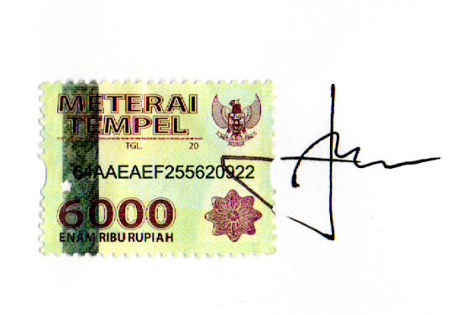
March 10, 2020
Signature

Toipah

