COPYRIGHT TRANSFER AGREEMENT FORM

Name of Principal Authors : Fadhlinaa Afiifatul Aarifah
Address of Principal Authors : UIN Sunan Kalijaga Yogyakarta
Tel/Fax : -
E-mail : fadhlinaa90@gmail.com
Author(s) Name : Fadhlinaa Afiifatul Aarifah, Muhammad Izzul Haq Zain
Manuscript Title : TOMBS OF IMOGIRI KINGS: COMMUNITY PERSPECTIVE IN THEIR RELATIONSHIP OF FUNCTIONAL THEORY
Date Received : March 10, 2020

- I/We declare that the submitted paper is my original research work. I am submitting this manuscript for publication in Teosofia: Indonesian Journal of Islamic Mysticism. This manuscript has not been previously published and is not currently under review elsewhere.
- I/We reserve the following: (1) All proprietary rights other than copyright such as patent rights. (2) The right to use all or part of this article in future works of our own such as in books and lectures. Print or Type Name and Title of Author.

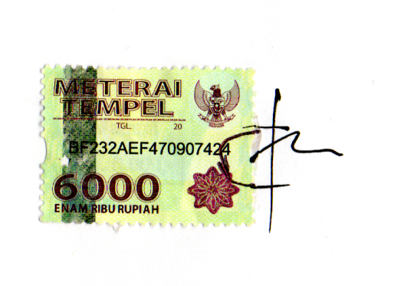
Date: March 10, 2020
Signature

Fadhlinaa Afiifatul Aarifah

