COPYRIGHT TRANSFER AGREEMENT FORM

Name of Principal Authors : Egi Tanadi Taufik
Address of Principal Authors : State Islamic University of Sunan Kalijaga Yogyakarta
Tel/Fax : -
E-mail : tanadiegi@gmail.com
Author(s) Name : Egi Tanadi Taufik, Siti Mufidatun Rofiah, Nazifatul Ummy Al Amin
Manuscript Title : QUESTIONING THE “KOREAN WAVED” HIJAB STYLE IN INDONESIA: A Contemporary Qur’anic Approach
Date Received : March 11, 2020

- I/We declare that the submitted paper is my original research work. I am submitting this manuscript for publication in Teosofia: Indonesian Journal of Islamic Mysticism. This manuscript has not been previously published and is not currently under review elsewhere.
- I/We reserve the following: (1) All proprietary rights other than copyright such as patent rights. (2) The right to use all or part of this article in future works of our own such as in books and lectures. Print or Type Name and Title of Author.

March 11, 2020
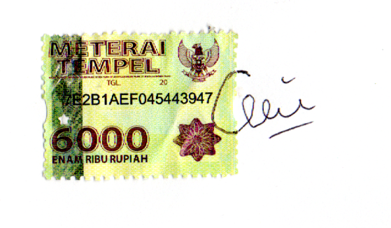
Signature

Egi Tanadi Taufik

