COPYRIGHT TRANSFER AGREEMENT FORM

Name of Principal Authors : Faizatun Khasanah
Address of Principal Authors : Universitas Terbuka, Tangerang Selatan
Tel/Fax : -
E-mail : Faizatunkhasanah1@gmail.com
Author(s) Name : Faizatun Khasanah
Manuscript Title : Islamic Spirit versus “Islam Syari’ah” (Contextually Thought of Gus Dur)
Date Received : 10 March 2020

- I/We declare that the submitted paper is my original research work. I am submitting this manuscript for publication in Teosofia: Indonesian Journal of Islamic Mysticism. This manuscript has not been previously published and is not currently under review elsewhere.
- I/We reserve the following: (1) All proprietary rights other than copyright such as patent rights. (2) The right to use all or part of this article in future works of our own such as in books and lectures. Print or Type Name and Title of Author.

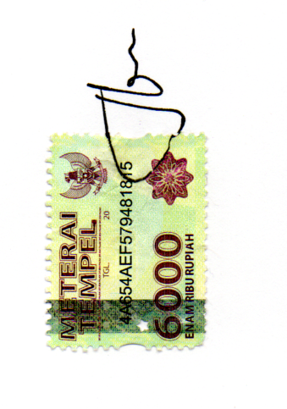
March 11, 2020
Signature

Faizatun Khasanah

