

**VISION: JOURNAL FOR LANGUAGE AND FOREIGN LANGUAGE LEARNING, 20xx**

**VOL.X, NO.x, x-xx**

http://dx.doi.org/10.21580/vjv7xxxxxx

**THE EFFECT OF PHOTOVOICE ON SPEAKING SKILL**

Rifqi Aziz Hidayat

Universitas Pancasakti Tegal

[Rifqiayat@gmail.com](mailto:Rifqiayat@gmail.com)

Rofiudin

Universitas Pancasakti Tegal

[Rofiudinza.ups@gmail.com](mailto:Rofiudinza.ups@gmail.com)

Endang Sulistianingsih

Universitas Pancasakti Tegal

[Endang.sulistia@gmail.com](mailto:Endang.sulistia@gmail.com)

**ABSTRACT**

Speaking is one of the ability that crucial in language learning and teaching method, as a result the goal of learning language is to be able to communicate with the target language. Good English ability especially speaking is needed by students to support them to speak up in many fields. But students still difficult in speaking, they can’t imagine what they want to speak, they afraid and unconfident if they try to speak English, therefore the teacher should provide the students probability to speak up and use the method that the students need. Photovoice is a suitable method that using camera for supporting the process of teaching-learning. The objective of the study is to identify the effect of using Photovoice on speaking skill. The writer used speaking test to complete and process the data. The participants of the study were the students of senior high school in Pemalang. The outcome of the study revealed that the students who taught using Photovoice had better ability in speaking than the students who are not taught using Photovoice. Through this method the students become interest and active during study, they seemed, enjoy and excited in exhibition or presentation.

**ARTICLE HISTORY**

Received

Accepted

**KEYWORDS**

Photovoice, Speaking, k-12, EFL learner.

**s**

**Introduction**

Speaking is one of our most complex cognitive, linguistics and motoric skills. Trough speaking, information can be given or received (Bailey & Nunan, 2005), Sometime when someone conveys the information to others h/she using gesture or body movement. Based on our observation, speaking ability for Senior High School are crucial matter since many students quiet and passive in the class, they still struggle with grammar and pronunciation. The other matter is sometimes their classmates laugh at them because they make mistakes in spelling. Those students then become less confident.

Some experts give a solution for developing students' speaking ability, they suggest various methods, and one of the methods is Photovoice. Wang & Burris (1997) define Photovoice as an activity which is involved photographic to introduce their society. In teaching and learning process, the students take some photos with their group, deciding together to describe each photo by using their own ideas in order to tell what happens in there. It makes easier for the students to combine photo that they have taken and then describe the photo in spoken form. In the study. Photovoice means the message contained in the photo is described by the students in spoken form. Because when the students try to speak up, they don’t imagine what they should to speak up, students confused arrange the words, and the students scary to make mistake, they less confident, then they did not fascinated by learning English particularly in speaking, therefore it becomes un solving for the students problems.

Many researchers that were conducted the research used Photovoice, Dwi et al (2018) they conducted research that focuses on speaking class with teachers’ questions and Photovoice, the result of their research is with teachers’ questions and Photovoice makes the students develop speaking fluency in speaking category. Putri (2018) applied Photovoice in teaching English guiding, and her stated that trough Photovoice made the speaking students improved. Furthermore, some researchers show that Photovoice effective in writing, because Photovoice helped students visually, focused, and development as effective writers (Zenkoev,Harmon. 2009). Then Dicicco (2014) the researched applied Photovoice as a reflection method to develop reading students’. The result of the research is in the Photovoice process helpful in reflections about reading and it eliminated opinion that reading is boring and difficult.

Through Photovoice, we can make the students develop in their skill especially in speaking, and can improve their confident to speak up in front of the class, and improve motivate in learning English. In this study, we used Photovoice to teaching speaking the students. This study had a research question: does Photovoice give a positive effect on the students' speaking skill?

Review of Related Theory

Ones express a feeling, opinion, and information. Speaking is producing sound to convey the meaning orally (Nunan, 2003). We as social human use speaking to make conversation with others, exchange the information, share the feeling, wish and etc. So speaking is very important because: (1) Language is a mechanism for communication. (2) For a smooth running of any system, if the speaker did not speak up smoothly, it makes miss understanding between communicator and communicant. (3) In order to become a good communicator one needs to be proficient in many skills such as listening, speaking, reading, and writing. (4) An effective speaker can get the attention of the audience and can share information clearly (Qureshi, 2012).

Syakur (1987) says that speaking is a complicated skill that has components in learning language, such as: (1) Grammar, it is required for the students to prepare an accurate sentence in oral communication or written. (2) Vocabulary is the essential access a language, it is the foundation the pyramid, and without words, there would be no language structures. (3) Pronunciation is the process for the students' to supply clearer language after they speak. (4) Fluency are often outlined because the ability to talk fluently and accurately.

In the activity of learning language, speaking has criteria that support in teaching, Brown (2003) states there are effective ways and criteria in the test. Those criteria are classified in term of many forms of speaking performance: (1) Imitative is activity when the student just repeat what the teacher says or what the communicator says, and the communicant just try to repeat in the spoken form, (2) Intensive is the activity when the teacher doesn't give an explanation of how to pronounce but ask them to read aloud text and check their communication, (3) Responsive, an activity when the students try to how to give a respond (feedback) or make conversation, (4) Interactive is similar to responsive, and the difference is the participant and topic, but in the process of interactive there are two or more student, (5) Extensive this is the last of oral production, in this process the student will try to produce a monologue text.

Teaching speaking seems so difficult and challenging for English teacher, many students have the same difficult to speak up their expressions, feelings, opinion, and wishes in front of the class. Because the student scares to makes a mistake, shy to speak up, and etc. Sometimes if the students come forward in the class and try to speak up, other students tries to laugh at their friends if making mistakes. Therefore the teacher must have many ways to make the students more confident or enjoyable in the teaching-learning process. The teacher should give the students chance to speak up or practice to come forward. To make the students enjoy to practice with their ideas.

There are many ways in teaching to make the students more enjoyable in the classroom activities, the teacher more creative to make the activities or learning process more comfortable, like the teacher using media to teaching the students, change the old method to new method that is easier to apply or practice in the classroom.

The methods that appropriate the students need, such as Photovoice. Caroline Wang and Mary Ann Burris that introduced the method in the 1990s, the method has activity that the people take a photo with photographic technique, then the photo can analysis and describe (Wang & Burris,1997). Then Strack, Magill, & McDonagh (2004) state the participants in the Photovoice process study how to use cameras and take object photo in society, then tell the strength and weakness. Palibroda, Krieg, Murdock, & Havelock (2009) stated that Photovoice is activity that uses photography in the group or individuals with the result of the photo, it makes their understanding of a community issue.

According (Velea & Alexandru, 2017) applying Photovoice have many benefits to apply in the teaching-learning process, such as: (1) Improve written and oral communication, (2) Develops teamwork skills, (3) Creates powerful visuals materials, (4) Stimulates creativity and spirit of initiative, (5) Improve self-

esteem, (6) Stimulating reflection on reality.

Photovoice also have limitations in teaching-learning process, according to (Velea & Alexandru, 2017) his mention that the limitation of Photovoice are: (1) The time needed is relatively long, needed time management. (2) Participants getting trouble to express their ideas about their photos. (3) An deeply analysis of the problem can also make negative feelings. (4) The students should be warned of this risk, damage, and losing camera. (5) The activities must be monitoring to know the progress of the students in the activity.

**Methodology**

The research used quantitative research. We used quantitative research because we wanted to find out about the effect of Photovoice on speaking skill. To know it, we must calculate the numeric data from the test given to the students after using Photovoice. In collecting data, we used a speaking test that included: Grammar, Vocabulary, Comprehension, Fluency, and Pronunciation. Then to make accurately took the result of data, we met face to face with students directly, and we used the recorder to re-listen the students’ voice one by one. The speaking test was explained the photo especially natural disaster, and the topics were determined by we, the topics were earthquake, flood, and rainbow. Then the students had 3 minutes to explain the photo. The population was also the sample; they were the students of senior high school in Pemalang. The total numbers of students were 60. The students were in the second grade when the writer has conducted the research.

The observation was conducted before the treatment. In this study, we used experimental research as a type of research, experimental research is a research method used to look for the effect of treatment. Generally, one or more variables are manipulated to determine their effect on the dependent variable. We conducted the research in two group design, in a different class, but in the same grade. We took the class with the total of the students were the same to collect the data. The first class that we selection as the experimental group that gave treatment used Photovoice method. And the second class as a control group, we used as the comparator.

In applying the Photovoice we taken from Photovoice path by Wang & Burris (1997), the steps begin Phase 1: introduced Photovoice, Phase 2: take photographs using camera, Phase 3: discussing the result of the Photograph, Phase 4: writing text, Phase 5: selection the photo, Phase 6: invite people to share in discussion, Phase 7: options to present an exhibit.

**Result**

We conducted the research in eight meetings in two classes as a sample. There was an Experimental group and Control group. In teaching Experimental group, we used Photovoice, and in the Control group, we did not use Photovoice. Describe the activity of research in Experimental group as below:

1. Treatment

The first meeting was conducted on Thursday, 21st of March 2019. We introduced the method, explained the concept of the method and benefits of this method, the students looked interested in the method, and we got full attention from the students. The second meeting was conducted on Monday, 25th of March 2019. We explained about explanation text, social function, and generic structure based on the example that we gave before. Then the students wrote the example of the text about a natural disaster that the writers wrote and explained in front of the class. The students understood directly because the English teacher explained before we came into this class, and we suggested to the students to read the text to know pronunciation students. Then the students couldn't read clearly, they struggled in pronunciation and fluency, they looked nervous.

The third meeting was conducted on Tuesday, 28th of March 2019. We gave the material like in the second meeting and told about the grammar of explanation text. We gave the text again, then the students read one by one like in the second meeting. The students read three sentences until one paragraph and we corrected their speaking. Then the students looked confident but still struggled in pronunciation and fluency.

The fourth meeting was conducted on Monday, 1st of April 2019. We repeated the material again like in the second, and third meeting to make sure the students understood about the material, and to make the students good in pronunciation. Then we suggested the students made a group consisted of 5 until 6 students. Every group must bring one handphone for taking photo. After that, the students went out of the class and take the photo around the school. But in taking photo the students faced difficulties. They were confused to take a photo, because the students did not pay attention if we gave instructions, and students were not cooperate well, even some students made a joke with the others.

The fifth meeting was conducted on Tuesday, 4th of April 2019. We suggested the students selected the photos that the students took before. And the students tried to write the text based on their photos. In these activities many students feel confused, what they should do first. Then we explained instructions to make easier and helped the students arranged the words.

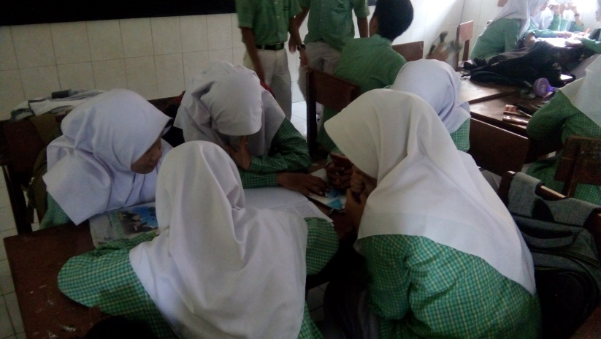

**Figure 1. The students work in group.**

In the work in group, the students stated that when we explained instructions such as 5W+1H questions. It is very effective, caused it guide the students easier arrange the words become paragraph. They could express their ideas with answering questions based on 5W+1H, such as:

* What do you see here?
* What happening here?
* Why does situation exist?
* Etc.

The sixth meeting was conducted on Tuesday, 11th of April 2019. The students continued to complete writing their text and make sure that they had a good preparation for presentation in front of the class in the next meeting.

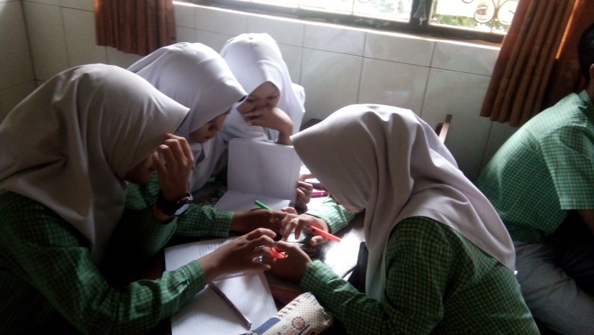

**Figure 2. The students work in group.**

Based on this figure above, we could see that the students very seriously to

finish their writing. They used handphone to help search the vocabulary that they wanted, then the other students tried to arrange word by word become sentences.

The seventh meeting was conducted on Monday, 15th of April 2019. We set up a display with an LCD projector to help the student presentation, and to make interested. Many photos were showed in front of class. Then the students saw their friends presentation in forward, explained the photos, students argued the photos, and exchanged information. In reality, the students felt confident to speak up in forward, although they still struggled in pronunciation, but all presentations were well done.

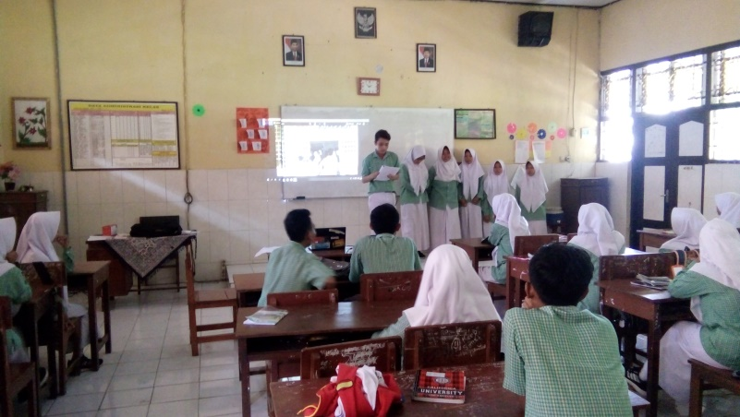

**Figure 3. Presentation.**

Based on the figure above, we could see that used Photovoice collaborate with LCD Projector could make the students interested, and felt enthusiastic. They could see many photos showed in forward, and also the students could give opinion based on the presentation their friends.

1. Result of Students’ Photographic

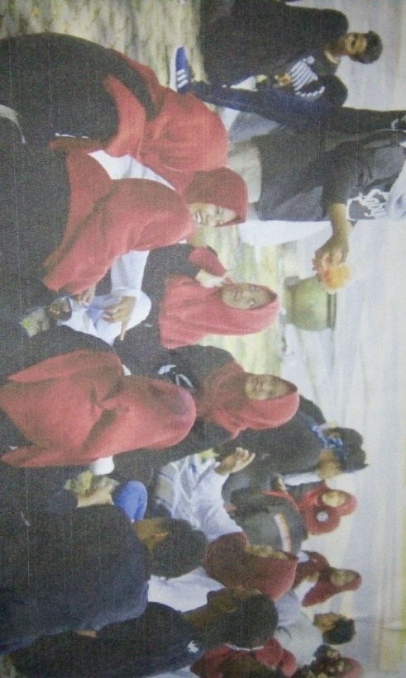

**Figure 4. Social Group**, by Nanda, Neysa, Putri, Refina, Ristiana, Risky.

Social groups are groups of people who have a shared awareness of membership and interact with each other. The purpose of make group is to sharing and getting information.

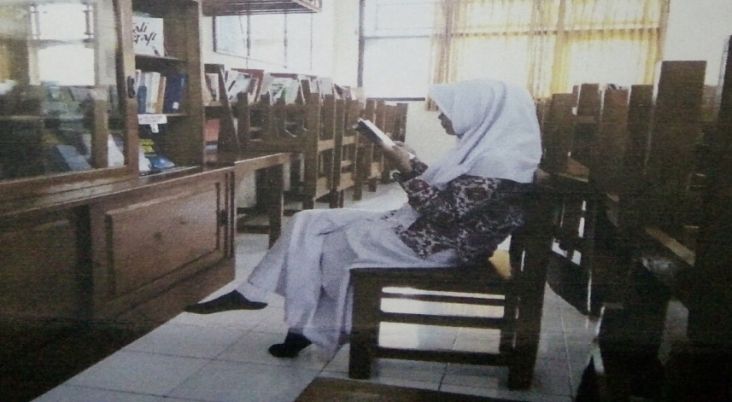

**Figure 5. Library** , by Ahmad, Dhea, Dwi, Mudia, Sus, Tegar.

The library is a place to read, add insight, increase knowledge and place to do exercise. The situation in the library is students who are reading or looking for answer through books in the lbrary, the library is very important place that must be have in every school, because the library becomes a place to find out many knowledge and sources about education.

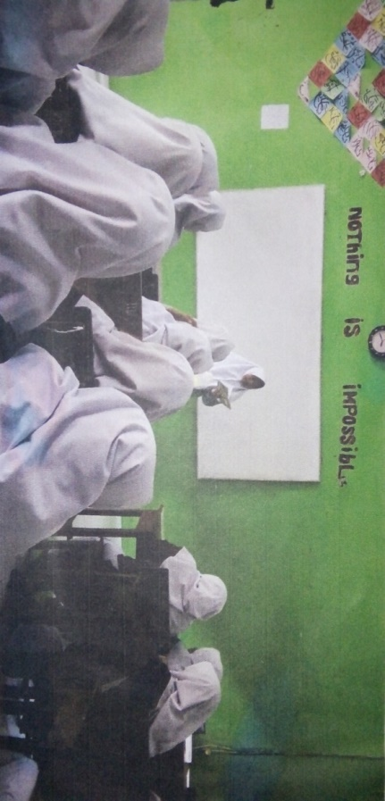

**Figure 6. Organization of Adolescent Mosque**, by Asti, Diah, Irna, Mila, Yusuf, Yoga.

Adolescent mosque is a gathering of mosque young men who carry out social religious activities, which is the organization in the state of senior high school in Pemalang, we called IRMA.

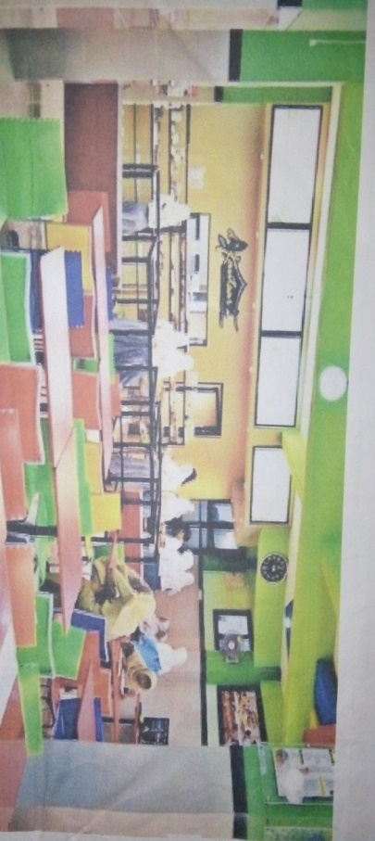

**Figure 7. Canteen**, by Hanif, Alhidayah, Indah, Muliya, May, khaonaeni.

Cantteen is a room in a public building that can be used by students to eat, not only for eat, canteen also the place that the students gathering and sharing information with others.

After conducting the treatment, we gave speaking test to the experimental and control group to find out the significant difference of implementing Photovoice in the research and to know about the effect of Photovoice on the students’ speaking skill.

Speaking test was conducted on Tuesday, 18th of April 2019. In the process of collected the data, we met face to face with the students directly, and we used the recorder to re-listen the students’ voice one by one. The speaking test explained the photo especially natural disaster, with the topics that determined. The topics were earthquake, flood, and rainbow. Then the students have 3 minutes to explain the photo.

The results of speaking Test of Experimental Group and Control Group to see whether or not gives positive effect to the students, we needs to calculate the result of mean, median, modus, the standard deviation of variant between experimental group and control group. They are compared to get further data. Before analyzing the data, there was the result of calculated independent sample t-test, as follows

**Table1. Independent sample t-test**

|  |  |  |  |  |  |  |  |  |  |  |
| --- | --- | --- | --- | --- | --- | --- | --- | --- | --- | --- |
|  | | | | | | | | | | |
|  | | Levene's Test for Equality of Variances | | t-test for Equality of Means | | | | | | |
| F | Sig. | T | Df | Sig. (2-tailed) | Mean Difference | Std. Error Difference | 95% Confidence Interval of the Difference | |
| Lower | Upper |
| Score speaking test | Equal variances assumed | 2.921 | .093 | 2.093 | 58 | .041 | 4.267 | 2.038 | .187 | 8.346 |
| Equal variances not assumed |  |  | 2.093 | 54.849 | .041 | 4.267 | 2.038 | .182 | 8.351 |

From the computation data above, the result of computing t-test on the data above showed 2.093 with Df 30+30-2 = 58, it is obtained t-table was 1.672. So it concluded that t-value was higher than t-table (2.093>1.672), It means that used Photovoice gave positive effect on students speaking skill.

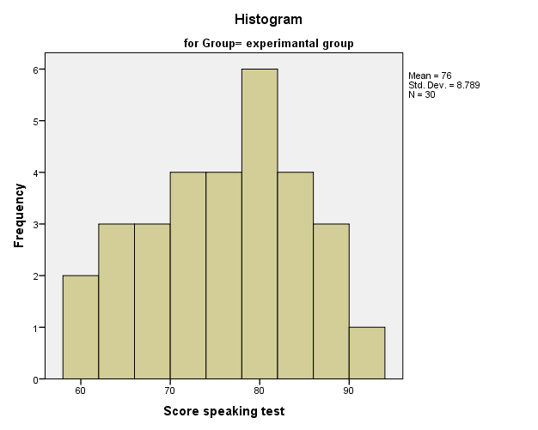

**Figure 8. Histogram the result of Experimental group**

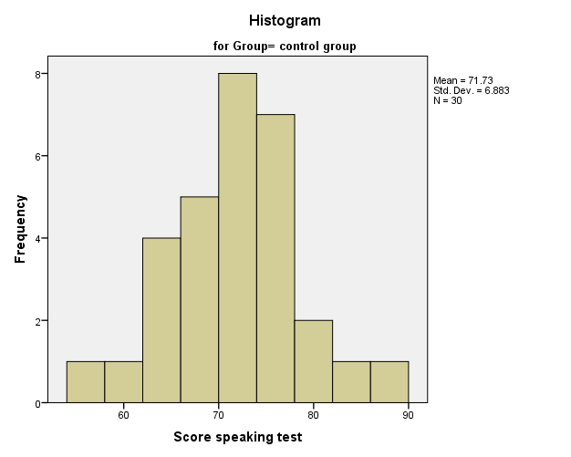

**Figure 9. Histogram the result of Control group**

Based on Figure.1 and figure.2, it concluded that the result of the speaking test experimental group had a better result than the speaking test of the control group, It means that the experimental group had better efforts in learning speaking by Photovoice. In the activity of the research in the experimental group, the students felt interested in teaching-learning process, because in the activity of teaching-learning, many activities that used by Photovoice, such as the students taking photos, group discussion, showed photos, an exhibition or presentation.

**Discussion**

Based on the result it revealed that photovoice is an effective method to improve student's speaking ability. Photovoice is an interesting method because there are a lot of things in the surroundings can be taken as a object of the photos that to be discussed. The students could choose their photos based on their interest. The photos could be used as a device for discussion. Various kinds of photos showed in the class could avoid students' boredom.

In this research, we used the Photovoice Path taken from (Wang & Burris,1997) to teach them, such as: In the Phase 1: introduced Photovoice, Phase 2: take photographs using camera, Phase 3: discuss Photograph, Phase 4: writing text, Phase 5: selection the photo, Phase 6: invite people to share in discussion, Phase 7: to present and exhibit. Unfortunately, in reality, the writers applied modification path. We modify some rule that appropriates in the situation of the students.

The modification path are: in the phase 2 until 3 the we gave the students materials about explanation text, to make sure that the students understood in the material, trained the students about spelling well by reading text one by one, and also make easier the students in process writing such as arrange the word become good sentences, because the students little confused in the activity, and still struggle in spelling pronunciation.

Afterwards we applied the activities of taking photo in the fourth phase. To make the students easier in this activity, the students just used camera from their handphone instead of using the digital camera. Then in the last phase, we used the LCD projector to attract the students’ attention.

Based on Velea & Alexandru (2017) applying Photovoice has many benefits like, improve written and oral communication, develops teamwork skills, creates powerful visuals materials, stimulates creativity and spirit of initiative, improve self-esteem, stimulating reflection on reality, but in the second grade students on senior high school in Pemalang we found the students improve their written and oral communication, develops teamwork, create powerful visuals materials, and improve self-esteem, stimulate reflection on reality and develop critical way of thinking. So the result of the research, we agreed with the statement above, and we added that Photovoice also develops a critical way of thinking.

Velea & Alexandru (2017) state that the limitations of Photovoice are: The time needed is relatively long, needed time management. Participants got a trouble to express their ideas about their photos. In deeply analysis of the problem can also make negative feelings. The students should be warned of this risk, damage, and losing their camera. The activities must be monitoring to know the progress and the result of the students.

We found that there are limitations from the implementation of Photovoice when conducted research at second grade students in Pemalang: there was a long time, or wasted time in the process of taking photo, because the students did not focus on what their need, the students sometimes made a joke with other students and it wasted time.

When the process of writing, there were the students still confused and may have trouble expressing their ideas, because they still joked with other friends, and we tried helped the students to solve the problems with gave instructions. In the process of taking photos the students just used the camera from their handphone, so it was very difficult to the students if they did not bring handphone.

We always monitored the progress, because in the method the students are involved in teaching-learning process. We just facilitated and guided the students if they got trouble or felt confused during the activity, and made sure that the activity in this method was appropriate with what we wanted.

This method is very effective if the teacher implements it in relax situation. Students can sit and look at the others students presentation in front of the class with various photos that are showed. It will be more exciting if it is supported with LCD projector, and the teacher can manage time of all activities well.

**Conclusion**

Photovice is not only effective for students but also makes the student interested and motivated in learning speaking. The students also able to express their creativity trough camera, they seem to enjoy the activity of taking photo. In addition they can sharpen their critical thinking and expressing ideas through presentation. Their ability in describing or visualizing the photo were revealed through presentation.

Eventhough the whole activities in Photovoice make the students’ speaking skill were improved but the time to take the photo is time consumption if the teacher can’t manage the time. The students sometimes get easily distracted since they like joking with their pairs while taking photo. Also most of the students feel uneasy when composing of the photo description. And this mean that the teacher should pay attention in guiding the lesson.

**References**

Bailey, K. M., & Nunan, D. (2005). Practical English language teaching: speaking.

Brown, A. (2003). Interviewer variation and the co-construction of speaking proficiency. *Language Testing*, *20*(1), 1–25.

Dicicco, M. (2014). Picturing the Reader : English Education Pre- service Teachers â€TM Beliefs About Reading Using Photovoice, (January).

Dwi, D., Megawati, A., Ari, D., Nurhayati, W., & Pangestu, B. S. (2018). Photovoice : Exploring the Role of Teacher ’ s Question for University Students ’ Fluency in Speaking Class, *2*(2017), 17–26.

Nunan, D. (2003). Second language teaching and learning . *Foreign Language Teaching and Research Press*.

Palibroda, B., Krieg, B., Murdock, L., & Havelock, J. (2009). A practical guide to photovoice: Sharing pictures, telling stories and changing communities. *Winnepeg, Manitoba: Prairie Women’s Health Centre of Excellence (PWHCE)*.

Putri, G. A. (2018). Photovoice Implementation in Teaching English Guiding at English Study Program College of Foreign Language (STIBA) Saraswati Denpasar. *English Focus: Journal of English Language Education*, *1*(2), 86–95.

Qureshi, I. A. (2012). THE IMPORTANCE OF SPEAKING SKILLS FOR, (5655), 1–10.

Strack, R. W., Magill, C., & McDonagh, K. (2004). Engaging youth through photovoice. *Health Promotion Practice*, *5*(1), 49–58.

Syakur, M. (1987). Language testing. Surakarta: UNS Press.

Velea, S., & Alexandru, M. (2017). PhotoVoice_Connector, 1–17. Retrieved from [https://www.erasmusplus.ro/library/files/Ghiduri COnnector 2017/PhotoVoice_Connector 2017.pdf](https://www.erasmusplus.ro/library/files/Ghiduri%20COnnector%202017/PhotoVoice_Connector%202017.pdf)

Wang, C., & Burris, M. A. (1997). Photovoice: Concept, methodology, and use for participatory needs assessment. *Health Education & Behavior*, *24*(3), 369–387.

Zenkoev, Harmon (2009). Picturing a Writing Process : Photovoice and Teaching Writing to Urban Youth, *52*(April), 575–584. https://doi.org/10.1598/JA