SUPPORTING INFORMATION
Molecular docking of Acetylacetone-Based Oxindole against indoleamine 2,3-dioxygenase: Study of Energy Minimization

Figure 1. The structure of ligand 1 and L-1MT

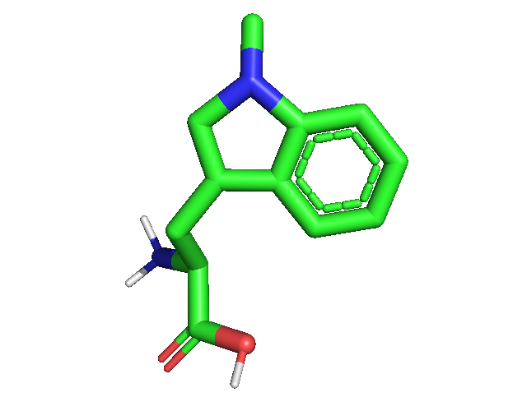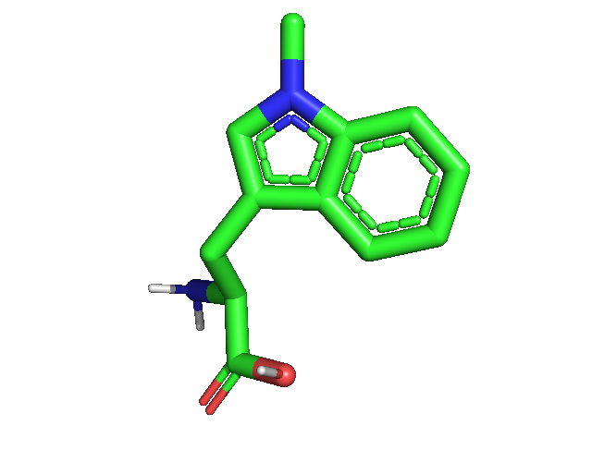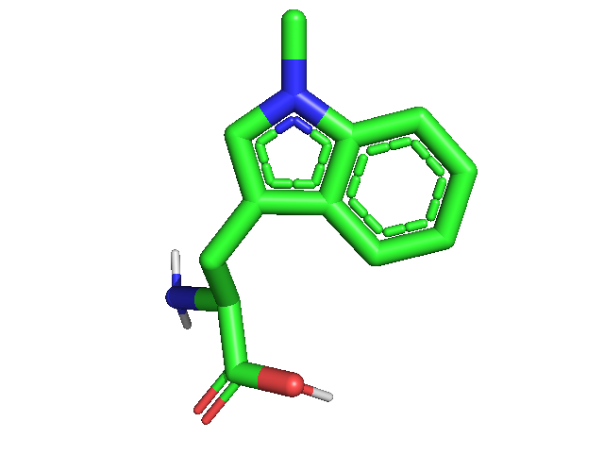
L-1MTa

E = 73.90 Kkal/mol

L-1MTb

E = 53.88 Kkal/mol

E = 54.94 Kkal/mol

1a

E = 16.64 Kkal/mol

1b

E = 21.86 Kkal/mol

1c

E = 23.52 Kkal/mol

L-1MTc

Figure 2. The structure conformation of ligand 1 and L-1MT resulting from minimization using (a) MarvinSketch, (b) Open Babel, and (c) without minimization

(A)
(B)
Figure 3. Representation of co-crystallized (A) and redocked PIM (B) to 2D0T

Table 1. Binding energy of ligand 1 and L-1MT
Ligand | (Pose) Binding Affinity (Kcal/mol)
1a | (1) -0.4; (2) 2.4; (3) 2.4
1b | (1) 0.2; (2) 2.4
1c | (1) 0.3; (2) 2.3; (3) 2.7; (4) 2.9
L-1MTa | (1) -2.8; (2) -2.1; (3) -1.3; (4) -0.9; (5) -0.7; (6) -0.1
L-1MTb | (1) -1.0; (2) -0.9; (3) -0.7; (4) -0.6; (5) -0.2; (6) -0.2; (7) 0.6
L-1MTc | (1) -1.1; (2) -1.1; (3) -0.8; (4) -0.8; (5) -0.2; (6) 1.2; (7) 1.5; (8) 1.8

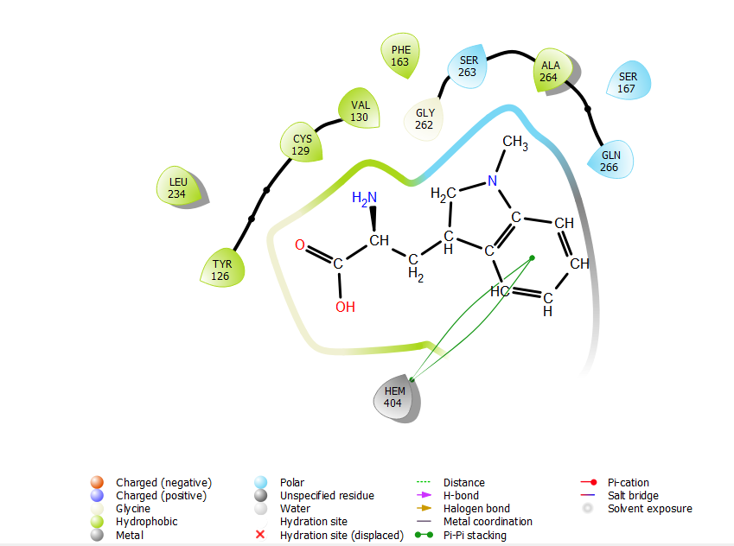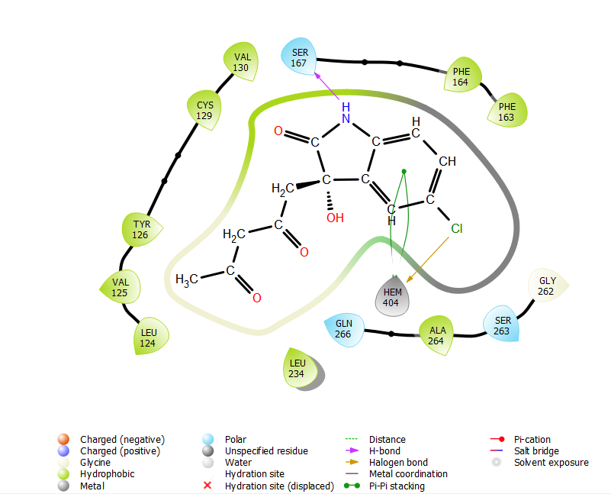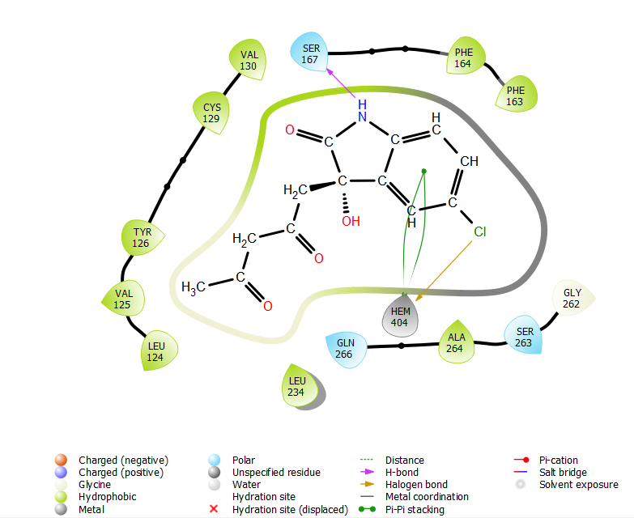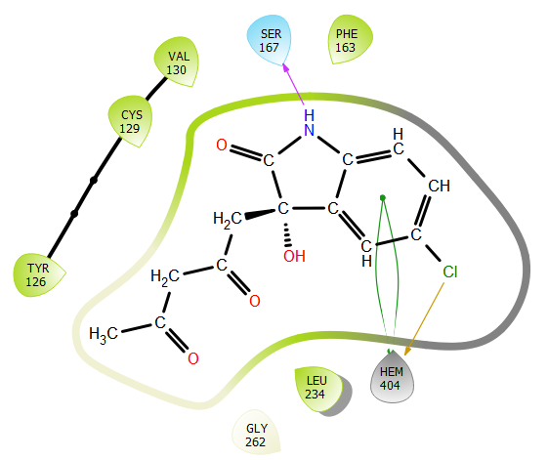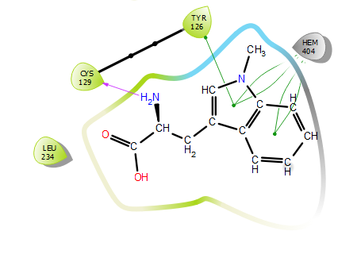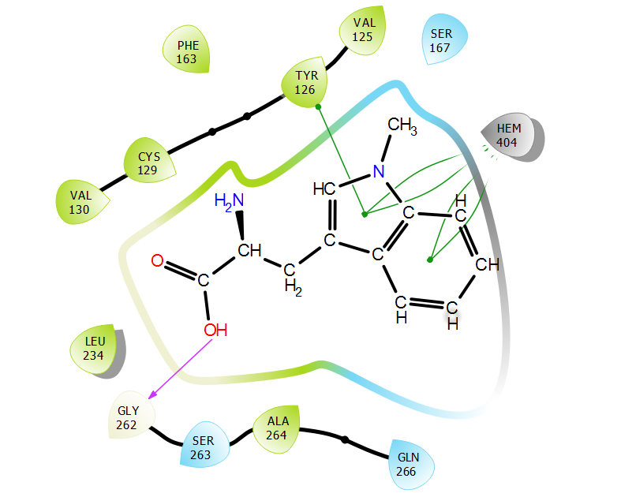
L-1MTa
1a
1b
1c
L-1MTb
L-1MTc
Figure 4. Interactions of ligand 1 and L-1MT with 2D0T

