CHARACTERIZATION OF EGGSHELLS NANOCATALYST, SYNTHESIZED BY BOTTOM-UP TECHNOLOGY

Jeremiah O. Masime*¹, Eric Ogur ²,
Betty Mbatia ³, Austin O. Aluoch ¹ and Geoffrey Otieno ¹

The Technical University of Kenya¹ (masimejo@yahoo.com)
Department of Chemical Sciences and Technology¹,
Department of Mechanical and Mechatronic Engineering ²,
P.O. Box 52428 - 00200. Nairobi- Kenya
United States International University-Africa
School of Pharmacy and Health Sciences ³
P.O. Box 67881-00200, Nairobi Kenya
Abstract
The bottom-up technique was used to prepare the nanocatalyst from waste egg shells for the production of yellow oleander biodiesel. In this study, the physicochemical and catalytic properties of the nanocatalysts were investigated using: X-ray fluorescence spectrometry (XRF), transmission electron microscopy (TEM), the Barrett-Joyner-Halenda (BJH) model to quantify the pore structure of the samples, and Brunauer-Emmett-Teller (BET) to calculate the exact surface area were the techniques used. The TG/DTG analysis was used to study the decomposition of the synthesized nanocatalyst into calcium oxide and CO₂. The results of the EDX, XRF, and FTIR analysis showed that the synthesized nanocatalyst was majorly CaO. At 90.46 ± 1.73%, this was higher than the control for incinerated eggshells. The particle sizes from the XRD analysis were ≈13.86 ± 0.987 nm. From TEM and SEM images the particles were spherical in shape with particle sizes ranging from ≈ 7 to 41 nm. BET analysis results indicated that the nanocatalyst was mesoporous with surface area, average pore diameter, and pore volume was; 5.54 ± 0.48 m²/g, 18.57 ± 2.16 nm, and ≈ 0.016 ± 0.0 – 0.017 ± 0.0 cm³/g, respectively. The surface area to volume ratios were 3.27 ± 10⁸ m⁻¹, 2.52 ± 10⁸, and 1.95 ± 10⁸ m⁻¹, respectively. Incinerated eggshells highest followed the synthesized nanocatalyst and CaO, respectively. The synthesized eggshell nanocatalyst was found to be a potential nanocatalyst.

Keywords: Synthesized nanocatalyst, Waste eggshells-, physicochemical properties

Introduction
The growing world population has led to the depletion of fossil resources, which has led to a growing demand for fuel from developing countries (Santos et al., 2019). Biodiesel has since been chosen as one of the alternative fuels and is renewable, biodegradable, non-toxic and environmentally friendly (Mavridis, 2013; Jeevanandam et al., 2018). Biodiesel was chosen as one of the alternative fuels because it is renewable, biodegradable, non-toxic and environmentally friendly (Tan et al., 2015). Homogeneous catalysts have been used in the production of biodiesel. However, they have some disadvantages as they are corrosive, toxic, hygroscopic and easily soluble in reaction mixtures. They also cause poor product quality. These catalysts can cause saponification reactions that require large amounts of fresh water for washing (Arévalo et al., 2016). This can lead to a reduction in biodiesel yield and also generates a large amount of waste water (Diamantopoulos, 2015). Homogeneous catalysts can also cause inevitable corrosion of the reactor. These result in the overall production costs being high (Hossain et al., 2019).
The heterogeneous catalyst is environmentally friendly, inexpensive, readily available, biodegradable, environmentally safe, reusable, and more competitive in biodiesel production. Most heterogeneous catalysts used in biodiesel production are alkali or alkaline earth metal oxides (Solomon et al., 2018). They have a large reaction surface and molecules attach themselves to the surface of the catalyst. Separating the biodiesel and cleaning it is quite easy and reduces the amount of waste water (Degirmenbasi et al., 2015). Production costs can also be reduced by reusing the catalyst (Tan et al., 2015; Galchar, 2017).
Solid wastes from mussel shells and chicken egg shells are useful in the preparation of heterogeneous catalysts. Eggshell CaO is a promising green catalyst in biodiesel production (Da Silva Castro et al., 2019). Among the various food wastes, eggshells have many bioactive compounds exhibiting high economic benefits (Birol, 2019). Internationally, about 250,000 tons of eggshell waste is released annually (Faridi and Arabhosseini, 2018). Waste egg shells are among useful agricultural biowaste materials that have the following properties; they are biodegradable, recyclable and biocompatible (Pedavoah et al., 2018). Egg shells are mainly composed of calcium carbonate (CaCO3), which accounts for about 93.6% by weight, followed by calcium triphosphate (0.8%), which accounts for about 10% of a hen's egg (Neunzehn, Szuwart and Wiesmann, 2015). The main component of eggshells is calcium carbonate, CaCO₃, which converts to calcium oxide and carbon dioxide when burned. It is therefore an excellent biomass resource for green CaO (Tan et al., 2015). Green heterogeneous catalysts can be prepared from it (Faridi and Arabhosseini, 2018; Oulego et al., 2020). Nanocrystalline CaO has a specific surface area that is 1.54 times higher than commercially available calcium oxide (Bharti, Singh and Dey, 2019). It has a large specific surface area and high catalytic activities, making it an efficient catalyst for the production of biodiesel with high yields (Santos et al., 2019).
Researchers have studied the preparation of heterogeneous nanocatalysts using top-down or bottom-up techniques (Mohammadlou, Maghsoudi and Jafarizadeh-Malmiri, 2016). It controls the size, shape, composition, and architecture (Patra and Baek, 2014; Tandon, 2015; Khan, Saeed and Khan, 2017) In the bottom-up process, nanoparticles can be integrated using substances by assembling atoms into new nuclei, which evolve into a nanoscale particle. In the top-down method, nanoparticles are produced by crushing bulk material into fine particles (Shah et al., 2015). The bottom up is the cost effectiveness, scalability and generally controlled shape and size of the product. The selection of the respective method depends on the chemical composition and the desired properties of the nanoparticles (Awan et al., 2016). Recently, many researchers have switched from bottom-up synthesis techniques to utilizing nature-based biogenic materials to synthesize calcium carbonate nanoparticles, which is generally a top-down approach (Mohd Abd Ghafar, Hussein and Abu Bakar Zakaria, 2017). Our focus is on using a microemulsion to form calcium carbonate from eggshells and thermally decomposing the precipitate to form CaO nanocatalysts.
The synthesized eggshell nanocatalyst was characterized using different methods. Thermal analysis using differential thermal analysis (DTA); to measure the temperature difference, differential scanning calorimetry (DSC); for heat difference measurement and thermogravimetric analysis (TGA); measures, among other things, the change in mass (María Zambrano Arévalo et al., no date). X-ray diffraction analysis (XRD) was used for determination; Crystallinity, particle size, structure and lattice constants (Salame, Pawade and Bhanvase, 2018). X-ray fluorescence (XRF) analysis was also used to determine the chemical constituents of the generated nanoparticles, transmission electron microscopy was used to examine the crystalline properties of the catalyst, and catalytic properties were also analyzed using BET and BJH. FTIR spectroscopy was used to confirm the functional groups present in the synthesized catalyst.

Methodology
2.1. Materials
Waste egg shells were collected from the Kenya University of Technology cafeteria, washed with tap water until the albumen was completely removed, and dried in an oven at 100. Clean and dried eggshells were broken into small pieces and ground to a fine powder in a china mortar and stored in desiccators at room temperature. The resulting powder was burned in a furnace at a temperature of 1000°C for 3 hours. The generated CaO was stored in a desiccator container for later use (Sharma and Virk, 2009).

2.2. Chemicals and Instruments
All chemicals were of analytical grade (Merck, > 99% purity), Ammonium carbonate, iso-octane, cetyl trimethyl ammonium bromide (CTAB), methanol n-butanol, n-butanol, and chloroform were purchased from Kobian Chemicals. These chemicals were used directly without any purification, and distilled water was also used in all experiments.

2.3. Synthesis of eggshells nanoparticles
The eggshells nanocatalyst was prepared using a modified Sharma and Virk procedure reported elsewhere (Sharma and Virk, 2009). The product from the microemulsion was incinerated at 1000°C separately for 3 hrs. Details are given in the next section.

2.4. Calcination process
After the synthesis of the nanocatalyst, as explained in 2.3. A laboratory muffle furnace (Linn High Thermo GmbH, LM 412.27, model DC021032 with a thermocouple type K, NiCr-Ni) was used to incinerate the samples at 1000 °C. Eggshell nanoparticles samples were incinerated in an alumina crucible at a heating rate of 10 °C/min for 3hours to ensure complete the decomposition of CaCO₃ in the eggshell to CaO, which is catalyst rich (Ayodeji et al., 2018). Calcination temperature and time are critical factors in the developing the active sites, structural and catalytic properties. (Banković-Ilić et al., 2017). The eggshells decomposed into the respective oxides; CaCO_{3 (s)} → CaO _{(s)} + CO_{2 (g)} and MgCO_{3 (s)} → MgO _{(s)} + CO_{2 (g)} (Correia et al., 2017).

2.4.I. Catalysts Characterization
The nanocatalyst was characterized by the thermal stability and weight loss of the burned eggshells, and the synthesized eggshell samples were evaluated by thermogravimetric analysis (TGA) (Mettler Toledo) in a temperature range of 30 °C to 1000 °C at a heating rate of 10 °C min1 under a nitrogen atmosphere and the samples were held at 100°C for 10 minutes. Powder X-ray diffraction (XRD), X-ray fluorescence (XRF), transmission electron microscopy (TEM), and Brunauer-Emmer-Teller (BET) surface. Bunaciu et al.,(2015), explained the characterization of catalysts using the X-ray diffraction (XRD) method (Bunaciu, Udriştioiu and Aboul-Enein, 2015). Scherrer’s equation was applied to calculate the CaO particle average crystallite size. The International Center for Diffraction Data Standard (JCPDS) was used to compare with those of the patterns to identify the crystalline phases (Rao et al., 2017). Chemical compositions were obtained using X-ray fluorescence (XRF) (Philips, model PW 2400) at a tube current of 1000 A with an acquisition lifetime of 30 s (Ayodeji et al., 2018). Samples for analysis using Transmission electron microscopy (TEM) were prepared by placing a drop of the nanoparticle suspension on a copper grid (Ted Pella, CA) and air drying it overnight. Imaging was done using a JEOL 123 microscope operated at 80 kV (JEOL, USA) (Zhou, Bennett and Keller, 2012; Michen et al., 2015). BET (Brunauer, Emmett, and Teller) surface area of the catalyst samples were obtained in a Micromeritics TriStar 3000 Surface Area and Porosity System analyzer by the low-temperature N₂ adsorption method. Prior to analysis, the samples were degassed at 120°C overnight (12 h) under a continuous flow of N₂ gas to remove the adsorbed contaminants and moisture from the surface and pores of the material (Chinthakuntla et al., 2014; Kumar, Some and Kiriamiti, 2014). ASTM C1274-12 Standard Test Method for Advanced Ceramic Specific Surface Area by Physical Adsorption was used (Brame and Griggs, 2016). The functional groups of incinerated eggshells and the synthesized eggshells catalyst samples were identified by Fourier transform infrared (FTIR) analyses using a (Nicolet Impact I-410, USA) at 400 - 4000 cm⁻¹ and the resolution was cm⁻¹.
Result and Discussion
3.1. Characterization of the nanocatalyst
3.1.1. TGA for incinerated eggshells and the synthesized eggshells nanocatalyst
The thermal properties were analyzed using thermogravimetric analysis. Figure 2 gives the results of the thermal analysis (TGA) of both the incinerated chicken eggshells and the synthesized eggshell nanocatalyst.

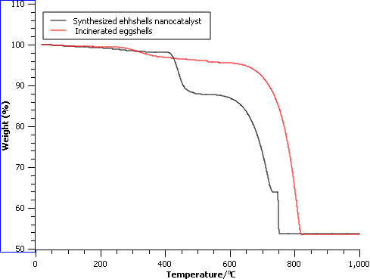
Figure 1: The TGA spectrogram for both incinerated chicken eggshells and the catalyst
When waste egg shells were incinerated at a temperature of 820°C, a total weight loss of 52% was recorded and CO2 was released into the environment. Three significant weight losses occurred between ≈200 and ≈900 °C upon thermal decomposition of the synthesized nanocatalysts. Jalu et al., (2021) studied the synthesis of calcium oxide nanoparticles from chicken egg shells and found a significant weight loss between ≈600 and 850 °C as CO₂ was released into the environment. First, there was a total weight loss of 45.62% based on the loss of volatiles such as water and organics. In the second phase, the mass loss was due to the release of CO₂ from the decomposition of CaCO₃. Ahmad et al., (2015) studied the thermal decomposition of waste egg shells to form calcium oxide catalysts. They observed two major weight losses. In the first stage, slight weight losses occurred at a temperature below 640°C. These were attributed to the loss of water molecules and organic compounds adsorbed on the material surface. In the second stage, there was a significant weight loss at 843 °C of 42.2% w/w. This was due to the thermal decomposition and conversion of the CaCO₃ phase to the CaO phase. Above this temperature, the weight of the sample remains constant. From the literature, the suitable temperature for the complete conversion of CaCO₃ to CaO is 900 °C.
3.1.2. TG/DTG for the synthesized nanocatalyst
DTG can be used to determine the rate of the thermal decomposition of a material. The DTG curve can be constructed from TGA analysis data as it is expressed as a percentage weight loss rate versus temperature or time (Widiarti et al., 2021). Figure 2 shows the results of the analysis.
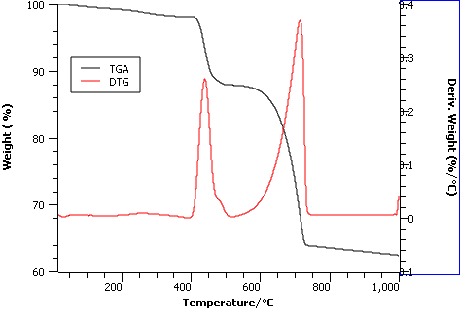
Figure 2: The TG/DTG spectrogram of synthesised eggshells nanocatalyst
When the decomposition temperature increased to about 200°C, a small weight loss of ≈ 2.55% occurred due to loss of moisture. The second weight loss of ≈ 10.07% w/w was due to the decomposition of CTAB. There was a significant weight loss of ≈ 25.12% in the temperature range from ≈ 512 °C to ≈ 1000 °C, which was attributed to a phase transformation from calcium carbonate (CaCO₃) to calcium oxide (CaO) accompanied by the loss of CO₂. The rapid weight loss and endothermic peaks at around ≈401°C to ≈512°C and ≈ 600°C to ≈750°C. These were due to phase transformations and thermal decomposition before 1000 °C, a satisfactory temperature for CaCO₃ decomposition. The slope of the curve increased sharply after 750°C and the curve was no longer horizontal. This temperature is also known as the thermal destruction temperature of the synthesized nanocatalyst and causes the catalyst structure to deteriorate. The destruction temperature is an important factor as it indicates the temperature range in which the material can be used without degrading and higher temperatures can change the material structure. The curve of the TGA diagrams was horizontal after the destruction temperature and the weight of the catalyst remained constant. Zaman et al., (2018) studied eggshell waste as a potential heterogeneous nanocatalyst for biodiesel production. They found that the TG/DTA curves of the nano CaO catalyst had two changes of mass losses. The first weight loss of ≈20.78% occurred between 450 and 500 °C due to the removal of Ca(OH)₂. The second weight-loss of ≈0.36%, from 650 to 900 °C calcination led to the decomposition of CaCO₃ to form CO₂ and CaO nanocatalyst.
3.1.3. TGA/DSC for the synthesized nanocatalyst
DSC is a thermoanalytical technique that analyzes material behavior by measuring heat flow in a sample as a function of temperature or time. DSC results could be used to determine the best temperature performance, Tg, and material melting or crystallization temperatures. The DSC was employed to detect phase transformation of the synthesized eggshells nanoparticles on heating (Shah et al., 2018). Figure 3 gives the Differential scanning calorimetry (DSC) results for the synthesized eggshell.
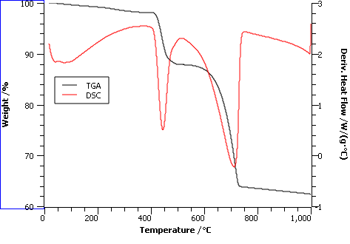
Figure 3 : The DSC spectrogram for synthesized eggshells nanocatalyst
The graph indicates the presence of three endothermic peaks. There is a minor weight loss up to ≈ 117.3 °C owing to moisture loss, and the decomposition of CTAB at temperatures above 200°C, leading to a total weight loss of 1.73 %. The second weight loss took place between ≈ 408.2 to 509 °C, it is the thermal decomposition of Ca(OH)₂. Nanocrystalline CaO is a significant phase because the final product of incineration eggshells and synthesized eggshells nanocatalyst is CaO. The mass loss between 600 and 867 °C is 47.2%, causing the decomposition of calcite, forming CaO, and releasing CO₂. Zaman et al., (2018) studied the DSC analysis of waste eggshells. They found that the uncalcined eggshell powder had three endothermic peaks. The first peak that appeared at ≈70.7 °C was due to removing physically adsorbed moisture. The peaks for the decomposition of organic substances like shell membranes and matrix protein were at ≈248.5 °C and ≈321.6 °C.
3.1.4. FTIR analysis of incinerated eggshells and synthesized catalyst
Figure 4 shows the FTIR spectra for incinerated eggshells.

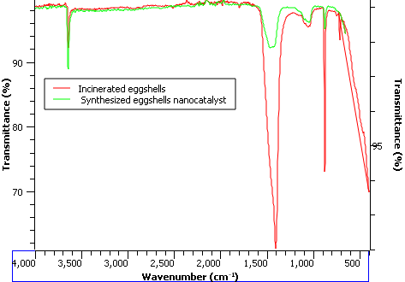

Figure 4: The FTIR spectrogram of incinerated eggshells and synthesized catalyst
The spectra showed a sharp and intense peak observed at 703.9 and ≈ 497 cm⁻¹ representing C-O stretching and bending modes of CaCO₃. The peak at 3649 cm⁻¹ represented the OH stretching mode during the adsorption of water by CaO. Other researchers have confirmed the findings. Angboriboon et al., (2012) studied the FTIR spectrum of calcium oxide from eggshells via calcination. They observed bands at 875.08 and 1423.55 cm⁻¹ and associated them with the vibrations of the carbonate groups. Peaks at ≈1418 and ≈1192 cm⁻¹ were ascribed to C-O bond stretching and bending modes of CaCO₃. Venkatesh et al., (2018) studied FTIR spectrum of CaO nanoparticles as a potential catalyst for biodiesel production. They depicted the characteristic absorption bands within the range 400–4000 cm⁻¹. Generally, all metal oxides exhibit FTIR peaks at lower wave numbers 400–800 cm⁻¹. The FTIR spectrum showed a strong peak at 430 cm⁻¹, which is the vibration of the CaO bond. Balaganesh et al., (2018) studied the FTIR spectrum of Porous Calcium Oxide Nanoparticles (CaO NPS) and obtained the same results. The carbonation of CaO nanoparticles was observed in the 1400 – 1500cm⁻¹ broadband. A narrowband around 750cm⁻¹ was due to the C–O bond and the characteristic vibration of Ca–O is intensive around band 600 cm⁻¹.
3.1.5. XRD Spectroscopy
XRD analysis was aimed at determining the chemical composition, physical properties and crystal structure of the nanocatalysts, as presented in Figure 5.

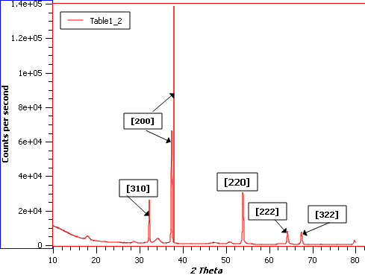

Figure 5 : XRD Spectra for incinerated eggshell
The spectrum of the incinerated eggshell calcined at 1000 °C had peaks at 2θ = 32.19°, 37.63°, 37.97°; 53.68° and 67.15°, respectively. These results confirmed that lime (CaO) is a significant component in the incinerated eggshell. The patterns were almost identical, and the major peak of the calcite phase (2θ = 29.4°) was not present in the XRD pattern of the synthesized eggshells nano CaO, implying that the CaCO₃ phase decomposed to form the CaO phase. Peng et al., (2018) studied the XRD spectrum of incinerated eggshells. They found that the spectrum for incinerated eggshell consisted of 2θ = 32.3°, 37.5°, 54.0°, 64.3°, and 67.6°, these corresponded to the spectrum of calcium oxide (CaO). Ayodeji et al. (2018) studied the XRD spectrum of calcined eggshell catalysts used for biodiesel production. They also observed peak characteristics of calcium oxide at 2θ = 29.0°, 32.5°, 47.5°, and 54.0°.
3.1.6. Particle size and crystal structure determination
The crystallite size of the catalysts samples was calculated using the Debye Scherer equation (Hargreaves, 2016).
The particle sizes () were calculated from X-ray diffraction data using the Scherrer formula:
,
where K is the Scherrer constant, = full width at half maximum of the reflection peak that has the same maximum intensity in the diffraction pattern, λ = wavelength of x-rays, and θ = diffraction angle of x-rays. The Scherrer constant K = 1.5406 Å in the formula accounts for the shape of the particle and is generally taken to have the value 0.94 for spherical particles.
3.1.7. Particle size distribution
The crystallite size of the catalysts samples was calculated using the Debye Scherer equation (Hargreaves, 2016). Tables 1 (a and b) give the particle size distribution.
Table 1a: Calculated grain sizes of the incinerated eggshell nanocatalyst using Scherrer’s formula (n = 10)
Diffraction angle (°) | d | a | Calculated particle sizes (nm) | Average particle sizes (nm)
18.00 | 4.92 | 8.53 | 18.24 | 23.1 2.53
18.01 | 4.92 | 8.52 | 19.19
23.01 | 3.86 | 8.63 | 18.71
28.72 | 3.11 | 8.78 | 22.86
29.37 | 3.04 | 8.59 | 32.39
29.42 | 3.03 | 9.09 | 33.54
34.08 | 2.49 | 8.29 | 29.24

Table 1 b: Calculated grain sizes of the synthesized eggshell using Scherrer’s formula (n = 6)
Diffraction angle (°) | d | a | Calculated particle sizes (nm) | Average particle sizes (nm)
32.17 | 2.78 | 4.82 | 17.28 | 13.860.99
37.51 | 2.40 | 4.79 | 15.33
37.80 | 2.38 | 4.76 | 15.24
54.01 | 1.70 | 4.80 | 12.25
64.66 | 1.44 | 4.99 | 11.56
67.62 | 1.39 | 4.99 | 11.50
37.51 | 2.40 | 4.79 | 15.33
Table 1 a and b, the average particle size for the synthesized eggshell nanocatalyst was 13.86 ± 0.987 nm. This value was lower than 23.1 ± 2.53 nm obtained from raw incinerated eggshells catalyst prepared without stabilizers. Fatimah et al., (2018) studied Scherrer's Equation to calculate the mean crystallite size of the calcium oxide nanoparticle from waste eggshell by the Sol-Gel Method. They found that the mean size of crystallite was ≈ 24.51 nm. (Venkatesh et al., 2018) determined the average crystalline size of the CaO NP using the Debye–Scherrer equation and found that the average crystalline size of the CaO NP to be ≈ 32 nm. The average lattice constant value of a = 8.6383, 4.9896, and 4.9611 Å, also confirmed that the sample predominantly has a Face Centered Cubic structure with high crystallinity (Hee et al., 2012). Figures 6 and 7 below gives the TEM images of the synthesized eggshell nanocatalyst.
3.1.8. Crystal Analysis Using TEM Images
Transmission electron microscopy images are useful in identifying the mesoporous structure of the CaCO₃ in eggshells structures. Figuren 6 (A & B) are TEM images of calcite crystals in eggshells nanocatalyst.

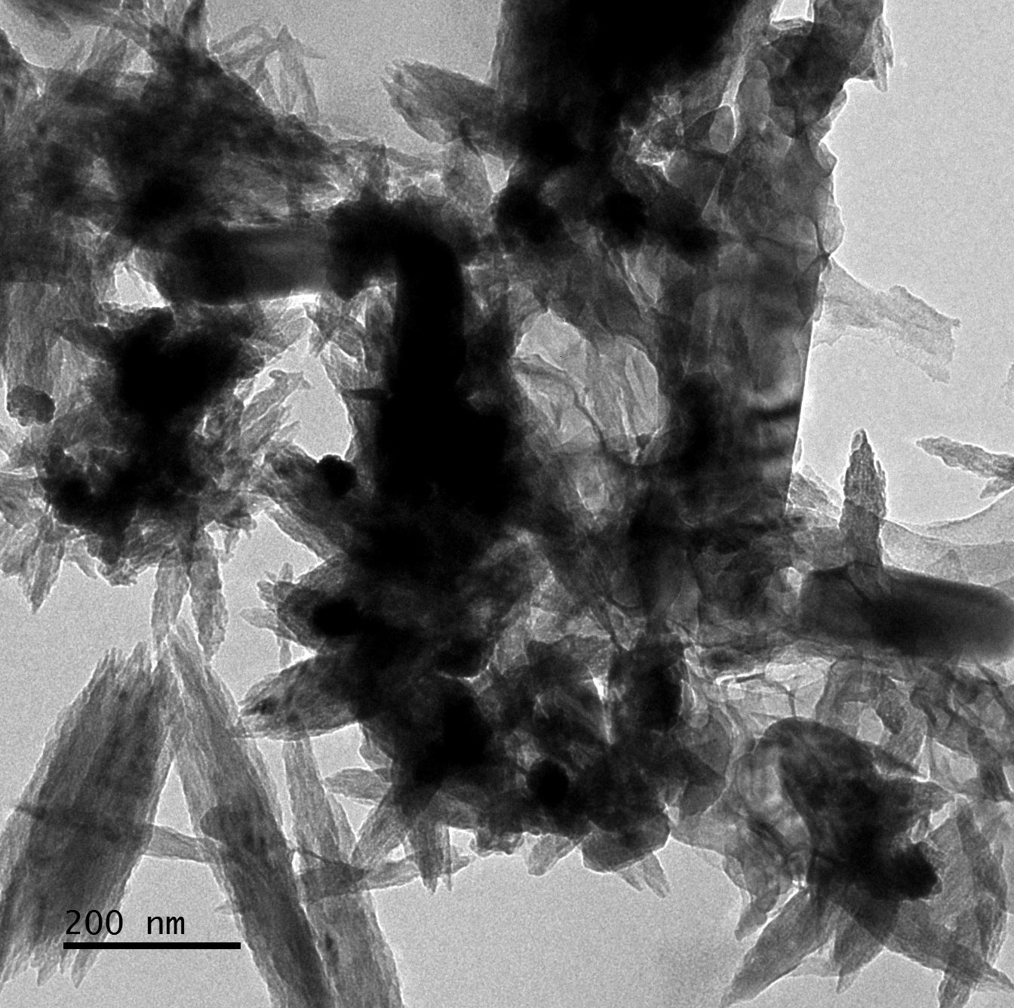
6 A-1
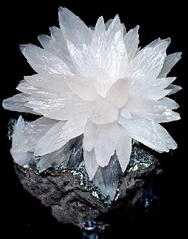
6 A-2
Figuren 6: A – 1: Calcite crystals in eggshells nanocatalyst, (A-2: Calcite I is trigonal-rhombohedral (a = 4.9896 Å))
Rodriguez-Navarro et al., (2009) studied the TEM images of the thermal decomposition to form CaO nanocrystals. They observed that at 850 °C, there was a complete conversion of CaCO₃ into CaO. Pseudomorphs showed a porous structure formed by oriented aggregates of larger (ca. 200–500 nm long and 30 nm in thickness) prismatic CaO crystals. The sizes of CaO nanocrystals observed with the TEM were consistent with XRD and SEM analysis.
Figure 6 (B1 & B2): Calcite crystals, the major constituent of eggshells nanocatalyst are the only stable calcium carbonate phase, stable at high temperatures; this is calcite III (A-1).
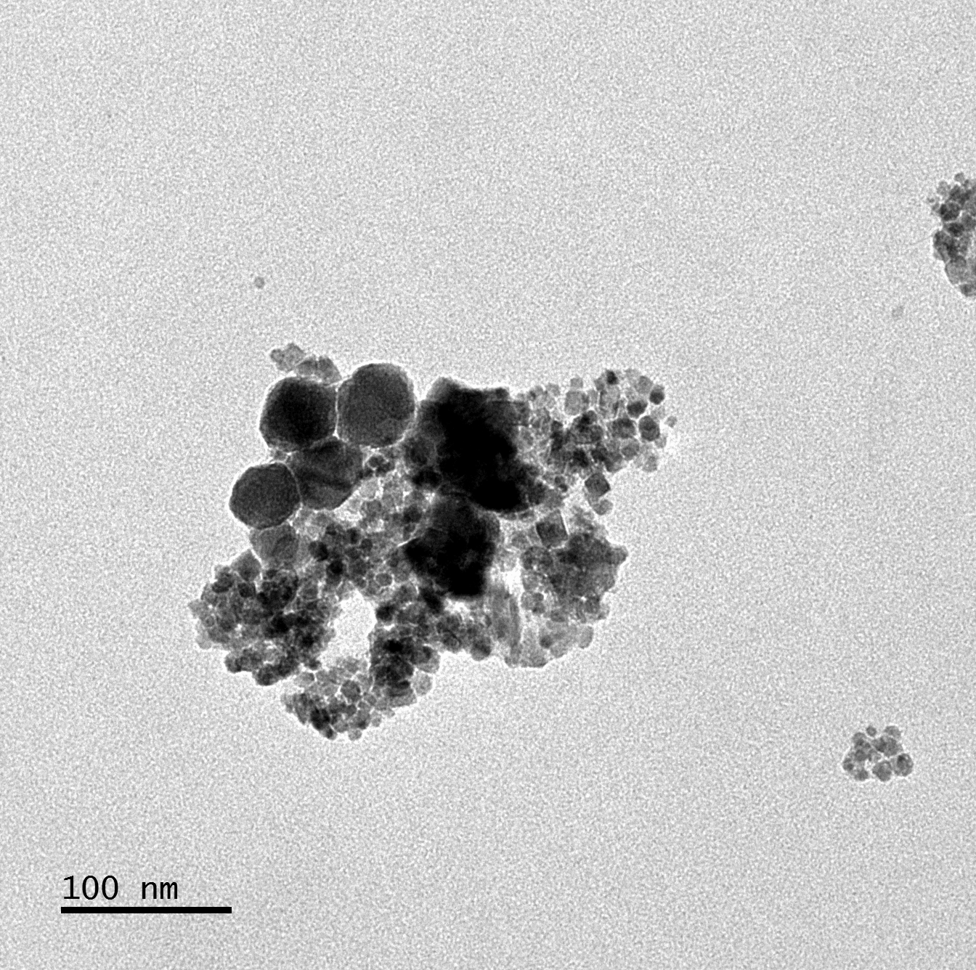
6 B-1
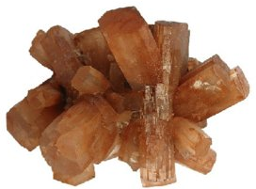
6 B2
Figuren 6: B-1: Calcite crystals in synthesized eggshells nanocatalyst (B-2: Aragonite orthorhombic (4.9611 Å)) (Hazen et al., 2013)
The Calcite crystals of the synthesized eggshells nanocatalyst. (B-2) is a typical Aragonite with an orthorhombic structure. Calcite and Aragonite are polymorphs of CaCO₃. Calcite is thermodynamically the most stable phase among these polymorphs, followed by aragonite. Vaterite is the least stable. Calcite I forms trigonal crystals, and aragonite forms orthorhombic crystals that appear tabular (Gopakumar and Treatment, 2017).
3.1.9. SEM Spectroscopy
The scanning electron microscope was used to analyze the morphology of powdered CaO products obtained from decomposition waste eggshells. Results are in Figure 7 (A & B).

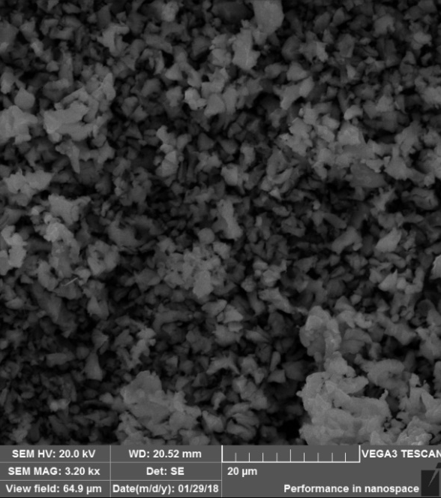
7 A
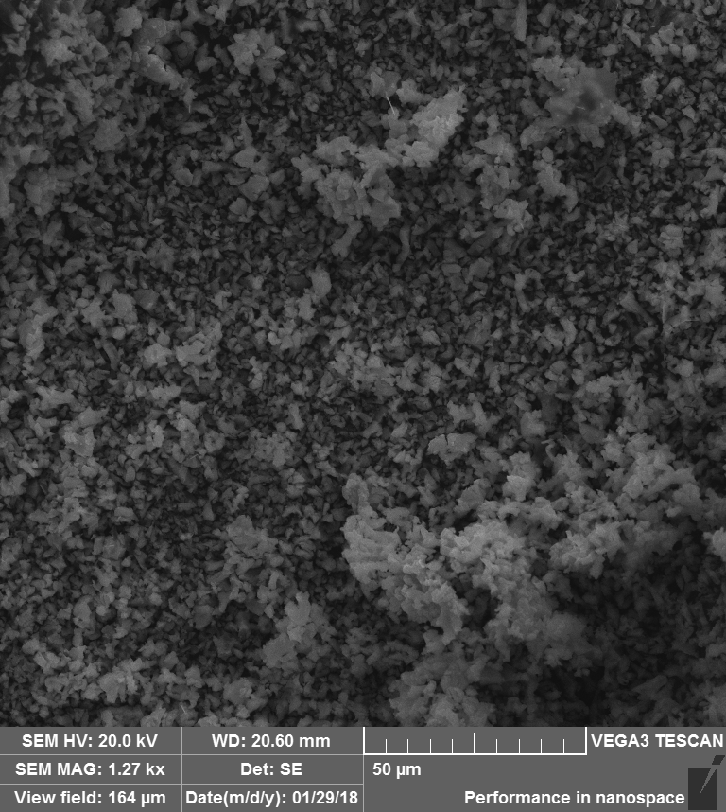
7 B
Figure 7 (A & B): SEM images of incinerated eggshells
The incinerated eggshells nanoparticles (NPs) had irregular shapes at different scales of between 20 and 50 μm. Almost spherical particles of incinerated eggshells were found in the samples. However, these particles agglomerated due to the higher surface tension brought about by the thermal decomposition of the samples. In another research, the particles were also at a nanolevel between 13 and 50 nm (Tahvildari et al., 2015). XRD analysis confirmed that the crystal particles were cubic (Chinthakuntla et al., 2014).
SEM images of synthesized eggshell nanocatalyst at different scales of 500 μm and HRSEM at 50 000 × are in Figures 8 A, and B.
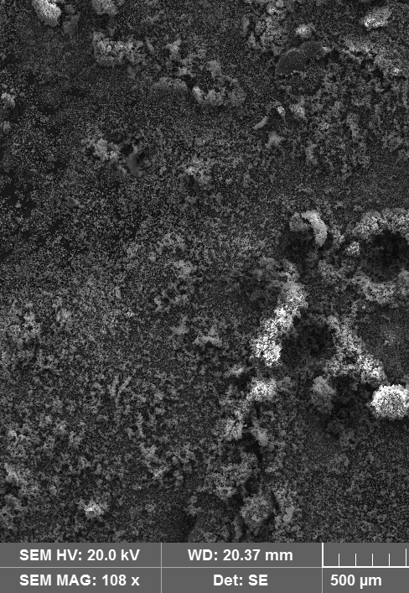
8 A
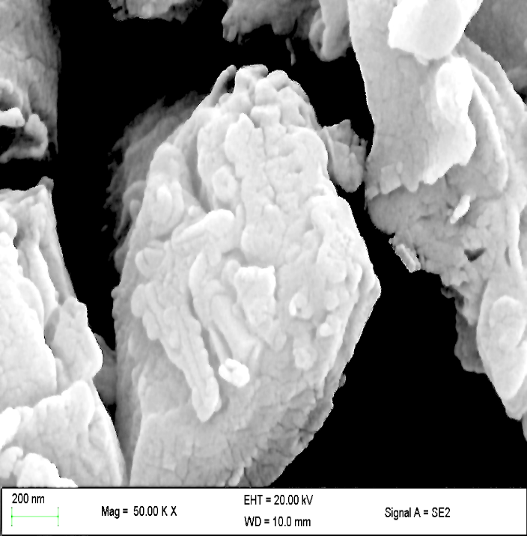
8 B
Figure 8: SEM Image of incinerated synthesized eggshells nanoparticles (a) A - SEM 108 × (b) B - SEM image 50 000 ×
These images reveal that the synthesized eggshell nanocatalyst was porous structures with irregular morphologies. This resulted from the CO₂ released during incineration, leaving behind agglomerate products ( Venkatesh et al., 2018). The synthesized eggshell nanocatalyst's size and morphology were not uniform as they are products of precipitation and sintering. They are formed from incinerated eggshells through microemulsion. Incineration increases the surface area, making it a potentially better nanocatalyst. Van der Waals forces of attraction accompany these high surface areas and are therefore responsible for agglomeration (Wu et al., 2013; Balaganesh et al., 2018). Mmusi et al., (2021) studied the SEM images of CaO-NPs derived from eggshells and found that the particles had agglomerated, suggesting that these particles are porous. Besides, they had a grain-like structure with spherical morphology, and the individual particles were nano-sized crystals.

3.2. EDX Spectroscopy
The nanocatalysts' composition was analyzed using energy-dispersive x-ray spectroscopy (EDS). EDX analysis used each elemental map and spectrum of the rosette region recorded to compare the microstructure and the distribution of O and Ca. Mapping images of the elements and the EDX spectrum from the same area are in Figures 9 (A to C).
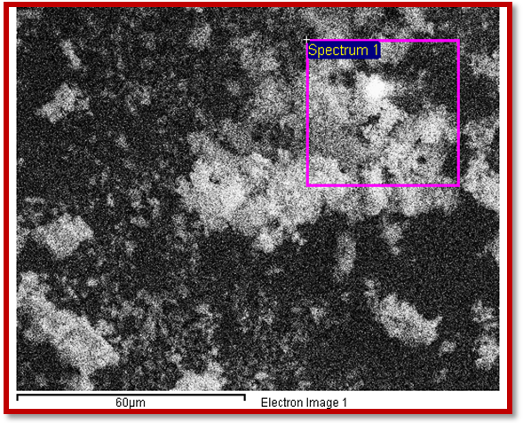
9 A
Figure 9 A: EDX spectroscopy of synthesized nanocatalyst showing the focused area
The SEM image of the synthesized eggshells nanocatalyst. It contains pseudocubic nanoparticles, and the surface is covered with amorphous CaO agglomerates during incineration. The small grains and aggregates could provide higher specific areas and higher biodiesel yield. The presence of CaO species on the synthesized nanocatalyst was further confirmed by EDX spectra, as depicted in Figures 9 B & C.
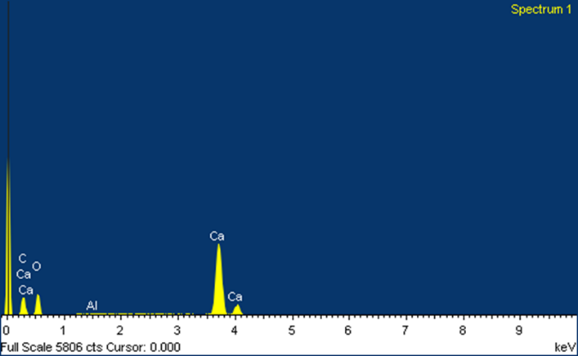
9 B
Figure 9 B: EDX spectrum of incinerated eggshells

The EDX spectra reveal that the incinerated eggshells catalyst samples were mainly calcium, carbon and oxygen as indicated.
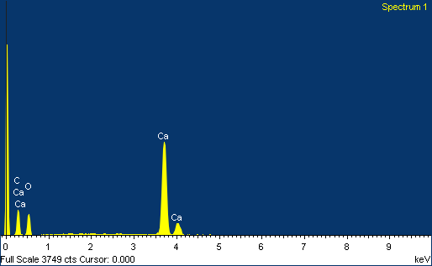
9 C
Figure 9 C: EDX spectrum of the synthesized eggshells
The EDX spectrum of the synthesized eggshells catalyst samples reveals that calcium and oxygen were the major elemental compositions. Mmusi et al., (2021) studied the SEM images of CaO-NPs derived from eggshells and found that the percentage atomic compositions were 38.18, 45.56, 6.05, and 0.01% for calcium (Ca), oxygen (O), carbon (C), and magnesium (Mg), respectively. These results confirmed that indeed CaO was present.
3.2.1. EDX mapping
Characterization of the eggshells nanocatalyst using EDX showed uniform material composition information. The result represents the amount of calcium, oxygen, and carbon present in the sample, with weight and atomic percentage, which are in Figure 10 A, B and C.

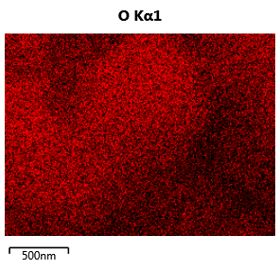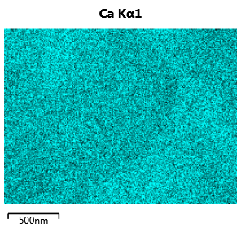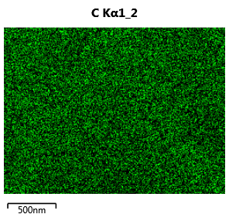
10 C
10 B
10 A
Figure 10 (A, B & C): EDX mapping for the synthesized nanocatalyst

EDS mapping for the synthesized eggshell nanocatalyst shows that oxygen, calcium, and carbon were present. Carbon is a by-product of the SEM tab. This diagram shows that oxygen and calcium elements are distributed sporadically over the entire catalyst surface. These elements were derived from the incinerated waste eggshells. Untuk et al., (2021) studied the SEM images of RSS/CaO synthesis and characterization of rubber seed shell (RSS) impregnated with calcium oxide as catalyst for biodiesel production. The RSS/CaO elements mapping also showed that carbon and calcium are superimposed. Superimposed images are due to the formation of mixed phases of elements proving that CaO is attached to the carbon support. The regular spatial distribution showed that the impregnated CaO was well scattered over the RSS carbon support.
Table 2: Summary of the EDX spectroscopy of the synthesized eggshells nanocatalyst
The elemental analysis of the chemically produced eggshells nanocatalyst is shown in Table 2 below (n = 6).

Element | Average weight % | Average atomic %
C | 25.94 4.12 | 34.717.46
Ca | 46.61 1.19 | 42.008.34
O | 31.401.20 | 11.672.38
The eggshell contained 46.61 ± 1.19 % and 31.40 ± 1.20 % of Calcium and Oxygen, respectively. Carbon (25.94 ± 4.12 %) was also observed because the samples were packed in a carbon-coated copper grid (200 mesh) (Dennymol and Joseph, 2014). Mohamed et al., (2021) studied the synthesis of novel eco-friendly CaO/C photocatalyst from coffee and eggshell wastes. After thermal treatment, they confirmed the presence of calcium (Ca) and oxygen (O) elements in the eggshell, with an average fraction of weight of about 92% and 8%, respectively. This confirmed the existence of the CaO phase.
3.2.2. XRF Spectroscopy
The chemical composition of incinerated eggshell and the synthesized nanocatalyst were obtained using X-ray fluorescence analysis. The results are summarized in Figure 11 below.

Figure 11: The chemical composition of the incinerated eggshells and the synthesized eggshells nanocatalyst
The calcium oxide content in the synthesized eggshells catalyst calcined at 900 °C for 3 hours is approximately 95.52 % w/w of CaO. However, the rest of the elements and compounds amounted to only 4.48 % w/w. This means that the synthesized eggshells' thermal treatment transforms the chemical composition from calcium carbonate (CaCO₃) to calcium oxide almost entirely. The major component of synthesized eggshells nanocatalyst are CaO 95.516 ± 2.04 %, P₂O₅ - 2.102 ± 0.09, Al₂O₃-1.637 ± 2.57 %, and MgO - 0.087 ± 0.02 %, respectively. The composition of CaO in the incinerated eggshells was lower at 90.457 ± 1.73 %. It also contained small amounts of Mg - 0.087 ± 0.02%, P₂O₅ - 2.102 ± 0.09%, Sr - 0.018 ± 0.01%, Ti - 0.057± 0.06%, Fe - 0.232 ± 0.02%, Cu - 0.018 ± 0.01%, and Zn -0.019 ± 0.01%. Tahvildari et al., (2015), produced biodiesel from cooking oils using CaO and MgO nanoparticles. They discovered that CaO nanoparticles showed a significant increase in biodiesel yield compared to MgO nanoparticles. They also concluded that various metal oxide nanocatalysts are the most efficient heterogeneous catalysts in biodiesel production from different feedstocks. Another research found that the gel-combusted CaO nanocatalyst improved surface area, porosity, basic site, and higher catalytic performance (Kesic et al., 2016). The elements present in the synthesized eggshell nanocatalyst have potential catalytic activities essential in producing yellow oleander biodiesel.
3.2.3. TEM Spectroscopy
The TEM images and SAED pattern of incinerated eggshells and synthesized eggshells nanocatalyst samples are in Figures 12 and 13
. 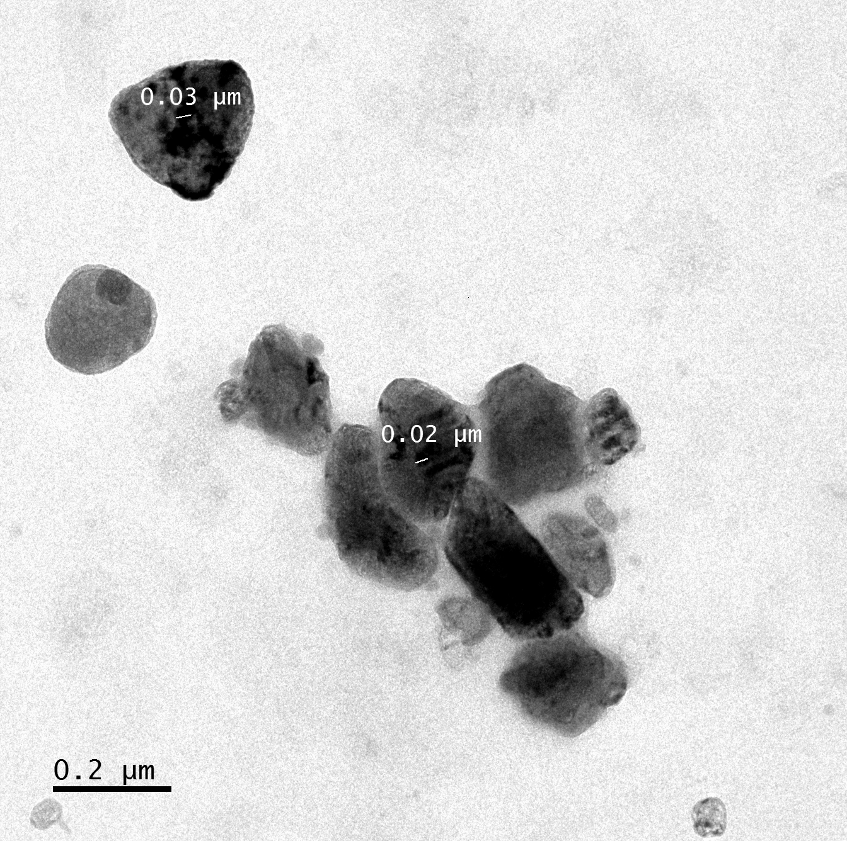 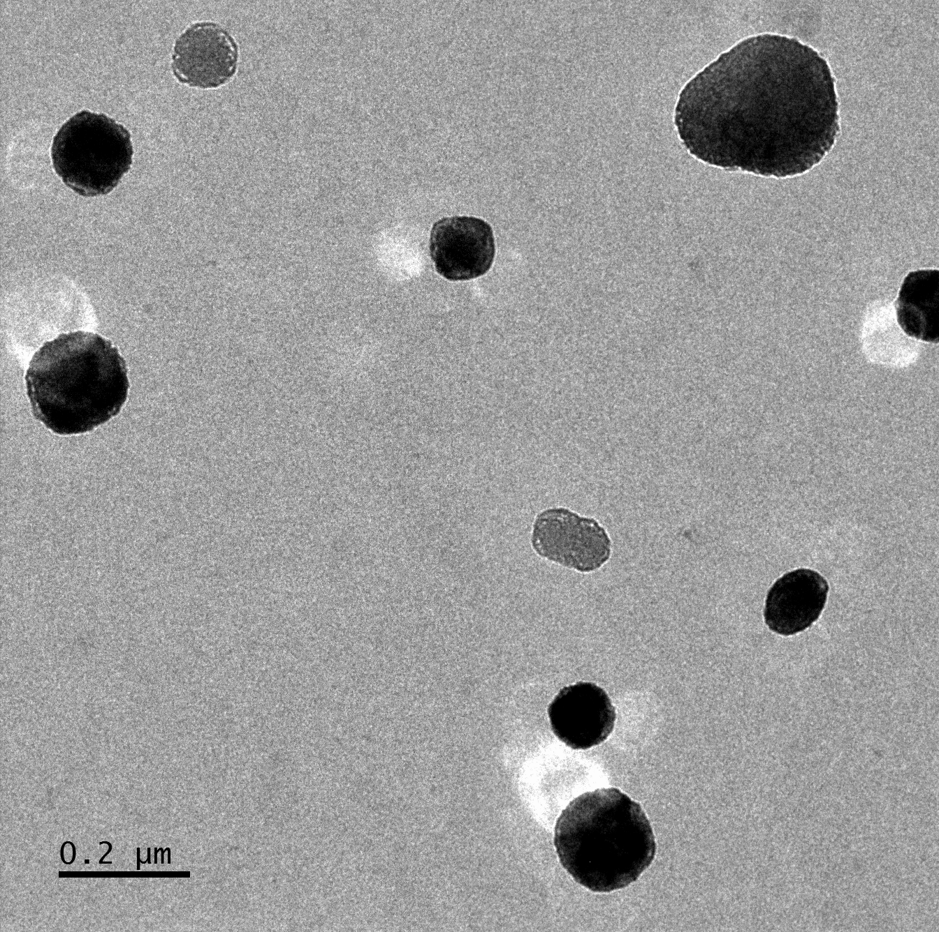
12A 1
12 B
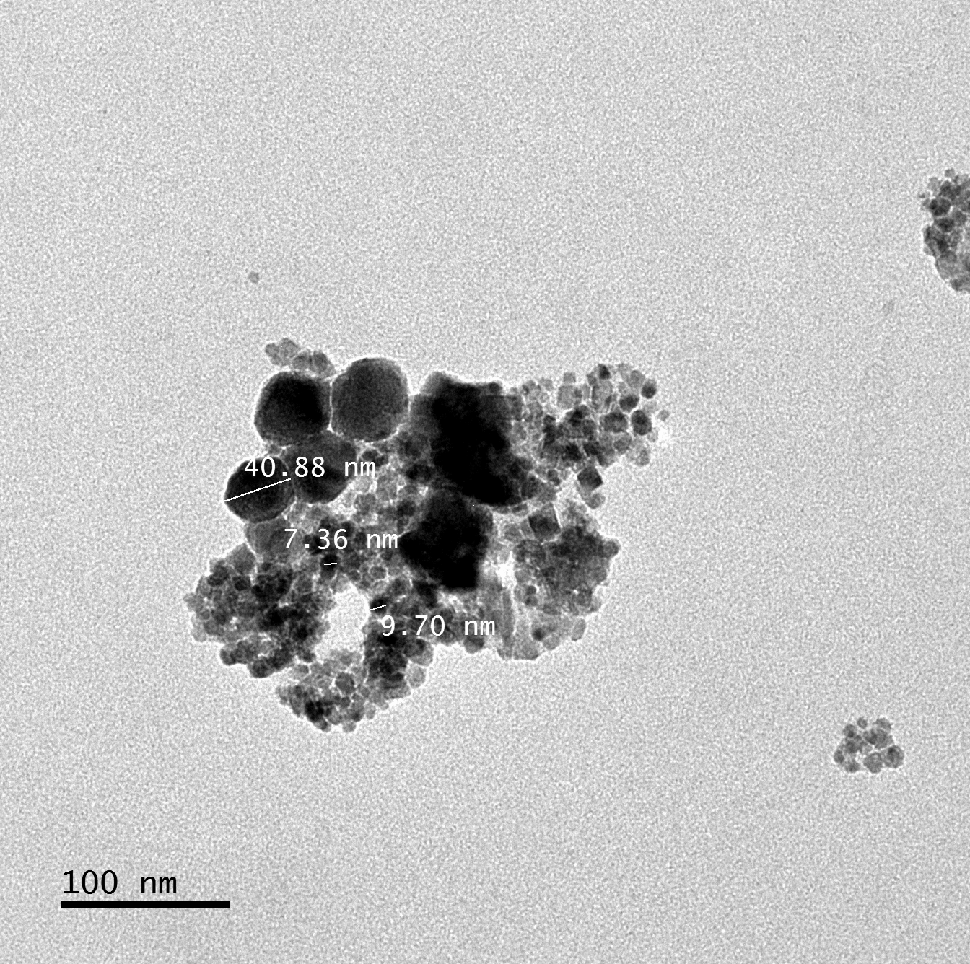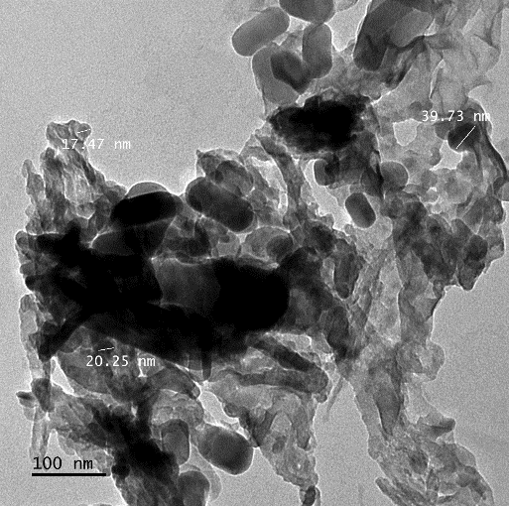
12 C
13 B 1
Figure 12 (A-D): TEM images of incinerated eggshells
These images confirmed that the CaO particles from incinerated eggshells are majorly spherical, approximately ≈7 to ≈ 41 nm in diameter, consistent with the XRD SEM measurements. Furthermore, Habte et al., (2019) studied the synthesis of nano-calcium oxide from waste eggshells by the Sol-Gel Method. Using FE-SEM image, they found spherical polycrystalline nanoparticles agglomerated to each other. The mean size of CaO nanoparticles was ≈ 198 nm. The effect of the bottom-up technique on the synthesis of synthesized eggshells nanocatalyst observed using the TEM and selected area electron diffraction (SAED) images.
13 A 1
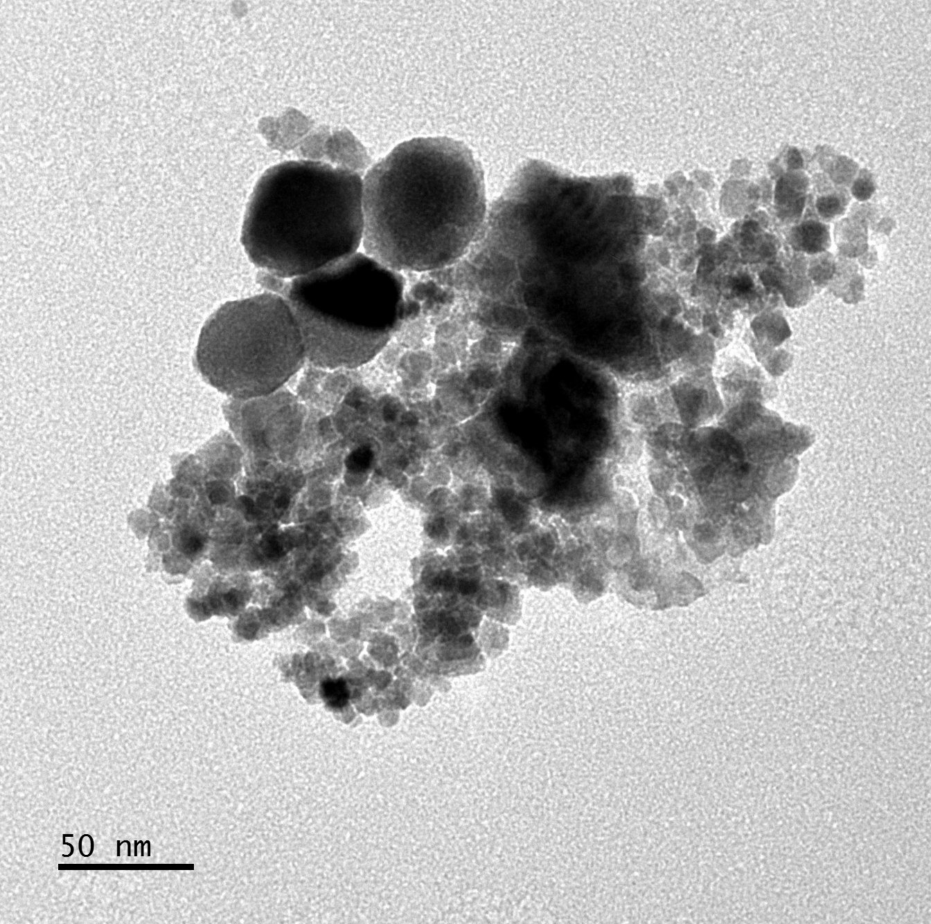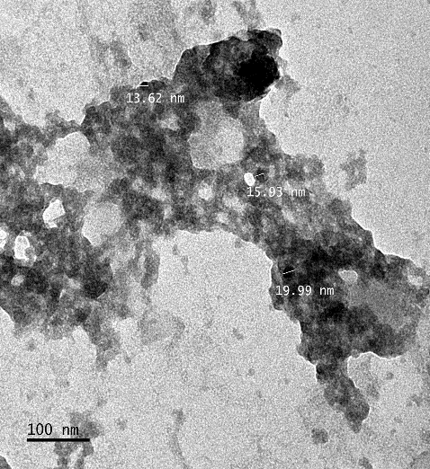
12 D
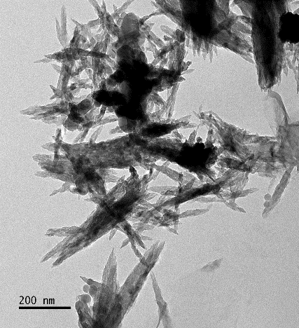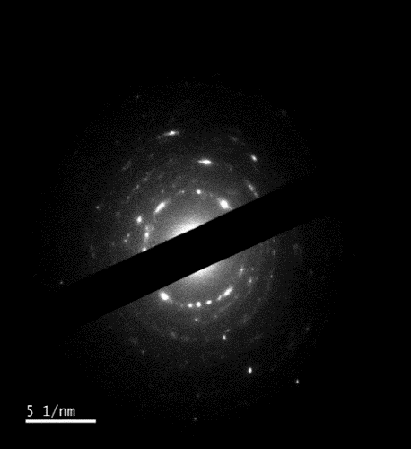
13 C
13 D 1

Figure 13 (A-D): TEM and SAED Images
The TEM images showed that the synthesized eggshell nanocatalyst had irregular agglomerates with particle sizes ranging from ≈ 13 to ≈ 48 nm. This agreed with the calculation using the Scherrer equation of the XRD pattern, indicating that the crystallite size was ≈ 27 nm. The porosity of the synthesized eggshells nanocatalyst was higher than that of incinerated eggshells. This was due to the CO₂ released from inside the structure during calcination (Ahmad et al., 2021). Venkatesh at al., (2018) studied the TEM image of CaO nanocatalyst and its application for biodiesel production using Butea monosperma oil. They found the NP agglomerates, with their sizes ranging from ≈ 10 to 15 nm; they also exhibited NP a cone-like structure.
The SAED pattern of synthesized eggshells nanocatalyst reveals the electron diffraction spots distributed as concentric rings. This further indicated the presence of nanosized crystals. In addition, the samples exhibit continuous rings around the sharp spot, which shows the polycrystalline nature of prepared samples [52]. Muthu et al., (2022) studied the TEM image in the rapid synthesis of eggshell-derived hydroxyapatite with nanoscale characteristics for biomedical applications. They found the selected area electron diffraction (SAED) pattern of the hydroxyapatite sample reveals bright spots arranged in a continuous ring, owing to its polycrystalline nature, indexed with Miller’s planes observed in XRD.

3.2.4. BET-BJH Analysis
The catalyst's surface area and pore diameter are two key characteristics to be evaluated in all catalysts. Therefore, the nanoparticles' surface areas were determined using the Brunauer–Emmett–Teller (BET) equation (Brame and Griggs, 2016). This research used the Barrett– Joyner–Halenda (BJH) method to calculate the pore size distribution and pore volume from the adsorption isotherm at (Correia et al., 2017). The result obtained from the N₂ physisorption analysis of synthesized eggshells nanocatalyst using liquid nitrogen at a temperature of 77 K is presented in Table 3 below.

Table 3: Summary report of Pore structure parameters of the samples calculated from nitrogen adsorption-desorption isotherms using the sorptometry method
SAMPLES
PARAMETERS: Incinerated eggshells Synthesized catalyst
Surface area (m²/g)
BET surface area 4.44 ± 0.38 5.54 ±0.48
t‒plot Micropore Area 0.0006 ±0.0 8.26 ±0.34
t‒plot External surface area 0.047±0.01 8.26 ±0.25
BJH Adsorption Cumulative Surface Area 4.30 ±0.57 6.07 ±0.17
BJH Desorption Cumulative Surface Area 4.26±0.27 6.18 ±0.28
Pore volume (cm³/g)
Single Point Desorption Total Pore Volume 0.019±0.01 0.017 ±0.0
BJH Adsorption Cumulative Pore Volume 0.025±0.01 0.016 ±0.0
BJH Desorption Cumulative Pore Volume 0.024±0.01 0.017±0.0
Pore size (nm)
Desorption Average Pore Diameter (4V/A by BET) 15.69±2.63 10.04± 0.98
BJH Adsorption Average Pore Diameter (4V/A) 23.10±2.17 10.87± 2.61
BJH Desorption Average Pore Diameter (4V/A) 22.93±2.94 10.72±1.71
Particle size (D_{BET} nm)
BJH Adsorption Average Particle size 41.78±5.62 29.59± 0.89
BJH Desorption Average Particle size 42.17±2.59 29.07±1.04

The results for BET analysis for the incinerated eggshells and the synthesized nanocatalyst. The synthesized nanocatalyst had a higher surface area of 5.54 ±0.48 m²/g than the incinerated eggshells, 4.44 ± 0.38 m²/g. The lower surface area in the incinerated eggshells is due to their large particle, and particle size confirmed in XRD and SEM analysis. This indicates that the synthesized nanocatalyst is a better catalyst.
The thickness plot (t-plot) analysis for micropore area was 0.0006 ± 0.0 m²/g compared to 8.26 ± 0.34 m²/g. The external surface area was 0.0470.01 m/g for the incinerated eggshells compared to 8.26-0.25 m²/g for the synthesized nanocatalyst. This confirms the presence of micropores in the incinerated eggshell samples.
The average adsorption pore size (4 V/A after BET) was 15.69 ± 2.63 nm for the incinerated eggshells compared to 10.04 ± 0.98 nm and the synthesized nanocatalyst. Similar results were obtained by BJH analysis; the average pore size of BJH adsorption (4V/A) was 23.10 ± 2.17 nm for the incinerated eggshells compared to 10.87 ± 2.61 nm for the synthesized nanocatalyst. The average pore size of BJH desorption was 22.93 ± 2.94 nm for the incinerated eggshells compared to 10.72 ± 1.71 nm for the synthesized nanocatalyst. These were applied to the incinerated eggshell and the synthesized nanocatalyst, respectively. An increase in the pore diameter leads to a reduction in the pore volume. In all of these cases, the incinerated eggshells are relatively more porous than the synthesized nanocatalyst. As a result, the incinerated eggshells would be more efficient during the catalytic process.
The BJH adsorption cumulative pore volume were 0.025 ± 0.0 for the incinerated eggshells compared to 0.016 ± 0 cm³/g for the synthesized nanocatalyst, and the BJH desorption average pore diameter (4V/A) were 0.024 ± 0.01 for the incinerated eggshells compared to 0.017 ± 0.0 cm³/g for the incinerated eggshells and the synthesized catalyst.
The average particle size of BJH adsorption of 41.78 ± 5.62 nm for the incinerated eggshells compared to 29.59 ± 0.89 nm for the synthesized nanocatalyst. However, the average pore size of BJH desorption was 42.17 ± 2.59 nm for the incinerated eggshells compared to 29.07 ± 1.04 nm for the synthesized nanocatalyst. This applied to both the incinerated eggshells and the synthesized nanocatalyst. The catalysts had pore diameters between 2 and 5 nm, indicating that they are mesoporous materials. Comparing each average adsorbent particle size, the synthesized nanocatalyst had a smaller average particle size in all tests. These results confirm previous analyzes such as XRD and SEM.
Bharti et al., (2021) studied the BET analysis of the synthesized CaO nanocatalyst for biodiesel production. They found that the specific surface area of the synthesized CaO nanocatalyst was 67.781 m² g⁻¹. At the same time, the average pore diameter was 3.302 nm. The surface area of commercial CaO has been reported as 13 m² g⁻¹, which is significantly lower than that of the synthesized nano-CaO. They also reported that a high specific surface area and smaller pore diameter impart mesopores in the catalyst, making it suitable for reaction through adsorption. A high surface area indicates high porosity and high functionality of the catalyst and the availability of a greater number of active sites. The same trend was observed in the average pore diameters (by 4V/A) for the incinerated eggshells. These were in the range of ≈ 15.69 ± 2.63 – 22.93 ± 2.94 nm. They were higher than that of the synthesized eggshell catalyst in the range of ≈ 10.04 ± 0.98 to 10.72 ± 1.71 nm. Pandit & Fulekar, (2017) studied the egg shell waste as heterogeneous nanocatalyst for biodiesel production and found that the newly synthesized nano-CaO had specific areas of 16.4 m² g⁻¹ with average pore diameter and pore volume of 5.07 nm and 0.0207 cm³/g respectively. El-Gendy et al., (2015) used the BJH method to calculate the pore size distributions over the mesopore for the prepared bio-catalyst recorded a total pore volume of 0.058 cm³/g. The characteristics of the CaO catalyst samples CaO-500 (°C) to CaO-900 (°C) used in the experiment were favorable for a liquid-solid heterogeneous phase reaction. They also provide sufficient reaction surface area for converting large triglyceride molecules into biodiesel.

3.2.5. The BET Plot
This research used the BET (Brunauer, Emmett, and Teller) equation to calculate the specific surface area from the adsorption data. The equation was valid for the in the range 0.05 to 0.30
(Brame and Griggs, 2016). Figure 14 below is the BET Plot for incinerated eggshells and the synthesized nanocatalyst.
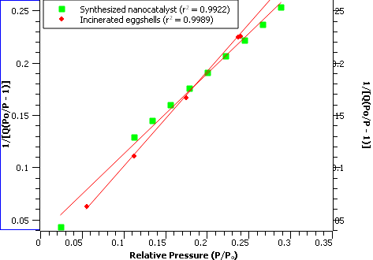

Figure 14: BET Plot for incinerated eggshells and synthesized eggshells derived nanocatalyst.
The readings were used to calculate the SA_{BET} for incinerated eggshells and the synthesized nanocatalysts, as indicated below;
From the above calculation, the BET surface area of the incinerated eggshell was 4.74 ± 0.89 cm²/g, while that of the synthesized eggshell nanocatalyst was 5.563 ± 1.29 m²/g. These results proved that the synthesized nanocatalyst had comparatively better catalytic properties due to the increased BET surface area. Hassan & Lakkimsetty (2018) studied the utilization of modified eggshells as a solid catalyst for converting waste cooking oil to biodiesel. They found that sample 1 had a surface area of 1.4022 m²/g, which is much lower than commercial CaO catalysts with a surface area of 3.0022 m²/g. For sample 2, the surface area increased to 3.5982 m²/g. Finally, a significant increase in the surface area was observed in sample 3, having a value of 11.8501 m²/g, which was comparatively higher than that attained through conventional impregnation of CaO catalyst. Bharti et al., (2019) studied CaO nanocatalyst for biodiesel production. They found that the specific surface area of the synthesized CaO nanocatalyst was 67.781 m²/g, and the average pore diameter was 3.302 nm.
Table 4 summarizes the surface areas of incinerated eggshells and synthesized eggshells nanocatalyst.

Table 4: Surface area analysis by calculation and using image J
 | S_{BET} | C_{BET} | S_{OBS}
Incinerated eggshells | 4.79 ±0.08 | 95.77 ±0.31 | 4.44 ±0.15
Synthesized nanocatalyst | 5.56 ± 0.15 | 18.96 ±0.25 | 5.44 ±0.08
From the above calculation, the BET surface area of the incinerated eggshell was 4.79 ± 0.08 cm²/g, while that of the synthesized eggshell nanocatalyst was 5.56 ± 0.15 m²/g. These results proved that the synthesized nanocatalyst had comparatively better catalytic properties due to the higher surface area. In both cases, the experimental (S_{OBS}) were lower than (S_{BET}) the calculated values. However, synthesized eggshells nanocatalyst had a higher surface area than incinerated eggshells. The C_{BET} for the incinerated eggshells fell within the BET validation range of 50 < C < 200. Synthesized catalyst hand had a lower C_{BET}, which is still valid with a higher S_{BET}. El-Gendy et al., (2015) studied the statistical optimization of biodiesel production from sunflower waste cooking oil using basic heterogeneous biocatalyst prepared from eggshells. They found that the S_{BET} of the catalyst prepared by incineration of eggshells at 800 °C for 2 h was 3.4056 m²/g. Thus, the higher S_{BET} recorded would promote its activity in the transesterification reaction.
3.2.6. Adsorption in micropores
This research studied the N₂ adsorption-desorption isotherms of incinerated eggshells and the synthesized nanocatalyst. These samples were annealed at 900 °C, and the results are in Figure 15 below.
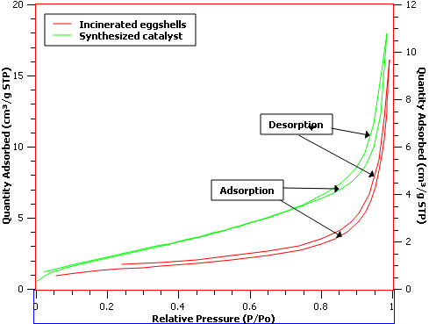
Figure 15: Isotherm Log Plot of N₂ on incinerated eggshells and the synthesized nanocatalyst
The nitrogen adsorption/desorption isotherm of the incinerated eggshell nanocatalyst and synthesized eggshells nanocatalyst. All samples displayed type IV isotherm, a characteristic of mesoporous materials based on IUPAC’s classification. These hysteresis loops characterize the pore characteristics with a wedge-shaped pore with narrow necks at one end (Zeng et al., 2016). On the other hand, the incinerated eggshells give rise to H3 hysteresis to indicate having slit-shaped pores. The isotherms of type H3 do not illustrate any limiting adsorption at high , which signifies particles aggregation inconsistency with obtained SEM results (Sargheini et al., 2012), indicating the slit-shaped mesopores. The same feature was not observed in synthesized nanocatalyst on IUPAC’s classification. The bottom-up technique for preparing the eggshells nanocatalyst altered the regular pore geometry significantly. As a result, the synthesized eggshells nanocatalysts displayed a typical s-shape behavior of Type IV isotherm and a standard H1 type hysteresis loop. H1 type hysteresis is cylindrical during condensation and spherical during evaporation. Its isotherm indicated that the micropores were filled with the gas at extremely low pressure. As a result, a monolayer started to form at the knee, making it a mesoporous material with cylindrical pores of uniform size and shape (Marinković et al., 2017). It forms a multilayer form above the relative pressure of 0.8, and a well-defined capillary condensation step occurred at a relative pressure of 0.8 - 0.99, indicating the uniform pore size distributions (Union, Pure and Chemistry, 1985). Furthermore, it forms a multilayer form above the relative pressure of 0.8, and a well-defined capillary condensation step occurred at a relative pressure of 0.8 - 0.99, indicating the uniform pore size distributions (Thommes et al., 2015).
3.2.6.1. Pore Size Distributions (Mesopore)
Desorption isotherm generally is more appropriate than the adsorption isotherm for this purpose. Mesopore size calculations based on cylindrical pore geometry assumption are done using the Kelvin equation (Thommes et al., 2015). For nitrogen as adsorbate: BJH (Bore size),
…………Equation 3.2.6.1.1.
Where; r_{p}: actual pore radius, t: thickness of the adsorbed layer.
Where; is the surface tension of nitrogen at its boiling point (8.85 ergs/cm² at 78 K., the molar volume of liquid nitrogen 34.7 cm³/mol,, R is the gas constant 8.314 x 10⁷ergs/deg/mol, T is the boiling point of nitrogen 78 K, is the relative pressure of nitrogen and is the kelvin radius of the pore.
From de Boer Equation,
……. Equation 3.2.6.1.3.
Figure 16 gives the pore volume
.
Table 5 below summarizes the calculation of
BJH pore size.
Table 5: Calculation of BJH pore size (n = 6)
 | r_{k} | t | r_{p}
0.0556 | 0.1024 | 3.3967 | 4.4076
0.1125 | 0.1146 | 3.8873
0.1749 | 0.1437 | 4.3492
0.2379 | 0.1744 | 4.7868
0.2399 | 0.1755 | 4.8009
0.3006 | 0.2083 | 5.2245

The calculated pore diameter was 8.816
(Å) or 0.8816 ± 0.067 nm, which is below
the mesoporous range of 2 - 50 nm range.
El-Gendy et al. (2015) also obtained a pore size
distribution between ~ 1.7 and 29.8 nm.
The synthesized eggshells derived
nanocatalyst was in the mesoporous range.
3.2.6.2. BJH Adsorption Cumulative Pore Volume (Larger)
The nanocatalyst's textural analysis was performed using the adsorption/desorption of N₂ based on the BJH methodology. Figure 16 gives the pore volume distributions of incinerated eggshells and synthesized eggshells nanocatalyst.
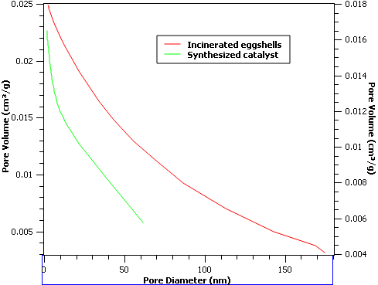
Figure 16: BJH adsorption cumulative pore volume
The distributions of incinerated eggshells and the synthesized catalyst ranged from ≈ 2 to 175 nm with a surface area of ≈ 3 to 90.41 cm²/g. They are mixtures of microporous, mesoporous, and macroporous particles. On the other hand, the synthesized catalyst exhibited microporous particles ranging from ≈ 2 to 65 nm, with surface area ranging from ≈ 2.5 to 61.69 cm²/g. Pore sizes were big enough to facilitate the diffusion of large molecules like triglycerides during biodiesel production. However, the decrease in pore volume and specific surface area. This change came about because of aggregation during the preparation of the eggshells derived nanocatalyst. There is no recorded research on the BJH cumulative pore volume of CaO.

3.2.6.3. The pore size distributions (PSD)
The BJH pore size distributions for synthesized eggshells nanocatalyst compared to the incinerated eggshells shown in Figure 17.

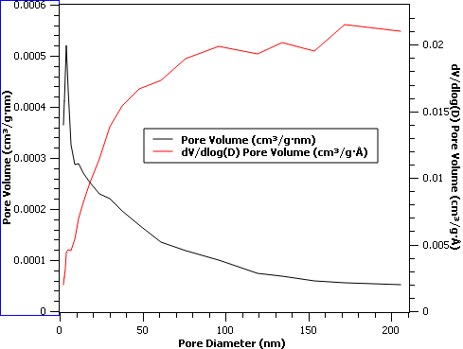
A

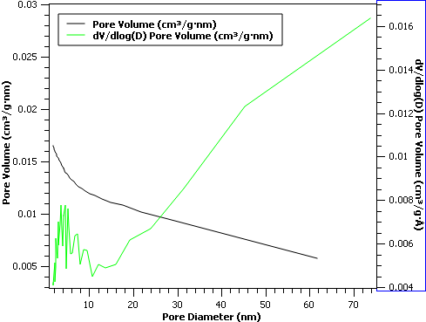
B
Figure 17: Pore size distributions of (A) incinerated eggshells and (B) Synthesized catalyst
The pores for the incinerated eggshells were generally between ≈ 25 < d < 200 nm, confirming a mixture of different particles. On the other hand, for the synthesized catalyst, the pore size distribution demonstrated that the catalyst's pore size was narrow, and the average pore diameter was between ≈ 2 < d < 63 nm, but majorly below 15 nm. The synthesized catalyst had unimodal pore size distributions, with average pore diameter values. On the other hand, the pore size distribution curves confirm that it was predominantly mesoporous. In comparison, the incinerated eggshell was a mixture of nanoparticles and macroparticles. The BJH (Barrett-Joyner-Halenda) adsorption cumulative pore volumes were 0.00285 cm³/g and 0.205 cm³/g for incinerated eggshells. The synthesized nanocatalyst registered 0.02611 cm³/g and 0.750 cm³/g, respectively. Confirming that the active site is near the nanocatalyst's external surface may lead to better and quicker interaction between the catalyst and the feedstock.
Ali et al., (2021) studied the effect of calcium oxide from waste chicken eggshell on HZSM-5. They found that the waste chicken eggs have a similar pore diameter of 3.87 nm with HZSM-5 catalyst, unlike commercial CaO, which slightly had a smaller pore diameter at 3.58 nm. They also observed that the total pore volume of waste chicken eggs is higher than CaO at 0.0156 cm³/g and 0.0063 cm³/g. As an alternative source of CaO, Waste chicken eggs have better textural properties than commercial CaO. This might be due to other elements in the waste chicken eggs, such as silicon, magnesium, potassium, and iron. The waste chicken eggs/HZSM-5 catalyst had BET surface area and total pore volume at 292.14 m²/g and 0.2663 cm³/g. they observed that the impregnation of waste chicken eggs on HZSM-5 had a significant effect of decreased BET surface area from 365.81 to 292.14 m²/g and increased total pore volume from 0.2291 to 0.2663 cm³/g. The decrease in BET surface area was attributed to the excellent dispersion of waste chicken eggs on the surface of HZSM-5 during the incipient wetness impregnation method. The increase in the total pore volume was also attributed to the waste chicken eggs having enlarged the pore of HZSM-5 during the preparation process.

3.3. Effects of reaction variables on the performance of nanocatalysts
The following reaction variables: Surface area/volume ratio of the nanocatalysts, reaction time, amount of catalyst, methanol: oil ratio, and reaction temperature were investigated. This study examined the catalytic performance using these variables in the transesterification reaction of yellow oleander oil to find the optimum reaction condition.
3.3.1. The surface-area-to-volume ratio of the nanocatalysts
Nanocatalysts yield a tremendous surface-area-to-volume ratio, which account for their versatility and effectiveness (Chaturvedi, Dave and Shah, 2012). The nanocatalysts' surface area to volume ratio are in Table 6 below.
Table 6: Surface area/volume ratio of the nanocatalysts
Nanocatalyst | SA/Vol ratio (m⁻¹)
Incinerated eggshells | 2.52 ×10⁸
synthesized eggshells nanocatalyst | 3.27 ×10⁸
CaO | 1.95 ×10⁸
The results indicate that the synthesized eggshells nanocatalyst samples possessed a surface area of 5.56 ± 0.15 m²/g, a pore volume of 1.7 × 10⁻⁸ m³/g, a mean pore diameter of 10.87 ± 2.61 nm, and a surface area to volume ratio of 3.27 × 10⁸ m⁻¹. Meanwhile, the Incinerated eggshells and CaO nanocatalyst samples had a lower surface area/volume ratio. These were 2.52 × 10⁸ and 2.52 × 10⁸ m⁻¹, respectively. Making the synthesized eggshells nanocatalyst was a better heterogeneous phase for producing yellow oleander biodiesel. The estimated TEM particle sizes for incinerated eggshells and synthesized nanocatalysts were; 5.61 ± 0.068 and 4.51 ±19.09 nm. These results confirm that synthesized eggshells nanocatalyst is better catalysis; it has many active chemical sites brought about by its large surface area. Reducing the particle size to the nanoscale increases the surface area/volume ratio, favoring high chemical reactivity and high catalytic activity [59]. BET and BJH analysis results confirmed that the analyzed samples were nanoparticles and had low porosity. There was a general decrease in particle size, surface area, and pore volume. This was caused by agglomeration at high temperatures during the calcination stage (Gaber et al., 2014). El-Gendy et al., (2015) recorded a total pore volume of 0.058 cm³/g for the mesoporous biocatalyst. Nasrollahzadeh et al., (2016) studied the BET/BJH analysis of Cu/eggshell and Cu/Fe₃O₄/eggshell nanocomposites. They found that surface area, average pore volume, and pore diameter of eggshell were ≈ 0.84 m²/g, ≈ 0.0049 cm³/g, and ≈ 3.22 nm, respectively. These results indicated that natural eggshells possessed low porosity.
3.3.2. Effect of the reaction time on the biodiesel yield
This study examined the effect of reaction time by conducting transesterification reactions of yellow oleander oil and methanol at different times. The results are presentable in Figure 18 below.
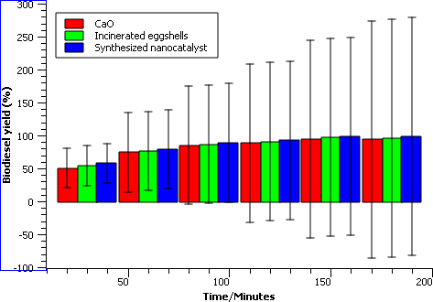
Figure 18: Effect of the reaction time on the biodiesel yield for two different nanocatalysts at the same loading
Increasing the reaction time from 30 to 180 minutes increased the biodiesel yield from 58.1 ± 4.23 % to 98.9 ± 0.83 % conversion for the synthesized nanocatalyst. However, for the incinerated eggshell nanocatalyst, the biodiesel yield increased from 54.3 ± 3.17% to 96.6 ± 1.66% conversion for the burned eggshells. For the CaO nanocatalyst, the biodiesel yield increased from 50.4 ± 1.27 to 94.3 ± 4.47%. In addition, because of the reversible transesterification reaction, the yield decreased with a longer reaction time. However, the biodiesel yield for the synthesized nanocatalyst was higher than for the burned eggshell nanocatalyst. This is due to a higher surface area created by the deposition of synthesized nanocatalysts supported by this study's XRD, SEM, TEM, and BET results.
Maneerung et al., (2016) studied the use of CaO catalysts prepared from chicken manure for biodiesel production. They found that in heterogeneous catalysis, the reaction rate is in a multiphased system, which is affected by specific surface area and mass transfer rate. The mass transfer problem can be reduced or eliminated by applying continuous stirring to the production process. Bet-Moushoul et al., (2016) studied the application of CaO-based/Au nanoparticles as heterogeneous nanocatalysts in biodiesel production. They found that while using dolomite catalysts. The plots showed that the reaction rate was low in the first 1 h because heterogeneous mass transfer systems caused the slow reactions, but the conversion increased gradually after 2 h of reaction time. However, after 5 h, all conversion levels demonstrated the requirement for higher catalyst loading to increase the transesterification yields.
3.3.3. Effect of catalyst loading on biodiesel production
Catalyst loading is another important parameter that needs to be optimized to improve the FFA conversion. Figure 19 gives the effect of catalyst loading on biodiesel yield.

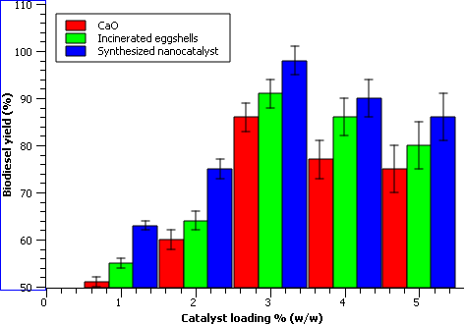
Figure 19: The effect of catalyst loading on biodiesel production
The catalyst loading in the oil varied from 1% to 5% (w/w). According to the recorded results, biodiesel conversion increased significantly with nanocatalyst loading, to a level where higher loading no longer increased biodiesel conversion. The total number of available active sites increased with increasing nanocatalyst loading. On the other hand, further increasing the nanocatalyst loading beyond the optimal 3% ratio can increase the viscosity of the liquid mixture and lead to a limited reaction rate. Increasing the catalyst loading from 1 to 3 wt% increased the amount of biodiesel produced. In CaO, incinerated eggshells, and synthesized nanocatalysts, the biodiesel yield is 86.3 ± 4.76, 91.3 ± 6.71, and 98.2 ± 1.23%, respectively. However, with catalytic loading, the biodiesel production yield decreased from 3 to 5 wt%. Increasing the catalyst loading led to particle cohesion and aggregation, resulting in a decreased active surface area. These also increased the viscosity of the solution, thereby reducing the biodiesel production yield (Musa, 2016). Kifli et al., (2018) studied the synthesis of alumina-CaO-KI catalyst to produce biodiesel from rubber seed oil. They found that the yield increased with increasing catalyst loading from 0 to 2% for all catalysts. The highest biodiesel yield with alumina CaO-KI, alumina-KI, and alumina-CaO were 91.6%, 90.7%, and 63.5%, respectively. They also observed that the optimal catalyst loading was at 2.0%, and biodiesel yield decreased with a further increasing amount of catalyst. As expected, alumina-CaO-KI gave the highest yield of biodiesel. This is due to a combination of factors; the high basicity of alumina-KI catalyst.
3.3.4. Effect of temperature on biodiesel production
The rate of transesterification in the presence of nanocatalysts significantly increases with the temperature. Research has shown that the optimal temperature for the oil methanolysis is the boiling point of methanol (65 °C) at the atmospheric pressure. Higher temperatures than the optimal one neither decrease the reaction time nor increase the conversion rate. But, when the reaction temperature exceeds the boiling point of methanol, it begins to evaporate. The contact time between methanol and oil is reduced, leading to decreased biodiesel yield (Banković-Ilić et al., 2017). Figure 20 shows the relationship between temperature changes and biodiesel yield.

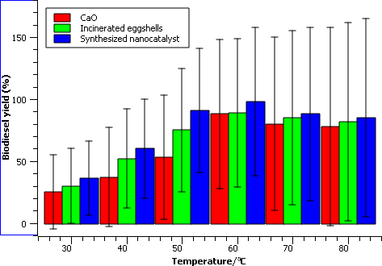
Figure 20: Effect of reaction temperature on the conversion of yellow oleander oil.
The biodiesel yield increased significantly when the reaction temperature was increased from 40 to 60 °C. This increase results from the use of nanocatalysts in biodiesel production. It increased from 37.4 ± 5.11 for CaO, 52.1 ± 3.32 for incinerated eggshells, and 60.1 ± 5.74 % to 88.3 ± 8.22, 89.2 ± 4.32, and 98.2 ± 6.12 %, and for the synthesized nanocatalyst. Since the transesterification reaction is an equilibrium reaction, an increase in temperature accelerates the reaction. As a result, the reaction proceeds faster at higher temperatures than at lower ones. However, biodiesel production decreased when the temperature was increased from 60°C to 80°C. Erchamo et al., (2021) studied improved biodiesel production from waste cooking oil with mixed methanol–ethanol using enhanced eggshell-derived CaO nanocatalyst. They found that the highest yield was obtained at the optimum temperature of 60 °C, giving a maximum yield of 89.5%.
3.3.5. Effect of the methanol/oil ratio on biodiesel production
The mole ratio of alcohol to oil is one of the most critical factors affecting the conversion efficiency, the yield of biodiesel, and biodiesel production cost (Musa, 2016). The conversion rate decrease above the optimum alcohol/oil molar ratio is attributed to the problematic separation of the phases (Banković-Ilić et al., 2017). Figure 21 shows the effect of the methanol/oil ratio on biodiesel production.

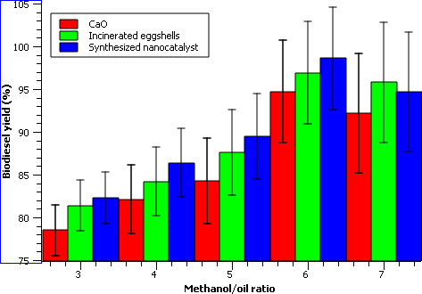
Figure 21: Effect of methanol/oil ratio on the yellow oleander biodiesel yield
The biodiesel yield increased with increasing methanol: oil molar ratio up to 6:1, yielding 94.7 ± 2.12, 96.9 ± 1.01, 98.6 ± 4.22%, respectively for CaO, incinerated eggshells, and synthesized nanocatalyst, respectively. However, beyond the optimum ratio of 6:1, the biodiesel yield decreased. This is related to the high molar ratio of oil to methanol interfering with the separation of glycerin because there is an increase in the solubility of glycerol in excess methanol. When glycerin remains in solution, it helps drive the equilibrium back to the left, lowering the yield of esters and promoting the displacement of the balance in the opposite direction toward the formation of mono, di, and triglycerides, thereby decreasing the production of esters. In addition, the overloading of methanol above the optimum value would inactivate the catalyst. This favors the transesterification process's backward reaction; a similar effect was observed for alcohol. Therefore, biodiesel yield decreases with the oil to methanol ratio beyond optimum value (Erchamo et al., 2021). Elkady et al., (2015) studied biodiesel production from waste vegetable oil via KM micromixer. They found that the 6: 1 reactant ratio recorded the lowest biodiesel conversion compared to the 12: 1 molar ratio that attained the maximum biodiesel conversion. The increase in alcohol to oil molar ratio above 12: 1 declines biodiesel conversion. This is due to the reversibility behavior of the transesterification reaction.
3.3.6. Effect of the reusability of nanocatalyst on the biodiesel yield
This study tested the reusability of the nanocatalysts in the transesterification of yellow oleander oil. Repeated use of a heterogeneous catalyst reduces the chemical reaction's overall processing cost (Kaur and Ali, 2014). The optimum transesterification conditions included; methanol to oil molar ratio of 3:1 at 65 °C reaction temperature in the presence of 2 wt.% catalysts. After every reaction, the nanocatalysts were recovered from the reaction mixture by filtration (Faruque, Razzak and Hossain, 2020). Next, they were washed with hexane and regenerated at 900 °C calcination temperature. Finally, the nanocatalysts were recovered, reactivated, and employed 5 successive catalytic cycles under the same experimental and regeneration methods. Figure 22, shows the results for the reused nanocatalyst.

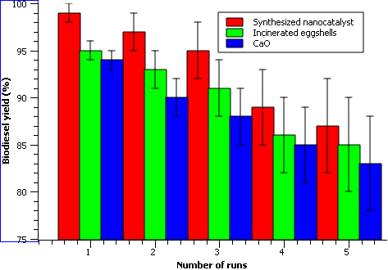
Figure 22: Effect of the reusability of nanocatalysts on the biodiesel yield
The synthesized nanocatalyst, the incinerated eggshells, and the CaO nanocatalysts were reused five times, and the biodiesel yields were 94.2 ± 4.73, 95.3 ± 3.72, 99.4 ± 3.11 %, respectively. However, most research results reported the reusability of CaO-based catalysts up to five cycles (Bet-Moushoul et al., 2016). Banković-Ilić et al., (2017). studied the application of nano CaO–based catalysts in biodiesel synthesis. They found that in the methanolysis of palm oil, a nano CaO catalyst maintained the sustained activity for 5 cycles, with a slightly lowered level of its activity after the second repetition. The catalyst activity decreased due to the blockage of active sites by the adsorbed intermediates or products. These included (mono – and diacylglycerols, glycerol) and the contamination by oxygen, water, and carbon dioxide from the air. Leaching active species into the reaction mixture also contributed to the decrease of catalyst activity.
The synthesized nanocatalyst had the highest surface area to volume ratio of 3.27 ×10⁸/m. The biodiesel yields were; 94.2 ± 4.73, 95.3 ± 3.72, 99.4 ± 3.11 % for CaO, incinerated eggshells, and synthesized nanocatalyst, respectively. The catalysts were reused 5 times without significant activity loss at the reaction temperature of 60 °C, methanol to oil ratio of 6:1, the catalyst amount of 3 % (w/w), and reaction time of 150 minutes. These gave the synthesized eggshells derived nanocatalyst better catalytic properties than CaO and incinerated eggshells. Banković-Ilić et al., (2017) studied the optimization of biodiesel production from waste vegetable oil using eggshell ash. They found that the catalyst obtained can only be reused up to 10 times without affecting the activity. CaO showed sustained activity after being recycled and reused 10 times. The biodiesel yield was relatively constant at 91% during these repeated uses. Beyond this, the yield was reduced to 30% when used for the 18th time.
Conclusion
In this research, an active synthesized heterogeneous CaO catalyst was successfully synthesized from incinerated waste eggshells. The eggshell CaO nanocatalyst was synthesized by using the bottom-up technology and thermally treated at 900 ˚C for 3 h to produce mesoporous CaO catalysts that have high basicity, high surface area, and active sites density with good morphology responsible for the catalytic activity. In an incinerated chicken eggshell, a total weight loss of 52 % occurred, at 820 °C temperature, and CO₂ released to the environment. The TG/DTG curves of the incinerated eggshells and the synthesized nanocatalyst present two events of mass losses. Exothermic reactions took place during phase transitions of vaterite to calcite (≈ 716 to 760 °C), and aragonite to calcite at high temperatures. Incineration below 526 °C did not lead to the formation of CaO. The thermal decomposition of calcium carbonate took place before 1000°C. The spectral characterizations of the synthesized nanocatalyst were investigated using XRD, XRF, TEM, BET, and BJH spectrographic techniques. The results reveal the presence of mesopores uneven particle surfaces with a low surface area, average pore diameter, and pore volume of 5.54 ± 0.48 m²/g, 18.57 ± 2.16 nm, and ≈ 0.016 ± 0.0 – 0.017 ± 0.0 cm³/g, respectively, and presented a uniform pore size. XRF confirmed the presence of CaO in the synthesized catalyst, XRD particle size measurements showed that the sample preparation was a crystalline nanoparticle with sample size 13.86 ± 0.987 nm and a Face Centered Cubic structure. In the FTIR spectra, a sharp and intense peak was observed at 703.9 and ≈ 497 cm⁻¹ representing C-O stretching and bending modes of CaCO₃. Therefore, the thermal decomposition of eggshells and the synthesized catalyst led to the formation of CaO.
.
Acknowledgement
The financial support of the Kenya National Research Funds (NRF), 2017/2018, and the Technical University of Kenya are sincerely acknowledged.
Reference
Ahmad, W., Sethupathi, S., Munusamy, Y., and Kanthasamy, R. (2021) ‘Valorization of raw and calcined chicken eggshell for sulfur dioxide and hydrogen sulfide removal at low temperature’, Catalysts, 11(2), pp. 1–20. doi: 10.3390/catal11020295.

Awan, I. Z., Hussain, S. B., Haq, A., and Khan, A. Q. (2016) General and PhysicaL 1026 Wondrous Nanotechnology.

Ayodeji, A. A., Ojewumi, M. E., Rasheed, B., and Ayodele, J. M. (2018) ‘Data on CaO and eggshell catalysts used for biodiesel production’, Data in Brief, 19, pp. 1466–1473. doi: 10.1016/j.dib.2018.06.028.

Balaganesh, A. S., Sengodan, R., Ranjithkumar, R., and Chandarshekar, B. (2018) ‘Synthesis and Characterization of Porous Calcium Oxide Nanoparticles (CaO NPS)’, International Journal of Innovative Technology and Exploring Engineering (IJITEE), (2), pp. 2278–3075. doi: 10.7324/RJC.2018.1111934.

Banković-Ilić, I. B., Miladinović, M. R., Stamenković, O. S., and Veljković, V. B. (2017) ‘Application of nano CaO–based catalysts in biodiesel synthesis’, Renewable and Sustainable Energy Reviews, 72(May), pp. 746–760. doi: 10.1016/j.rser.2017.01.076.

Bet-Moushoul, E., Farhadi, K., Mansourpanah, Y., Nikbakht, A. M., Molaei, R., and Forough, M. (2016) ‘Application of CaO-based/Au nanoparticles as heterogeneous nanocatalysts in biodiesel production’, Fuel, 164(October), pp. 119–127. doi: 10.1016/j.fuel.2015.09.067.

Bharti, P., Singh, B. and Dey, R. K. (2019) ‘Process optimization of biodiesel production catalyzed by CaO nanocatalyst using response surface methodology’, Journal of Nanostructure in Chemistry, 9(4), pp. 269–280. doi: 10.1007/s40097-019-00317-w.
Birol, F. (2019) ‘CO2 emmisions from fuel combustion’, pp. 1–165.

Brame, J. and Griggs, C. (2016) Surface Area Analysis Using the Brunauer-Emmett-Teller (BET) Method Scientific Operating Procedure Series: SOP-C Environmental Laboratory. Available at: www.erdc.usace.army.mil. (Accessed: 26 December 2018).

Bunaciu, A. A., Udriştioiu, E. gabriela and Aboul-Enein, H. Y. (2015) ‘X-Ray Diffraction: Instrumentation and Applications’, Critical Reviews in Analytical Chemistry, 45(4), pp. 289–299. doi: 10.1080/10408347.2014.949616.

Chaturvedi, S., Dave, P. N. and Shah, N. K. (2012) ‘Applications of nano-catalyst in new era’, Journal of Saudi Chemical Society, 16(3), pp. 307–325. doi: 10.1016/j.jscs.2011.01.015.

Ashok, C., Kumar, M. K., Chakra, C. S. Rao, K. V., and Dayakar, T. (2014) ‘Calcium Oxide Nano Particles Synthesized From Chicken Egg Shells by Physical Method’, (December 2014). Available at: https://www.researchgate.net/publication/270512385.

Correia, L. M. Cecilia, J. A. , Rodríguez-Castellón, E., Cavalcante, C. L. and Vieira, R. S. (2017) ‘Relevance of the Physicochemical Properties of Calcined Quail Eggshell (CaO) as a Catalyst for Biodiesel Production’, Journal of Chemistry, 2017. doi: 10.1155/2017/5679512.

Degirmenbasi, N., Coskun, S., Boz, N. and Kalyon, D. M. (2015) ‘Biodiesel synthesis from canola oil via heterogeneous catalysis using functionalized CaO nanoparticles’, Fuel, 153, pp. 620–627. doi: 10.1016/j.fuel.2015.03.018.

Dennymol, P. V. and Joseph, R. (2014) ‘Morphological Diversity in Nanohydroxyapatite Synthesized from Waste Egg Shell : Verification and Optimization of Various Synthesis Parameters’, The International Journal of Science and Technoledge, 2(6), pp. 179–185.

Diamantopoulos, N. (2015) ‘Comprehensive Review on the Biodiesel Production using Solid Acid Heterogeneous Catalysts’, Journal of Thermodynamics & Catalysis, 06(01). doi: 10.4172/2157-7544.1000143.

Erchamo, Y. S. Mamo, T. T. Workneh, G. A. and Mekonnen, Y. S. (2021) ‘Improved biodiesel production from waste cooking oil with mixed methanol–ethanol using enhanced eggshell-derived CaO nano-catalyst’, Scientific Reports, 11(1), pp. 1–12. doi: 10.1038/s41598-021-86062-z.

Faridi, H. and Arabhosseini, A. (2018) ‘Application of eggshell wastes as valuable and utilizable products: A review’, Research in Agricultural Engineering, 64(2), pp. 104–114. doi: 10.17221/6/2017-RAE.

Faruque, M. O., Razzak, S. A. and Hossain, M. M. (2020) ‘Application of heterogeneous catalysts for biodiesel production from microalgal oil—a review’, Catalysts, 10(9), pp. 1–25. doi: 10.3390/catal10091025.

Gaber, A., Abdel- Rahim, M. A., Abdel-Latief, A. Y. and Abdel-Salam, M. N. (2014) ‘Influence of calcination temperature on the structure and porosity of nanocrystalline SnO2 synthesized by a conventional precipitation method’, International Journal of Electrochemical Science, 9(1), pp. 81–95.

Galchar, J. B. (2017) ‘Production of biodiesel using Nano Catalysts, Review study’, © 2017 IJEDR |, 5(1). Available at: www.ijedr.org (Accessed: 18 December 2018).

Gopakumar, J. and Treatment, W. W. (2017) ‘Synthesis of Structurally Different Precipitated Calcium Carbonate’, (December 2016). doi: 10.13140/RG.2.2.18063.79525.

Hargreaves, J. S. J. (2016) ‘Some considerations related to the use of the Scherrer equation in powder X-ray diffraction as applied to heterogeneous catalysts’, Catalysis, Structure & Reactivity, 2(1–4), pp. 33–37. doi: 10.1080/2055074X.2016.1252548.

Hazen, R. M., Downs, R. T., Jones, A. P. and Kah, L. (2013) ‘Carbon mineralogy and crystal chemistry’, Reviews in Mineralogy and Geochemistry, 75(July 2014), pp. 7–46. doi: 10.2138/rmg.2013.75.2.

Hee, S., Won, I., Hee, Y., and Yeong, T. (2012) ‘Crystal growth and magnetic properties of spinel ( Co , Mn ) 3 O 4’, Journal of Crystal Growth, 344(1), pp. 65–68. doi: 10.1016/j.jcrysgro.2012.01.053.

Faruque, M. O., Razzak, S. A., and Hossain, M. M. (2019) ‘Optimization of biodiesel production from waste cooking oil using S–TiO2/SBA-15 heterogeneous acid catalyst’, Catalysts, 9(1). doi: 10.3390/catal9010067.

Jeevanandam, J., Barhoum, A., Chan, Y. S. Dufresne, A., and Danquah, M. K. (2018) ‘Review on nanoparticles and nanostructured materials: History, sources, toxicity and regulations’, Beilstein Journal of Nanotechnology, 9(1), pp. 1050–1074. doi: 10.3762/bjnano.9.98.

Venkatesh, Y. K., Mahadevaiah, R., Shankaraiah, L. H., Ramappa, S., and Basanagouda, A. S. (2018) ‘Preparation of a CaO Nanocatalyst and Its Application for Biodiesel Production Using Butea monosperma Oil: An Optimization Study’, JAOCS, Journal of the American Oil Chemists’ Society, 95(5), pp. 635–649. doi: 10.1002/aocs.12079.

Kaur, N. and Ali, A. (2014) ‘Kinetics and reusability of Zr/CaO as heterogeneous catalyst for the ethanolysis and methanolysis of Jatropha crucas oil’, Fuel Processing Technology, 119, pp. 173–184. doi: 10.1016/j.fuproc.2013.11.002.

Kesic, Z., Lukic, I., Zdujic, M., Mojovic, L. and Skala,D. (2016) ‘Calcium oxide based catalysts for biodiesel production: A review’, Chemical Industry and Chemical Engineering Quarterly, 22(4), pp. 391–408. doi: 10.2298/CICEQ160203010K.

Khan, I., Saeed, K. and Khan, I. (2017) ‘Nanoparticles: Properties, applications and toxicities’, Arabian Journal of Chemistry. doi: 10.1016/j.arabjc.2017.05.011.

Kumar, A., Some, D. K. and Kiriamiti, K. H. (2014) ‘Pretreatment of CaO Catalyst for Transesterification of Croton Megalocarpus Oil’, 1(2), pp. 57–62.

Arévalo, A. M. Z., Ortega, G. C. C., Lozada, W. A. V., Ariza., I. E. P., Bautista, M. M. C., and Ríos, J. S. V. (2016) ‘Catalysis Science & Technology’. doi: 10.1039/C5CY01989C.

Arévalo, A. M. Z., Ortega, G. C. C., Lozada, W. A. V., Ariza, I. E. P., Bautista, M. M. C., and Ríos, J. S. V. (2017) ‘Conceptual approach to thermal analysis and its main applications Aproximación conceptual al análisis térmico y sus principales aplicaciones’. doi: 10.15665/rp.v15i2.1166.

Marinković, D. M., Avramović, J. M., Stanković, M. V., Stamenković, O. S., Jovanović, D. M. and Veljković, V. B.
(2017) ‘Synthesis and characterization of spherically-shaped CaO/Γ-Al2O3 catalyst and its application in biodiesel production’, Energy Conversion and Management, 144(May), pp. 399–413. doi: 10.1016/j.enconman.2017.04.079.

Mavridis, I. M. (2013) ‘Biomedical Inorganic Polymers’, in. doi: 10.1007/978-3-642-41004-8.

Michen, B., Geers, C., Vanhecke, D., Endes, C., Rothen-Rutishauser, B. Balog, S. & Petri-Fink, A. (2015) ‘Avoiding drying-artifacts in transmission electron microscopy: Characterizing the size and colloidal state of nanoparticles’, Scientific Reports, 5. doi: 10.1038/srep09793.

Mohammadlou, M., Maghsoudi, H. and Jafarizadeh-Malmiri, H. (2016) ‘A review on green silver nanoparticles based on plants: Synthesis, potential applications and eco-friendly approach’, International Food Research Journal, 23(2), pp. 446–463. doi: 10.1007/s00405-012-2084-6.

Mohd Abd Ghafar, S. L., Hussein, M. Z. and Abu Bakar Zakaria, Z. (2017) ‘Synthesis and Characterization of Cockle Shell-Based Calcium Carbonate Aragonite Polymorph Nanoparticles with Surface Functionalization’, Journal of Nanoparticles, 2017, pp. 1–12. doi: 10.1155/2017/8196172.

Musa, I. A. (2016) ‘The effects of alcohol to oil molar ratios and the type of alcohol on biodiesel production using transesterification process’, Egyptian Journal of Petroleum, 25, pp. 21–31. doi: 10.1016/j.ejpe.2015.06.007.

Neunzehn, J., Szuwart, T. and Wiesmann, H. (2015) ‘Eggshells as natural calcium carbonate source in combination with hyaluronan as beneficial additives for bone graft materials , an in vitro study’, Head & Face Medicine, pp. 1–10. doi: 10.1186/s13005-015-0070-0.

Oulego, P., Laca, A. Calvo, S. and Díaz, M. (2020) ‘Eggshell-supported catalysts for the advanced oxidation treatment of humic acid polluted wastewaters’, Water (Switzerland), 12(1). doi: 10.3390/w12010100.

Patra, J. K. and Baek, K. (2014) ‘Green Nanobiotechnology : Factors Affecting Synthesis and Characterization Techniques’, 2014.

Pedavoah, M. M., Badu, M., Boadi, N. O., and Awudza, J. A. M. (2018) ‘Green Bio-Based CaO from Guinea Fowl Eggshells’, Green and Sustainable Chemistry, 08(02), pp. 208–219. doi: 10.4236/gsc.2018.82015.

Rao, D.V., Gigante, G.E. Cesareo, R., Brunetti, A. Schiavon, N., Akatsuka, T., Yuasa, T. and Takeda, T. (2017) ‘Synchrotron-based XRD from rat bone of different age groups’, Materials Science and Engineering C, 74, pp. 207–218. doi: 10.1016/j.msec.2016.11.136.

Salame, P. H., Pawade, V. B. and Bhanvase, B. A. (2018) ‘Characterization Tools and Techniques for Nanomaterials’, in Nanomaterials for Green Energy. Elsevier, pp. 83–111. doi: 10.1016/B978-0-12-813731-4.00003-5.

Santos, S., Nobre, L., Gomes, J., Puna, J., Quinta-Ferreira, R., and Bordado, J. (2019) ‘Soybean oil transesterification for biodiesel production with micro-structured calcium oxide (CaO) from natural waste materials as a heterogeneous catalyst’, Energies, 12(24). doi: 10.3390/en12244670.

Sargheini, J., Ataie, A., Salili, S. M., and Hoseinion, A. A. (2012) ‘One-step facile synthesis of CaCO 3 nanoparticles via mechano-chemical route’, Powder Technology, 219(March), pp. 72–77. doi: 10.1016/j.powtec.2011.12.011.

Shah, A. H., Zhang, Y., Xu, X., Dayo, A. Q., Li, X., Wang, S., and Liu W. (2018) ‘Reinforcement of stearic acid treated egg shell particles in epoxy thermosets: Structural, thermal, and mechanical characterization’, Materials, 11(10). doi: 10.3390/ma11101872.

Shah, M., Fawcett, D., Sharma, S., Tripathy, S. K. and Jai Poinern, G. E. (2015) Green synthesis of metallic nanoparticles via biological entities, Materials. doi: 10.3390/ma8115377.

Sharma, P. and Virk, H. S. (2009) ‘Fabrication of Nanoparticles of Barium Carbonate/Oxalate Using Reverse Micelle Technique’, The Open Surface Science Journal, 1(1), pp. 34–39. doi: 10.2174/1876531900901010034.

Da Silva, L. C., Barañano, A. G., Pinheiro, C. J. G., Menini, L., and Pinheiro, P. F.
, L. et al. (2019) ‘Biodiesel production from cotton oil using heterogeneous CaO catalysts from eggshells prepared at different calcination temperatures’, Green Processing and Synthesis, 8(1), pp. 235–244. doi: 10.1515/gps-2018-0076.

Solomon, P. R., Ranganathan, S., Muniyandi, B., Thangaraj, B., and Lin, L. (2018) ‘Catalysis in biodiesel production—a review’, Clean Energy, 3(1), pp. 2–23. doi: 10.1093/ce/zky020.

Tahvildari, K., Anaraki, Y. N., Fazaeli, R., Mirpanji, S., and Delrish, E. (2015) ‘The study of CaO and MgO heterogenic nano-catalyst coupling on transesterification reaction efficacy in the production of biodiesel from recycled cooking oil’, Journal of Environmental Health Science and Engineering, 13(1), pp. 1–9. doi: 10.1186/s40201-015-0226-7.

Tan, Y. H., Abdullah, M. O., Nolasco-Hipolito, C., and Taufiq-Yap, Y. H. (2015) ‘Waste ostrich- and chicken-eggshells as heterogeneous base catalyst for biodiesel production from used cooking oil: Catalyst characterization and biodiesel yield performance’, Applied Energy, 160, pp. 58–70. doi: 10.1016/j.apenergy.2015.09.023.

Singh, S. B., and Tandon, P. K. (2015) ‘Catalysis : A Brief Review on Nano-Catalyst’, Journal of Energy and Chemical Engineering, , Vol. 2 Iss. 3, PP. 106-115.

Thommes, M., Kaneko, K., Neimark, A. V., Olivier, J. P., Rodriguez-Reinoso, F., Rouquerol, J. and Sing, K. S. W. (2015) ‘Physisorption of gases, with special reference to the evaluation of surface area and pore size distribution (IUPAC Technical Report)’, Pure and Applied Chemistry, 87(9–10), pp. 1051–1069. doi: 10.1515/pac-2014-1117.

I.U.P.A.C. (1985) ‘International Union of Pure Commission on Colloid and Surface Chemistry including Catalysis * Reporting Physisorption Data for Gas / Solid Systems with Special Reference to the Determination of Surface Area and Porosity’, 57(4), pp. 603–619.

Widiarti, N., Bahruji, H., Holilah, H., Ni’mah, Y. L., Ediati, R., Santoso, E., Jalil, A. A., Hamid, A. and Prasetyoko, D. (2021) ‘Upgrading catalytic activity of NiO/CaO/MgO from natural limestone as catalysts for transesterification of coconut oil to biodiesel’, Biomass Conversion and Biorefinery, 8(August). doi: 10.1007/s13399-021-01373-5.

Wu, S. C., Tsou, H. K., Hsu, H. C., Hsu, S. K., Liou, S. P., and Ho, W. F. (2013) ‘A hydrothermal synthesis of eggshell and fruit waste extract to produce nanosized hydroxyapatite’, Ceramics International, 39(7), pp. 8183–8188. doi: 10.1016/j.ceramint.2013.03.094.

Yadav, A. K., Pal, A., Ghosh U. & Gupt, S. K.
(2017) ‘Comparative Study of Biodiesel Production Methods from Yellow Oleander Oil and its Performance Analysis on an Agricultural Diesel Engine’, International Journal of Ambient Energy, 0(0), pp. 1–18. doi: 10.1080/01430750.2017.1381152.

Zeng, Y., Tan, S. J., Do, D. D., and Nicholson D.
(2016) ‘Hysteresis and scanning curves in linear arrays of mesopores with two cavities and three necks. Classification of the scanning curves’, Colloids and Surfaces A: Physicochemical and Engineering Aspects, 496, pp. 52–62. doi: 10.1016/j.colsurfa.2015.08.023.

Zhou, D., Bennett, S. W. and Keller, A. A. (2012) ‘Increased mobility of metal oxide nanoparticles due to photo and thermal induced disagglomeration’, PLoS ONE, 7(5). doi: 10.1371/journal.pone.0037363.

